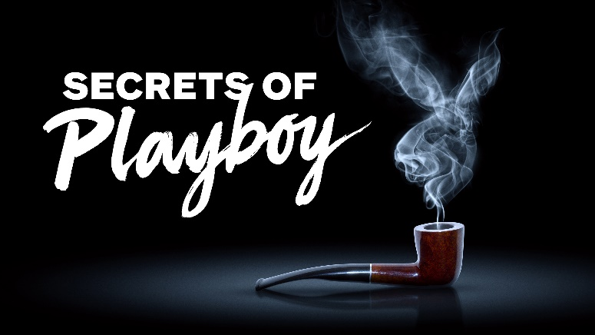

Premieres across Benelux on Wednesday 6 April from 22.00

To date, hundreds of international press outlets have reported on Secrets of Playboy with coverage in Los Angeles Times, People, UsWeekly, TV Guide, The New York Post, USA Today, Forbes, Nylon, Daily Beast, CNN, Nightline, Entertainment Tonight, Inside Edition, BBC News and dozens of others.

PRESS COMMENTS:

“Secrets of Playboy unravels multiple layers of the toxic Playboy ethos.”
Buzzfeed

“The Playboy mystique and Hugh Hefner's legacy receive a serious debunking in "Secrets of Playboy,"
CNN

“Docuseries Secrets of Playboy has lifted lid on sexual abuse at Hugh Hefner's Playboy Mansion”
Daily Mail

“Secrets of Playboy’ uncovers the seedy underbelly of Hugh Hefner’s empire”
Nylon

“Secrets of Playboy” goes down [as] the #1 unscripted cable launch of the 2021-22 TV season.
Cablefax Daily

“A+E's Docuseries 'Secrets of Playboy' Will Ruffle Your Cottontail”
Distractify

“Secrets of Playboy is a Scathing, Truly Nauseating Documentary”
The Hollywood Gossip

“Secrets of Playboy' Is Proof Playboy Shouldn't Exist Anymore”
Jezebel

“The world has long wondered what really goes on behind the walls of the Playboy Mansion. The new docuseries Secrets of Playboy lets viewers in on all the secrets.”
Suggest

