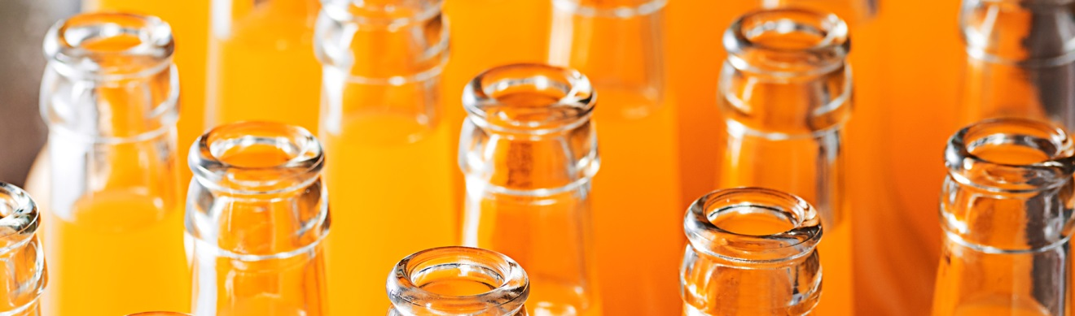
A new generation of yellow and orange beverage colors by Chr. Hansen
Refresh and revitalize your beverage brands with these new, improved functionality, color solutions
Denmark – November 24th, 2017
Extending its existing range of CapColors® and ColorFruit® Chr. Hansen is launching four new color solutions for beverage. With these two new orange and two new yellow solutions, Chr. Hansen wants to give beverage manufacturers better choices when it comes to color, performance and cost on the journey to naturality.
“At Chr. Hansen Natural Colors, it is our goal to help food & beverage manufacturers meet the increased demand from consumers for natural color ingredients. This is true also in the beverage category which has its own unique challenges with color when it comes to stability and performance. With our patented encapsulation technique and state-of-the-art emulsion products, we are able to provide stable color solutions with high resistance to heat treatment and light exposure,” explains Jakob Dalmose Rasmussen, Global Marketing Director for Chr. Hansen Natural Colors.
“At the same time, our range of solutions provides manufacturers choice when it comes to cost and where on the journey to naturality they want their brand to be,” adds Jakob.
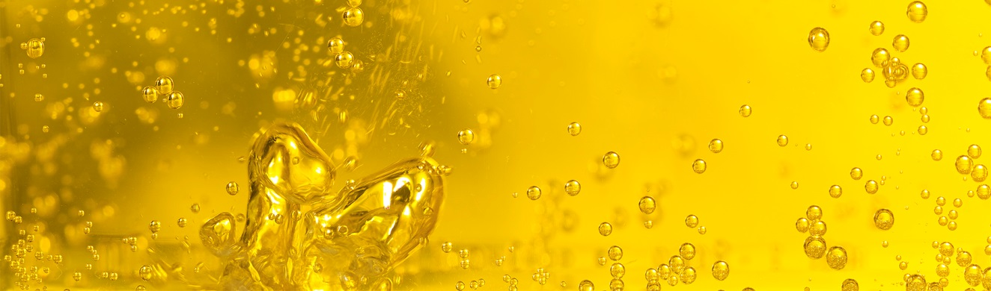
The new yellow color range is suitable for multiple applications: carbonated or still, with or without juice. The new orange colors are suitable for a range of applications containing juice including concentrates, carbonates stills and energy drinks.

Meeting market needs for natural beverage colors
Consumer preferences towards natural ingredients are on the move. In a recent consumer study from FMCG Gurus ‘65% of consumers said they check product labeling for artificial colors sometimes or more often’. These trends are also impacting the beverage category, where ‘30% of consumers said that Natural Color claims are important when it comes to beverage purchases’.
“At Chr. Hansen we are determined to stay in the forefront of innovation in the beverage color market, providing the newest natural color possibilities. That is why we are delighted to launch these four new solutions. They are an example of how we apply our innovative technology to serve the beverage industry”, states Jakob.
The two new CapColors® orange solutions utilize Chr. Hansen’s newest patented encapsulation technique to improve the functionality of the natural color in the final application. The CapColors® orange solutions require that the final application contains a small amount of juice to stabilize the color and secure that full strength of the color is obtained.
The two new robust, transparent yellow Colorfruit® emulsions offer a versatile color solution in both juice and non-juice based applications. The clear transparent color offers a strong natural alternative to dyes such as Tartrazine or Sunset Yellow.¹
Unique technology for improved functionality
Stine Kreutzmann, Technical Industry Manager at Chr. Hansen Natural Colors, has worked on the development of these new color solutions:
“The four new colors are in liquid form and are easy for manufacturers to use. The colors are high strength, versatile and robust, offering multiple shade nuances from deep orange to transparent yellow. All products are stable towards heat treatment and light exposure, and they do not create any neck ring in the final application. As we know cost is always a parameter in beverage production, we have strived to deliver a cost efficient solution without compromising on quality,” concludes Stine.
More information on these latest innovations will be available at Food Ingredients Europe 2017 in Frankfurt from 28th-30th November, where Chr. Hansen will present the products to the market for the first time.

More information about our new generation of yellow and orange colors is available on website.

Chr. Hansen Natural Colors is the only provider of natural colors that combines 140 years of unique application and regulatory expertise with a strong, extensive global presence and the widest natural color portfolio in the industry. We are experts at helping companies convert to and utilize natural colors. All our raw ingredients are specifically sourced from nature to offer bright and consistent solutions. Chr. Hansen is a leading global bioscience company that develops natural ingredient solutions for the food & beverage, nutritional, pharmaceutical and agricultural industries. Chr. Hansen was founded in 1874 and today has more than 3,000 employees in 30 countries and is listed on Nasdaq Copenhagen.

