Online Data Backup: Revolution or Evolution?

Cloud computing has changed the way companies do business and is reshaping the marketplace allowing even small businesses to create a global reach finding clients and markets that would until now have been the preserve of much larger organisations. Online data backup, along with management and collaboration have created that revolution and now we must find a method of accessing the benefits they bring without disrupting the fabric of the business too much and too quickly.
Businesses have until now held their data as close to themselves as they can and by holding it on their own sites and servers exerted control over it. The main change that accessing the “global marketplace has brought is one of mindset; it’s now OK that your data is held and managed by a third party and there are now many compelling supporting economic justifications for doing so.

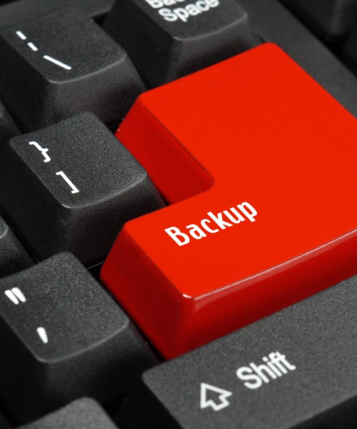

To see this revolution in the round we must understand the drivers behind it so we need to look at the way data has been backed up until now. Backups are not a glamorous, high-profile task in any business and in a small or medium-sized business especially, there are always more pressing things to do. As a consequence, many businesses operate backup using incomplete or otherwise inadequate processes:
- Critical data is not backed up or backed up infrequently, which means recovery is at risk.
- Backup is a tape based manual process where tapes which are frequently over-written and seldom checked so consequently they may be impossible to read rendering the process pointless as restore is hopeless.
- Backup can be to tapes or CD both of which need changing manually and as we all know from experience, any manual process that can go wrong will go wrong.
- Backup processes often rely on one individual who may not be available should recovery be needed.
- Backups may be stored only locally, close to primary servers, putting the business at serious risk if that local site is compromised.
- Backups may be taken off site; again this is a manual process reliant on human intervention.
- Backups fail to meet regulatory requirements or industry standards for data protection and retention
Most small and medium-sized business have some form of backup solution in place but these are typically time-consuming to operate, used inconsistently, or offer inadequate protection from disasters like fires and floods. These reflect lack of time, staff and expertise and means many businesses have been using a backup solution for years that is costly and/or out of date.

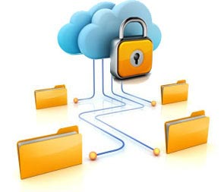
Here is the true value of the online data backup revolution; it delivers a quick and simple method of doing state of the art backup.
Online backup or “remote backup” runs as a service operating by sending backup data securely over the Internet to a highly available data center. Here it is held on highly available storage arrays and managed by data protection experts. This delivers enterprise-class data protection for small to mid-sized businesses without the overhead of costly and complex management.
The keys here are high availability and security; taking these in turn, all aspects of the network, data center and storage arrays have built in redundancy meaning any single part of the system can fail without losing access to the data or affecting the data itself. The data center will have at least two power supplies, at least two internet connections. Every hardware system will have at least two power supplies and the storage arrays are configured in a way so that should a hard drive fail the data is both present and accessible. Configuring the system in this way means your data is accessible from anywhere in the world with internet access should you suffer a disaster.
In common with any other cloud service, online backup is self-provisioning via an admin console delivered through a web browser; using this means you do not need to buy hardware, manage a complex installation or manage software upgrades. New features are added by the provider and delivered to all clients seamlessly and simultaneously to all customers. The services operate on a pay-as-you-go model based on cost/Gb with an elastic service meaning users can increase or decrease use as required without penalty. Monthly/annual subscription typically includes 24x7 support and the automated nature means the client gets an “always on” service so backups are triggered by file changes or run to a schedule. In this way once the initial backup is made, only block level changes are backed up meaning bandwidth is used very efficiently. Of all these things, the most important is that the automated nature means the requirement for manual backups or managing storage media disappears.
Online backups will back every file type up meaning you need only one type of software whereas previously you would have needed one type of software for each file type and are properly versioned with multiple copes held allowing restores to a selected point in time. You can run online backups on every machine in your business rather than just file servers, so you can backup laptops only occasionally connected to the office network.
When using online backup services files are encrypted prior to transmission and stored in that encrypted form of the backup servers. Your data is encrypted with a password key known to you only (the service provider does not have this key) which means your data cannot be stolen. This fact plus the encryption means you are compliant with data privacy and security regulations.
You can create audit trails for your own business practices as each backup is confirmed by an email and should any issue arise you will be immediately notified.
Restores can be achieved by the end user in minutes, without outside expertise, from anywhere with internet access via a web browser 24x7x366 either using a wizard or choosing files from a list. Given that restores can be achieved in minutes at any time, day or night, on weekends or holidays testing the system is quick and easy. Worries about running out of drive space, replacing old equipment etc. disappear as this is now in the hands of the service provider.

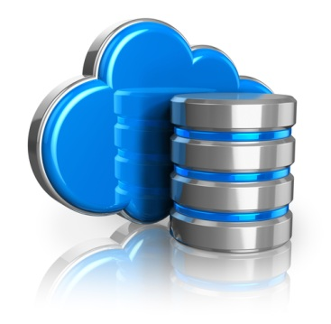

Is Online Backup Right for My Business?
Moving your IT into the cloud and backup online is a major step; no two businesses are identical so while there is a compelling case for making the move, you must consider these factors as part of the decision process.
The first question to ask is do we need to do this? “If it ain’t broke don’t fix it” is usually sound business logic; so if your current systems meet your needs, there is no reason to make the move. Yet.
Can you afford to make this move? Typically this a simple balance of the monthly costs payable to the service provider vs. the totals required to build your own in house infrastructures. To balance against this you must make a judgement of the costs of maintaining or upgrading the existing network and equipment including upkeep of obsolete hardware and software plus any value that might be realised from scrapping said equipment. How old is the equipment? What is the projected service life? Part of these considerations must be the age of the current network; can you realise the full benefits the move should deliver or is upgrading the existing infrastructure a more immediate priority?
Is your data suitable for moving into the cloud in its current form? How much is there ? Will that volume affect the capability to make the move? What type of cloud architecture will be most appropriate for your data? These are questions your service provider should be able to help with.
Making a move into the cloud will be disruptive; revolutionary change always is. This change will affect staff and the potentially the core business, so planning and timing are critical to achieving as smooth a change as possible.
We have seen many of the compelling reasons to move to online backups but we have also seen that this is a revolutionary change and an evolutionary approach cannot work. Online backup delivers many benefits but you must take full account of all the circumstances of your business before making that revolutionary leap.

For more details on Cloud Services and how to buy them, please see: http://www.managedserviceexpert.com/

