Press release

For Immediate Release

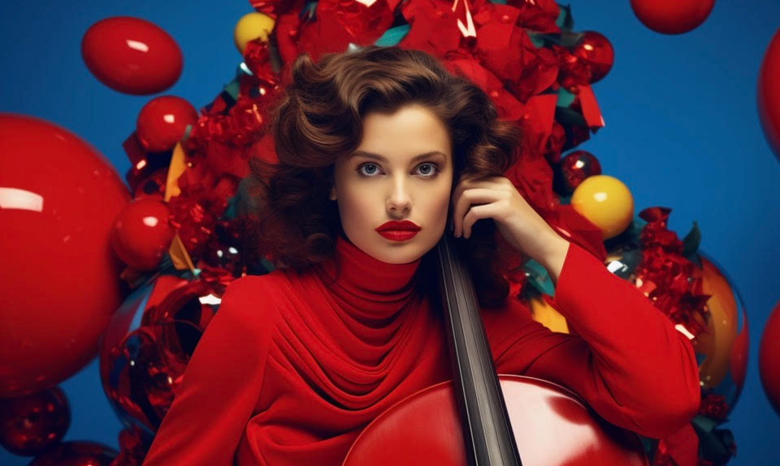

Zymphonica Unveils Magical Christmas Album “Christmas Strings”

The famed symphony orchestra collective, Zymphonica, led by the visionary arrangers and conductors Johan Landqvist and Rasmus Fors, proudly announces their newest musical gift this festive season – "Christmas Strings." This album masterfully marries the warmth of Christmas pop hits with the splendor of symphonic arrangements.

Dive into the festive delights of "Christmas Strings," featuring:

- "Happy Xmas (War Is Over)" - Zymphonica's rendition captures the profound essence of John Lennon's message of peace, augmenting it with an orchestral depth that speaks of hope and unity.
- "All I Want For Christmas Is You" - Mariah Carey's joyous hit is presented with the same infectious spirit, but this time enveloped in a touch of classical sophistication.
- "Last Christmas" - Zymphonica offers a symphonic take on Wham!'s cherished song, retaining its nostalgic charm while adding a refreshing orchestral elegance.
- "Do They Know It's Christmas" - Band Aid's anthem of love and unity is recreated with a heart-touching symphonic arrangement, underlining its timeless message.
- "Santa Tell Me" - Ariana Grande's modern favorite is beautifully transitioned into a lively orchestral celebration without losing its playful core.
- "Feliz Navidad" - Zymphonica's take on José Feliciano's joyful carol is a melodic embrace that combines both festive spirit and symphonic grace.
- "Rockin' Around The Christmas Tree" - Brenda Lee's iconic number gets a jubilant orchestral makeover, epitomizing holiday cheer.
- "Fairytale of New York" - The deep emotional resonance of The Pogues' ballad is intensified in this symphonic adaptation, resonating with both heartache and hope.

"Christmas Strings" is not just an album, but a symphonic journey through the festive season. Available now in all major music stores and streaming platforms, it invites listeners from all musical backgrounds to rediscover the magic of Christmas.

For further details, interviews, or promotional requests, please contact
Helene Wigren
PR & Beyond
Email: Helene.Wigren@prbeyond.se
Phone: 070-752 76 05

About Zymphonica:
Based in the heart of Stockholm, Zymphonica is not just another symphony orchestra, but a dynamic collective that breathes fresh life into timeless music. Spearheaded by the talented arrangers and producers, Johan Landqvist and Rasmus Fors, Zymphonica has successfully blended the charm of classical symphonies with the vibrant pulse of today's hit songs.

Strategically located near landmarks of musical excellence such as the Royal Music Academy, the Swedish Radio Symphony Orchestra, The Royal Opera, and the Royal College of Music, Zymphonica's studios and office are not just spaces of work, but centers of creative confluence. Here, traditional orchestra meets contemporary pop, rock, and R&B, resulting in a harmonious blend that appeals to both classical enthusiasts and modern music aficionados.

By offering classical arrangements of the world's most popular hits, Zymphonica introduces listeners to a new realm of musical experience, where age-old instruments echo today's melodies. This unique approach not only bridges the generational gap but also elevates popular tunes to symphonic magnificence.
Beyond the music, Zymphonica's success is shaped by a team of visionaries. At the helm are arrangers and conductors Johan Landqvist and Rasmus Fors, whose combined expertise forms the core of Zymphonica's innovative sound. Complementing their efforts are the seasoned music supervisors and executive producers, Klas Lunding and Sanken Sandqvist. Their invaluable contributions ensure that with each arrangement, Zymphonica delivers not just a performance, but a musical journey that transcends genres and eras.

