FOR IMMEDIATE RELEASE

Intellian completes its next generation
Global Xpress portfolio with Inmarsat type approval

New GX60NX antenna brings the enhanced functionality and performance of Intellian’s cutting-edge NX Series to smaller vessels on the Inmarsat network

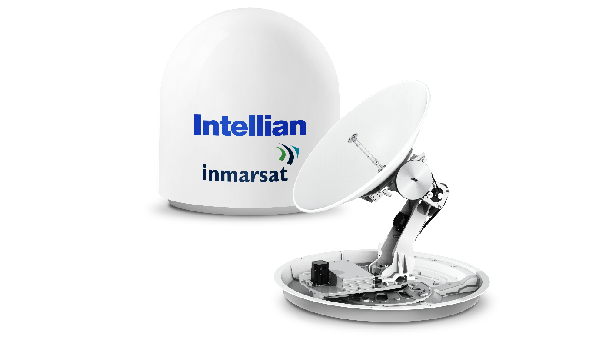
Intellian’s new GX60NX antenna, now type approved for use on the Inmarsat network

4 August 2020 – Intellian is proud to launch the latest addition to its next generation GX range of antennas: the GX60NX, designed specifically and now type approved for use with Inmarsat’s Global Xpress Ka-band VSAT network. This 65cm terminal, the smallest in the range, completes Intellian’s GX portfolio and brings the benefits of its market leading NX antennas to all vessels using Inmarsat’s Fleet Xpress service for reliable, fast connectivity at sea.
Thanks to its compact size and light weight, the GX60NX is ideally suited to smaller commercial vessels, where space is at a premium but the benefits offered by the latest technology are still required. The new form factor supports customers across all markets, including leisure and fishing.
The Below Deck Terminal (BDT), single cable antenna connection and AptusNX control software are identical to those used for the larger GX100NX, which is already approved. This allows ship management companies and ship owners to benefit from the ability to work with a standard platform across diverse fleets.
Inmarsat’s wholesale channel will benefit from the modem and mediator being built into the BDT, simplifying installation and allowing dual antenna systems to be easily configured with just the addition of a second NX antenna and Antenna Control Unit (ACU). The GX60NX is 2.5GHz Wideband Ka ready, and the BUC is easily upgraded from 5W to 10W if increased upload performance is required. This simplicity and flexibility will allow customers to immediately take advantage of future enhancements – including increased coverage and bandwidth afforded by Inmarsat’s rapid network expansion as new satellites are launched – as well as making full use of the market-leading services available today.
Ronald Spithout, President, Inmarsat Maritime, said: “We are delighted that the GX60NX has been type approved and is ready for use for our channel partners with Fleet Xpress. This reinforces our close and innovative partnership with Intellian. We now have more than 9,000 vessels using the service and we are seeing an increase in demand for digital and crew services, which is why we are launching a further seven satellites in the next three years.”
Intellian’s NX Series antennas share a host of features which set them apart from the competition. Designed with ease of installation in mind, the antennas come with pre-slung lifting straps in compact shipping crates, have no shipping brackets requiring removal and are terminated externally using a single coaxial cable to carry power, Tx and Rx signals, avoiding the need for the installer to remove the dome. Intellian’s innovative AptusNX software makes commissioning straightforward via a built-in wizard, and facilitates both remote and local diagnostics with health reports for the antenna systems and sensors.
Eric Sung, CEO of Intellian, commented, “We’re delighted to introduce the GX60NX antenna, completing our GX NX portfolio and bringing the benefits of our future-proof, user-friendly antennas to our valued customers in the small commercial, leisure and fishing markets. The integration of our market-leading technology with Inmarsat’s global network provides a seamless route to connectivity, whatever the needs of your business.”
The GX60NX will be commercially available in August, initially for Inmarsat’s wholesale partners.

-Ends-

About Intellian Technologies, Inc.
Intellian is the global leader of mobile satellite communication systems for maritime applications and a leading communication technology innovator for the government, military, energy, cruise and enterprise sectors. Founded in 2004, Intellian continues to invest in cutting-edge design, R&D, Quality Control, and advanced low environmental impact production facilities to deliver bold and pioneering solutions. These include the award-winning v240MT, the world’s first tri-band, multi-orbit antenna system and the future-proof NX series antennas optimized for high performance and low cost of ownership.

Intellian has a global presence with over 400 employees, 12 regional facilities and 5 logistics centers on 3 continents. The Intellian 24/7 global support desk provides dedicated assistance to 550 service provider partners and their customers in mission critical environments. Intellian Technologies Inc. is listed on the Korean Stock Exchange, KOSDAQ (189300:KS).

More information may be found at www.intelliantech.com.
For further enquiries, please contact:
Paul Comyns / VP of Marketing
Intellian Technologies USA
T + 1 949 727 4498 ext. 1301
Paul.Comyns@intelliantech.com

David Pugh
Saltwater Stone
T +44 1202 669 244
d.pugh@saltwater-stone.com
Sadie Brown / Marketing Manager
Intellian Ltd
T +44 2380 019 021 ext. 1612
Sadie.Brown@intelliantech.com

