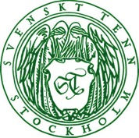
Press Release
Stockholm, March 11, 2016

Art jewellery inspired by nature on display at Svenskt Tenn

This spring in Stockholm, contemporary art jewellery is exhibited at various museums and galleries engaged in the project Art Jewellery 2016. Svenskt Tenn takes part by showing works inspired by nature from thirteen jewellery artists, while introducing a collection created exclusively for Svenskt Tenn by jewellery artist Märta Mattsson.

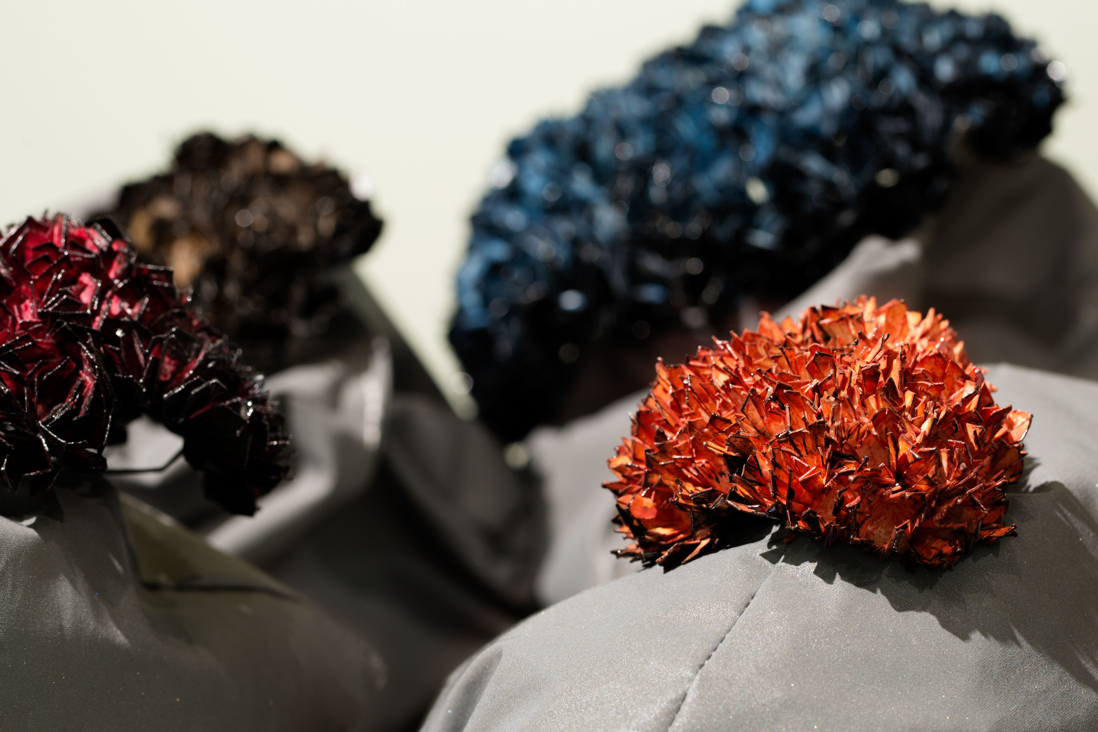
In 1943, Svenskt Tenn founder Estrid Ericson first presented pewter jewellery of her own design. She had found inspiration in Bronze Age jewellery at the Swedish History Museum, as well as in plants and animals. Now Svenskt Tenn takes part in the project Art Jewellery 2016, exhibiting works by thirteen contemporary jewellery artists. Each of their items has been inspired by nature in some way, and the artists have used a variety of materials, including recycled plastic, wood, seashells, paper and birch bark.

”Art jewellery is a key element of Svenskt Tenn’s legacy and of what we do today,” says Thommy Bindefeld, Marketing Director at Svenskt Tenn. ”It all started in the 1940s when Estrid Ericson created pewter jewellery working with chiseller Thure Carlsson, and the main part of these designs have stayed in our range. We are also proud to observe that five of the thirteen artists featured in our spring exhibition are part of Svenskt Tenn’s organisation.

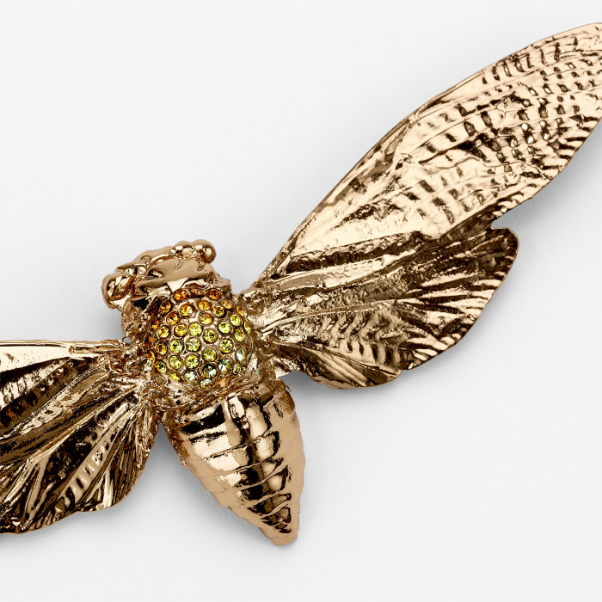
In conjunction with the exhibition, Svenskt Tenn introduces an all-new collection by jewellery artist Märta Mattsson, comprised of a necklace, a brooch and earrings.

”Until now, Märta Mattson has made each piece by hand, using insect specimen which she has prepared,” says Thommy Bindefeld. “For this occasion, she has designed her first series of brass jewellery for Svenskt Tenn to produce in limited edition. She is one of the most internationally distinguished Swedish jewellery artists, and we are very pleased that she has elected to collaborate with us.

The jewellery artists who contribute to the exhibition are Annika Pettersson, Hanna Hedman, Hanna Liljenberg, Helena Sandström, Catarina Hällzon, Ingrid Bärndal, Karin Roy Andersson, Mia Larsson, MURKY (Emelica Lidman and Mike Årsjö), Märta Mattsson, Sarah Hurtigkarl, Sofia Eriksson and Yasar Aydin.

The exhibition opens on March 12 and runs through April 10, 2016. The entire exhibition collection is for sale.

For further information, please contact:

Vicky Nordh, Marketing Assistant: +46 8-670 16 23 or vicky.nordh@svenskttenn.se

Thommy Bindefeld, Marketing Director: +46 8 670 16 02 or thommy.bindefeld@svenskttenn.se

Svenskt Tenn is an interior design company with retail stores at Strandvägen in Stockholm and online. Since 1975, Svenskt Tenn is owned by the Kjell and Märta Beijer Foundation, which provides research grants within ecology, medicine and the preservation of Swedish interior design tradition.

