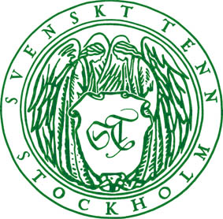
Press Release
Stockholm, October 2, 2014

Svenskt Tenn exhibits festive table settings in the spirit of Estrid Ericson

It is well documented how Svenskt Tenn founder Estrid Ericson mastered the art of table setting. The new exhibition which opens tomorrow provides inspiration to beautiful tables where products from the Svenskt Tenn archives are mixed with new designs, all arranged in the spirit of Estrid Ericson.

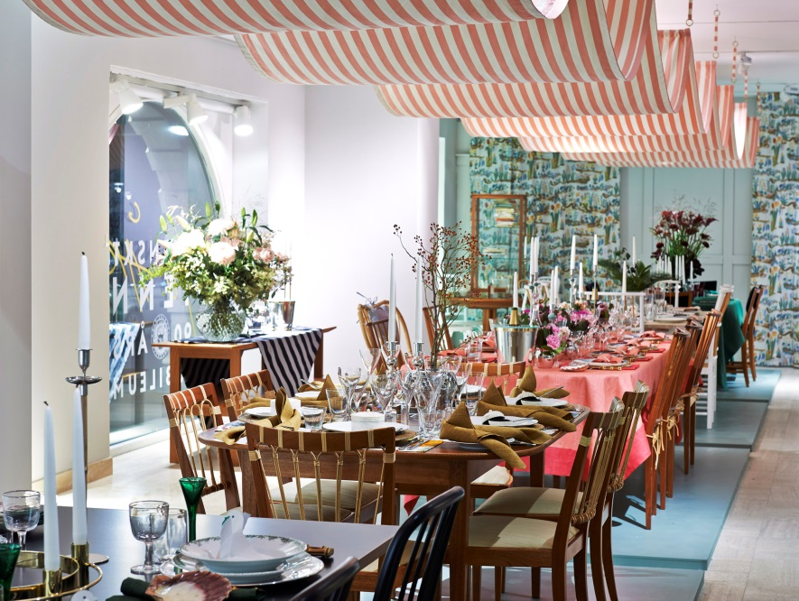
“The common attribute of the table setting exhibition is the excellence of design, materials and handicraft,” said Thommy Bindefeld, Marketing Director at Svenskt Tenn. “The blend of older and newer items using a variety of colors and materials creates a personal interior style with lasting qualities.”

Estrid Ericson was born into a hotelier family, which may explain why it came naturally to her to develop the art of table setting. In 1933, she called to a major exhibition at Svenskt Tenn headlined “Table, set yourself!’’, where she displayed tables arranged according to different styles. Svenskt Tenn now opens a new exhibition of table settings made in the same spirit.

The exhibition features a number of new products from the Svenskt Tenn archives; a dinner table, a bentwood chair in four colors (green, coral, black and white) and a tall pewter candlestick with a bamboo handle by Josef Frank, a vase by Anna Petrus, and a pewter table mirror. All these items are now for sale.

The exhibition is open through November 3 in the Svenskt Tenn store in Stockholm.

For further information, please contact:

Vicky Nordh, Marketing Assistant: +46 8-670 16 23 or vicky.nordh@svenskttenn.se

Thommy Bindefeld, Marketing Director: +46 8 670 16 02 or thommy.bindefeld@svenskttenn.se

Image bank: www.svenskttennpress.se User name: Press Password: Tenn

Svenskt Tenn was founded in 1924 by designer and drawing teacher Estrid Ericson (1894-1981). In 1934, she began her lifelong collaboration with Josef Frank, already an internationally well-known architect, urban planner and designer, who had recently left Austria to take up residence in Sweden. Together, the two laid the foundations for the interior design philosophy that Svenskt Tenn has since come to represent, combining Estrid Ericson's artistic talent and entrepreneurial spirit with Josef Frank's inspired and timeless designs to form what was soon to become a highly successful concept. Svenskt Tenn is owned by the Kjell and Märta Beijer Foundation.

