**Norsk fotograf blant de nominerte i Sony World Photography Awards 2015**

*Bildet til norske Clas Kristensen er plukket ut fra rekordmange 173,444 innsendte bidrag fra 171 land*

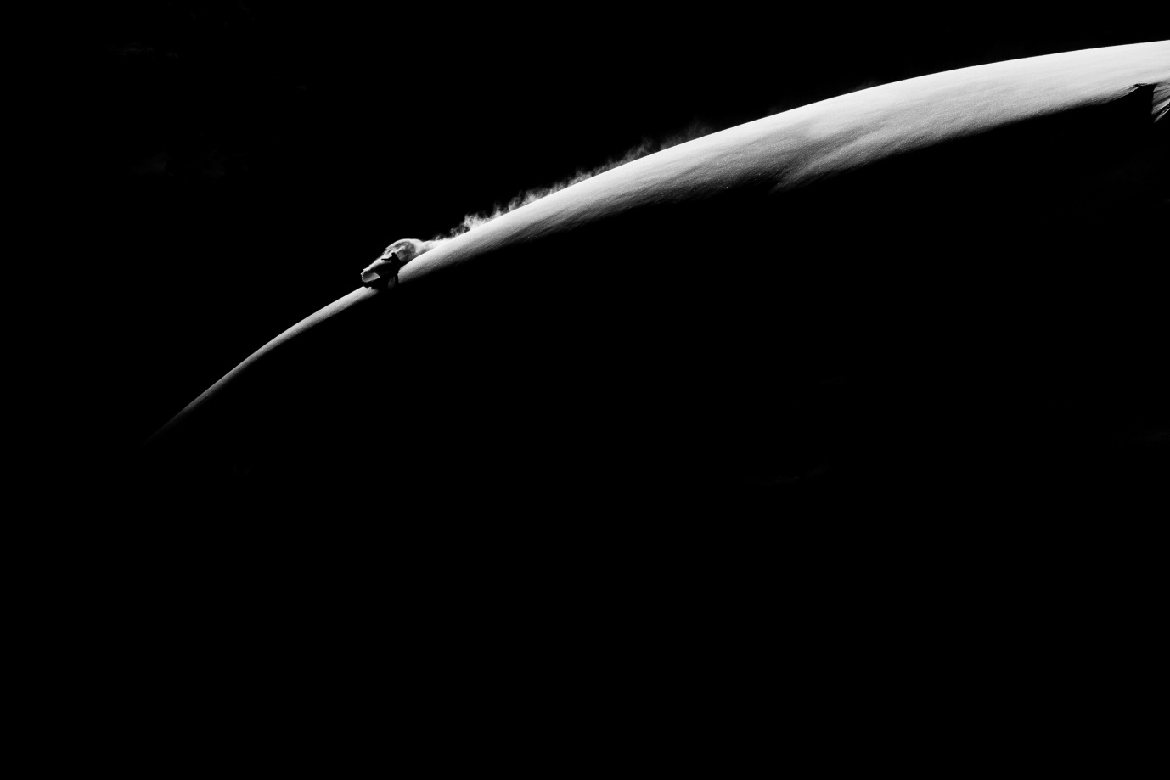(c) Clas Kristensen, Norway, 2015 Sony World Photography Awards

**Oslo, 24. februar:** I dag ble det kjent at én norsk fotograf er blant de nominerte i verdens største fotokonkurranse, Sony World Photography Awards 2015.

Clas Kristensen går videre innenfor kategorien «Sport» i den profesjonelle konkurransen med sin bildeserie «Moon Landing». Bildene er plukket ut fra 173,444 innsendte bidrag fra 171 land – det høyeste antall bidrag i prisutdelingens historie og en økning på 24 prosent sammenliknet med fjoråret.

Som finalist i den profesjonelle klassen, vil Clas Kristensen bli vurdert for tittelen Professional Sport Photographer of the Year og konkurrere om den ærefulle tittelen L’Iris d’Or/ Photographer of the Year samt en pris på 25,000 dollar.

34 år gamle Clas Kristensen er frilansfotograf og lege. Han er selvlært innenfor fotografi, og har utallige ganger fått sine bilder publisert i snowboard-magasiner verden over. Hans fantastiske vintersportslige svart-hvitt-bildeserie er fotografert i Tromsø, hvor han også bor.

– Det er en stor ære å bli nominert. Spesielt når man vet at man konkurrerer mot så mange talentfulle profesjonelle fotografer fra hele verden, uttaler Clas Kristensen.

Alle vinnerne innenfor de profesjonelle kategoriene, samt vinnerne av den Åpne konkurransen, Ungdoms- og Studentkonkurransen og L’Iris d’Or vil bli annonsert på en gallaseremoni i London den 23. april. Fotografen som går av med tittelen Open Photographer of the Year vil også motta 5,000 dollar, og alle vinnerne vil motta det siste innen digitalfoto-utstyr fra Sony.

De nominerte bildene i konkurransen vil bli utstilt ved Somerset House i London fra 24. april – 10. mai som en del av Sony World Photography Awards 2015 Exhibition, og fotografene vil få sitt arbeid publisert i 2015-utgaven av Sony World Photography Awards-boken. Billetter er tilgjengelig på [www.worldphoto.org/2015exhibition](http://www.worldphoto.org/2015exhibition).

**Bilder:** [**press.worldphoto.org**](http://press.worldphoto.org/) **og** [**Image.net**](https://www.image.net/)

**For ytterligere informasjon om** **Sony World Photography Awards, vennligst kontakt:**

Jill Cotton, Senior Press Manager, World Photography Organisation

+44 (0) 20 7886 3146/ [jill@worldphoto.org](mailto:jill@worldphoto.org)

Kristine Bjørge, PR Manager, World Photography Organisation

+44 (0) 20 7886 3049 / [kristine@worldphoto.org](mailto:kristine@worldphoto.org)

**Eller**

Lene Aagaard, PR Communications Manager, Sony Nordic  
+45 (0) 43 55 72 92 / [lene.aagaard@eu.sony.com](mailto:lene.aagaard@eu.sony.com)

**Eller**

Anette Jamtvedt, Navigator Kommunikasjon

938 56 352 / [anette@navigator.no](mailto:anette@navigator.no)

**NOTES TO EDITORS**

* 177, 444 images were entered in total to the 2015 Sony World Photography Awards:

87,505 Professional entries; 79,264 Open entries and 6,675 Youth entries images

* 139,554 images were entered to the 2014 awards

**Shortlisted photographers**

**PROFESSIONAL CATEGORIES**

Photographers were invited to enter a series of between 3 and 10 images into any of the following 13 categories. Judges were asked to select up to 10 photographers for the shortlist. Photographers are listed alphabetically

Architecture

* Joanna Bałaś, Poland
* Cosmin Bumbutz, Romania
* Jonathan Carvajal, Colombia
* Antonio La Grotta, Italy
* Massimo Siragusa, Italy
* Vadim Sivak, Ukraine

Arts & Culture

* Alessandra Bello, Italy
* Maurizio Beucci, Italy
* Aristide Economopoulos, United States
* Dennis Fung, Hong Kong
* Olaf Schuelke, Germany
* Koh Soon, Malaysia
* Brent Stirton, South Africa
* Pierre André Transunto, Italy
* Rich Wiles, United Kingdom
* Gili Yaari, Israel

Campaign

* Jonathan Banks, United Kingdom
* 片村 文人/ Katamura Fumihito, Japan
* Eduardo Leal, Portugal
* Amit Madheshiya, India
* Sebastian Gil Miranda, France
* Fei Maohua, China
* Jonathan Syer, United Kingdom

Conceptual

* Alejandro Almaraz, Argentina
* Kursad Bayhan, Turkey
* Meike Fischer, Germany
* Lisa Gimenez, Argentina
* Daesung Lee, South Korean
* Jordi Pizarro, Spain
* Katia Platonova, Russia
* Rahul Talukder, Bangladesh
* Julie van der Vaart, Netherlands

Contemporary Issues

* Corentin Fohlen, France
* Shah Newaz Khan, Bangladesh
* Lisa Krant, United States
* Annalisa Natali Murri, Italy
* Brent Stirton, South Africa
* Boguslawa Trela, Poland
* Scott Typaldos, Switzerland

Current Affairs

* Valery Melnikov, Russia
* John Moore, United States
* Vladyslav Musiienko, Ukraine
* Herman Verwey, South Africa

Landscape

* 鵬峻 顏/ Peng-Chun Yen, Taiwan
* Laia Abril, Spain
* Armando Avallone, Italy
* Simon Butterworth, United Kingdom
* Simon Norfolk, United Kingdom
* Rudi Sebastian, Germany
* Eva Skalak, Czech Republic
* Giulio di Sturco, Italy
* Danila Tkachenko, Russia

Lifestyle

* Dovile Dagiene, Lithuania
* Julia Fullerton-Batten, United Kingdom
* Ramil Gilvanov, Russia
* Alvaro Gomez Vidal, Spain
* Chen Jian, China
* Fan Li, China
* Jiangsong Li, China
* JM Lopez, Spain
* Yoko Naito, Japan
* Mahadev Rojas Torres, Venezuela

People

* Johan Bavman, Sweden
* Carla Kogelman, Netherlands
* Sabine Lewandowski, Germany
* Tali Mayer & Janos Chiala, Italy
* Cecila Meller, France
* Jennifer Osborne, Canada
* Liza Van der Stock, Belgium
* Giovanni Troilo, Italy

Portraiture

* Christian Berthelot, France
* Rodrigo Illescas, Argentina
* Jens Juul, Denmark
* Tomasz Lazar, Poland
* Kerry Mansfield, United States
* Ruben Salgado Escudero, Spain
* Dougie Wallace, United Kingdom

Sport

* Salil Bera, India
* Riccardo Bonomi, Italy
* Irina Dainakova, Belarus
* Sascha Fromm, Germany
* Guorong Jia, China
* Anthony Kham, Cambodia
* Marcin Klocek, Poland
* Clas Kristensen, Norway
* Ronaldo Land, Brazil
* Jonathan Yeap Chin Tiong, Singapore

Still Life

* Peter Franck, Germany
* Kirill Golovchenko, Ukraine
* Kimmo Metsäranta, Finland
* Vova Pomortzeff, Russia
* Emanuele Satolli, Italy
* Mong-Yong Sim, Malaysia
* Krishna Tummalapalli, India
* Donald Weber, Canada

Travel

* Nazir Azhari Bin Mohd Anis, Malaysia
* Nadia Maria Dias, Indian
* Andrea de Franciscis, Italy
* Peter Franck, Germany
* Zbynek Hrbata, Czech Republic
* Bernhard Lang, Germany
* Yoko Naito, Japan
* Vasilis Ntamplis, Greece
* Adhi Prayoga, Indonesia
* Farid Sani, Iran

**OPEN CATEGORIES**

Presiding Chair: Sam Barzilay, Creative Director, United Photo Industries (US)

Judged on a single shot and open to photographers of all abilities, judges were asked to select up to 10 shortlisted images per category.

Architecture

* Gina Alderson-Hicks, Australia
* Armin Appel , Germany x 2
* Marcus Bayer, Germany
* Goran Erfani, Iran
* Michiel Hageman, Netherlands
* Cesar March, Spain
* Andrea Rossato, Italy
* Jürgen Schrepfer, Germany
* Klaus Wäscher, Germany

Arts and Culture

* Aprison Aprison, Indonesia
* Muhammad Berkati, Indonesia
* Kai Heimberg, Germany
* David Martin Huamani Bedoya, Peru
* Hector Muñoz Huerta, Mexico
* Adrian Jaszczak, Poland
* Partha Sen, India
* Alessandro Spiga, Italy
* Elangovan Subrmania, India
* Marius Vieth, Germany

Enhanced

* Lione Bakker, Netherlands
* Ceslovas Cesnakevicius, Lithuania
* Antony Crossfield, United Kingdom
* Lisa Griffin, Ireland
* Nenad Martic, Croatia
* Daniel Necula, Romania
* Manh Ngoc Nguyen, Germany
* Milad Safabakhsh, Iran
* Zoltan Toth, Hungary
* Theo de Witte, Netherlands

Low Light

* Dhrubajyoti Bhattacharjee, India
* Katja Gragert, Germany
* Rodrigo Jardon, Mexico
* Tsang Kam Man, China
* Alexander Kitsenko, Ukraine
* Nick Ng Yeow Kee, Malaysia
* Darren Nisbett, United Kingdom
* Iskra Parvanova, Bulgaria
* Zol Straub, Australia
* Ian Thuillier, Ireland

Nature & Wildlife

* Seyed Babak Musavi, Iran
* Gal Gross, Israel
* Harfian Herdi, Indonesia x 2
* Melissa Little, Australia
* Peep Loorits, Estonia
* Yasuyuki Oono, Japan
* Yvonne Spane, Germany
* Jassen Todorov, United States
* Antoine Weis, Switzerland/ Luxemberg

Panoramic

* Marcio Cabral, Brazil
* Mohammad Reza Domiri Ganji, Iran x 2
* Alexander Klebe, Germany
* Wojciech Kruczynski, Poland
* Markus Kuhn, Germany
* Mike MacKinven, New Zealand
* Pierumberto Pampanin, Italy
* Norman Quinn, United Kingdom
* Klaus-Peter Selzer, Germany

People

* Saeed Barikani, Iran
* Amitava Chandra, India
* Sergio Diaz, Spain
* Krzysztof Kowalski, Poland
* Raquel Lopez-Chicheri, Spain
* Simon Morris, United Kingdom
* Agus Purnomo, Indonesia
* Saleh Rozati, Iran
* Peter Voss, Germany
* Hui Hua Wang, Singapore

Smile

* Mohammad Amir Hamja, Bangladesh
* Ummu Kandilcioglu, Turkey
* Christine Kapuschinsky Johnson, Austria
* Kiatthaworn Khorthawornwong, Thailand
* Wilson Lee, Hong Kong
* Joseph Makeni, Kenya
* Steffen Rothammel, Germany
* Peter Voss, Germany
* Umair Wadood, Pakistan
* 方 梓勳, Taiwan

Split Second

* Ata Mohammad Adnan, Bangladesh
* Panom Archarit, Thailand
* Uwe Hennig, Germany
* Small Monte Lee, China
* Cesar March, Spain
* Jaime Massieu, Spain
* Eko Prihariyanto, Indonesia
* Lessy Sebastian, Indonesia x 2
* Tarek Touma, Lebanon

Travel

* Kumar Bishwajit, Bangladesh
* Ioulia Chvetsova, France
* Byron Dilkes, United Kingdom
* Jorge Fernandez, Spain
* Yasen Georgiev, Bulgaria
* Kok Keong Na, Malaysia
* Enrico Madini, Italy
* Ismail Abdul Mutalib, Indonesia
* Vladimir Proshin, Russia
* Massimo Rumi, Italy

**YOUTH COMPETITION**

Open to photographers aged 19 and under, judged by the World Photography Organisation.

Culture

* Mohammad Baggale Asghari Baghmishe, Iran
* Gaurang Bhatt, India
* Zhu Lin Ch'ng, Malaysia
* Pnar Efe, Turkey
* Reuben Foong, Singapore
* David Pereira, Singapore
* Beatriz Rocha, Portugal
* Andres Felipe Caicedo Sierra, Colombia x 2

Environment

* Krishan Bansal, United States
* Alex Foden, United Kingdom
* Fernando Henrique, Venezuela
* Nihal Koppath, United Arab Emirates
* Daniel Malikyar, United States
* Sepehr Razmju, Iran
* Jacopo Sironi, Italy
* Yong Lin Tan, Malaysia x 2
* Ivan Turukhano, Russia

Portraits

* Adi Dekel, Israel
* Daniil Maksyukov, Russia
* Marco Toc, Guatemala

**FURTHER NOTES**

**About World Photography Organisation (WPO)**

WPO is a home where photography is celebrated and the art of the photographer is recognised. Working with professional , enthusiast and student photographers alike, the World Photography Organisation provides a global network across the photographic industry to not only to raise the level of conversation around the subject, but to increase awareness and appreciation of this artform. WPO hosts a year-round portfolio of industry and public events including: **Sony World Photography Awards**, the world’s largest photography competition and accompanying global exhibition; the **World Photography Student Focus Programme**, inspiring and working with the next generation of photographers, and **Photo Shanghai,** Asia Pacific’s premier art fair dedicated to photography. In addition, WPO has a thriving online presence via its website, Twitter, Facebook and Instagram and addresses the industry’s latest issues in its monthly online publication, **The Magazine.** For more information please **visit** [**www.worldphoto.org**](http://www.worldphoto.org)

**About Sony Corporation**

Sony Corporation is a leading manufacturer of audio, video, game, communications, key device and information technology products for the consumer and professional markets. With its music, pictures, computer entertainment and online businesses, Sony is uniquely positioned to be the leading electronics and entertainment company in the world.  Sony recorded consolidated annual sales of approximately $75 billion for the fiscal year ended March 31, 2014.  Sony Global Web Site: <http://www.sony.net/>