AMARO MONTENEGRO CROWNS
ITS 2019 VERO BARTENDER

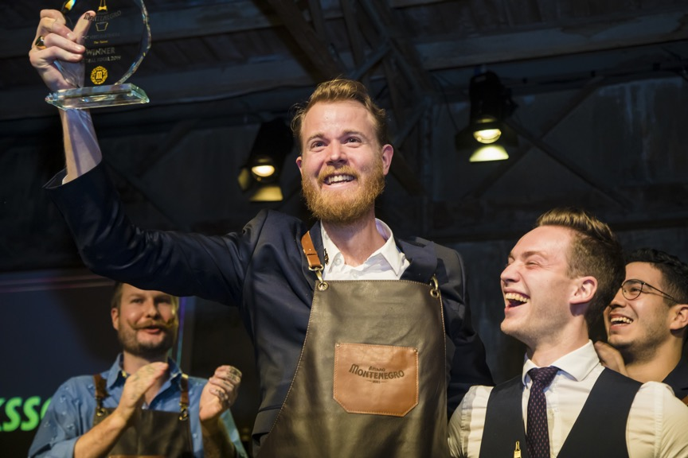
MARCUS FREDRIKSSON OF SWEDEN BEAT 11 CONTESTANTS TO TAKE THE TITLE AT THE GLOBAL FINAL IN MILAN, ITALY

WEDNESDAY 20 NOVEMBER 2019 - Milan, Italy - AMARO MONTENEGRO, one of Italy’s oldest and most iconic liqueur brands, has declared Marcus Fredriksson from Care Of, Sweden as the Vero Bartender following the global final in Milan this week. Fredriksson beat 11 other finalists to win the title after impressing a panel of venerated judges with his dedication to creating the most inventive sharing style cocktail. ‘Around The Corner’ was inspired by the local ingredients that can be found near Care Of and his home in Sweden. Marcus impressed the judges with an engaging presentation and his ability to mix sweet and savoury flavours in order to enhance the complexity of Amaro Montenegro.

‘Around The Corner’ has won Marcus Fredriksson the title of the ‘True Bartender’ and an exclusive trip to Brooklyn Bar Convent 2020, where he will have the opportunity to meet some of the best the global industry has to offer in order to refine the art of mixology.

A PRIZE FOR ALL
The Vero Bartender competition kicked off with regional and national heats in July and culminated this week with 12 global finalists attending an unparalleled residency programme across Italy. Commencing in Milan, finalists representing Italy, the United States, Australia, the United Kingdom, Spain, Germany, Switzerland, Austria, Belgium, the Netherlands, Albania and Sweden explored the city before attending seminars by industry heavyweights Monica Berg, International Bartender of The Year 2019 and co-owner of Tayēr+Elementary, London and Erik Lorincz, former Head Bartender of the American Bar at The Savoy and owner of Kwānt, London, ranked 47 in the World’s 50 Best Bars 2019.

After a 2-day programme of presentations and judging, Fredriksson was presented with the coveted prize of the Vero Bartender 2019 following deliberation from the esteemed team of judges also including Yolanda Evans, international travel and mixology journalist and Amaro Montenegro’s Master Herbalist, Matteo Bonoli. Once the winner had been announced, the remaining bartenders travelled to Florence to experience expert talks and masterclasses before arriving at the home of Amaro Montenegro, in the heart of Bologna.

A GLOBAL VICTORY
Marcus Fredricksson, Care Of – Sweden: “I’m so proud to be crowned The Vero Bartender 2019! I was intrigued by the challenge to create a unique sharing style cocktail, and taking inspiration from the locally grown ingredients used I decided to present my cocktail in a watering can and plant pots with a miniature garden for the judges to water. I’m always excited to experiment with flavour and presentation, and Amaro Montenegro is such a versatile liquid with great flavour which made it so much fun to play around with!”

Francesco Scaglione, Director of International Division of Gruppo Montenegro - "The latest edition of The Vero Bartender reached an even more significant number of contestants than in previous years, with over 150 masterclasses held worldwide and 2,500 bartenders taking part. Amaro Montenegro is increasingly looking towards emerging international markets, the future and, thanks to an innovative approach to mixology, is strengthening its ties with the community of bartenders.”

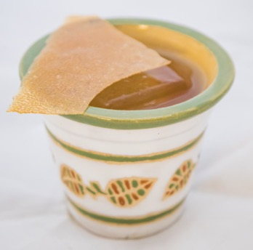
AROUND THE CORNER BY MARCUS FREDRIKSSON

50 ml Amaro Montenegro
30 ml Lactic Acid Fermented Apple Juice
15 ml Walnut Honey
18 ml Seaweed Infused Vermouth
3 drops Saline Solution

Stir ingredients and serve in a watering can and flowerpots
Garnish with dried apple crisps

www.amaromontenegro.com
@amaromontenegro_ww
#TheVeroBartender

- Ends –

For more information and media assets, please contact:
Rosie Sury
Tel: +44 7530 122561
Email: Rosie@shift6pr.global

Notes to Editors:
About Amaro Montenegro
Amaro Montenegro, celebrated as the world’s best liqueur*, was perfected in 1885 and features the essence of 40 botanicals from around the globe, collected during the travels of explorer and herbalist Stanislao Cobianchi. The signature complex taste is characterized by a pleasing blend of sweet and bitter notes. Amaro Montenegro is a favorite of bartender and mixologists for its tremendous versatility in crafting inventive cocktails and adding a flavorful twist to classic drinks. What distinguishes Amaro Montenegro from other herbaceous liqueurs is its balanced bitter-sweet flavor, smooth texture and milder proof – making it the difference in the drink. A product of Bologna Italy, Amaro Montenegro’s secret recipe remains unchanged as does the boiling, maceration and distillation process that was practiced more than 130 years ago.

*Amaro Montenegro was named 2018 Best Liqueur by the 2018 San Francisco World Spirits Competition
Please enjoy Amaro Montenegro responsibly.

