Prestige Red Wine Kit Concentrate from Gert Strand AB of Sweden a Big Hit at Amazon UK

[www.amazon.co.uk](http://www.amazon.co.uk)

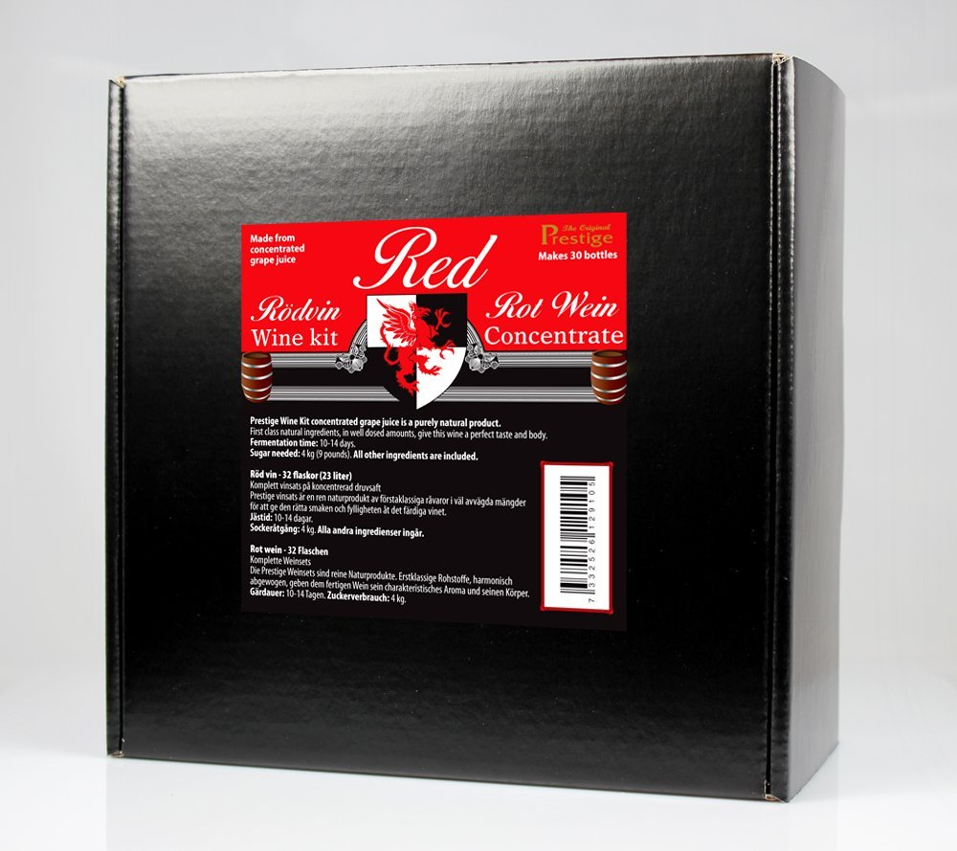

Author - Thomas Strom

Gert Strand AB of Sweden is a recognized brand in the food and beverages industry throughout Europe. The brand offers innovative products that are a cut above the rest with importance given to the health of its buyers. In addition to delicious sugar-free essences, concentrates, and allied products, the company also offers yeasts and kits for the industry and avid home enthusiasts. One such product from their stable is the Prestige Red Wine Kit Concentrate.

Respected Swedish company Gert Strand AB has made it a habit of introducing innovative products into the European market at regular intervals. The brand now offers UK buyers a chance to experience their products by offering them on reliable online shopping website Amazon UK.

One ingenious product from Gert Strand AB of Sweden is the Prestige Red Wine Kit Concentrate. Each kit can make 30 bottles of 750 ml each of delicious red wine within a matter of days. The kit is packed attractively, which in turn also makes for a great gift for people within the UK.

Buyers can get rewarded with 30 bottles of 750 ml each once they ferment the chosen mixture with the items provided in this kit. Fermentation time required is between 10 to 14 days in order to bring out the best wine flavor. The final wine will possess an alcoholic strength of around 11.5 percent.

Buyers will merely require basic home-brewing equipment along with 4 kg or 8.8 UK pounds of sugar to create delicious wine. All other ingredients are present in the kit which weighs around 1.9 kgs when shipped by Amazon UK.

The Prestige Red Wine Kit Concentrate offered by Gert Strand AB is a totally natural product. The company has more than 35 years of experience in the wine industry and this product is an example of their experience as well as expertise. This product will produce red table wine with a light and fruity flavor upon complete fermentation.

Gert Strand AB states that this kit has exactly the same ingredients as the ones which the company supplies to commercial distilleries. The kit contains the General Bayanus Wine Yeast which a special yeast best suited to deliver all types of wine. The product also utilizes an unpasteurized filling process so as to preserve the quality of the ingredients in the kit.

Buyers buying the Prestige Red Wine Kit Concentrate offered by Gert Strand AB from Amazon UK can enjoy completely free shipping across the UK.

Interested buyers can visit the following link at Amazon.co.uk to view all details of this product and buy online…

<http://www.amazon.co.uk/Prestige-Wine-Concentrate-Makes-Bottles/dp/B008FYYBYY/ref=sr_1_11?ie=UTF8&qid=1383569343&sr=8-11&keywords=gert+strand+ab>

Category

Grocery

Company Name

Gert Strand AB

Thomas Strom

Gert Strand AB

Box 50221

212 12 Malmo

Sweden

Fax +46 40 183025

thomas (-at-) gertstrand.se

ABOUT

Gert Strand AB of Sweden was established in 1974 and is a dynamic company with a wide range of innovative products that are supplied to the beverage industry as well as to retail clients. Among their range of unique products are Turbo Yeast, Alco Base Turbo yeast, high alcohol fermentation technology with micro nutrients, and flavors for carbonated water for both consumers and the beverage industry. (The beverage industry website of Gert Strand AB is [www.distillery-yeast.com](http://www.distillery-yeast.com)).

Keywords

Wine making kit, prestige red wine kit concentrate, red wine making kit concentrate, red wine kit