Choosing a Cloud Computing Company

You will be aware of the current levels of hyperbole surrounding and may even be aware of some of the claims being made; moving into the world of cloud computing is a major decision and you must take adequate steps to ensure it is the right place for your business and its IT.
Cloud computing is conceptually appealing to a broad range of businesses especially start-ups and SMEs where managing networks and computers is a major distraction from running more the business. Software upgrades, computer crashes, security countermeasures etc. quickly build into a full time job and so outsourcing quickly starts to make sense as a means of accessing services without a dedicated member of staff. Cloud computing appeals as a means of accessing a number of more sophisticated applications and services at a relatively low cost; these savings are realised through multi-tenant access allowing many customers access to the same software and servers simultaneously. These multi-tenant arrangements deliver a both elasticity of use (whereby the user can increase or decrease usage as required) and pay-as-you-use model.

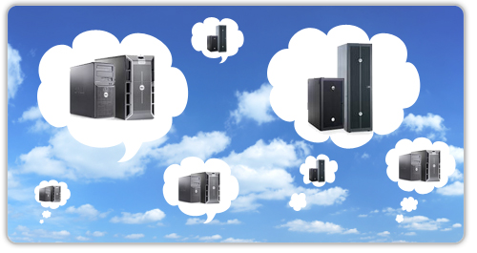

Part of the cloud adoption process is to question the investment you have made in the existing infrastructure with regards to hardware and software licences, projected life of servers etc. and/or whether any of that might be recouped when you move into the cloud.
Moves into the cloud are typically justified on financial grounds but you must take a holistic approach to the business question of cloud adoption and you may be able to make a case on operational and/or productivity grounds too. You will need the whole picture about the planned move; what will migration cost and how will we benefit.
Once you have a clear view of the complete business case, you can then begin to understand the technical options open to you and from that begin to understand the choice of vendor.
Part of the process that you must consider is that regardless of the size of your organisation, certain applications are mission critical and not all cloud providers are created equal; essentially, the choice made here is vital to the future of the business.
Cloud based services – what you will be buying - fit into the following 3 categories:
- Infrastructure-as-a-service: Vendor delivers network and servers for use by your business paying for capacity and storage used.
- Platform-as-a-service: Vendor delivers and manages operating system and database plus all else required to run certain platforms.
- Software-as-a-service: Vendor runs the software application for you on pay-for-use basis. Your business does not require either software licences or supporting infrastructure and this is a typical means of delivering applications such as CRM, hosted email etc.
Once you understand where your requirement fits you then must address the following questions:
- The product:
  - Does it meet the business needs?
  - Easy to use?
  - Improve on the existing tools?
- How does it meet compliance with the legal framework of my industry?
- The provider:
  - A stable business with many customers?
  - How happy are those customers?
  - Well-funded and/or a possible acquisition target?
- The migration: you must anticipate the potential for the transition process to the chosen service/provider will be problematic.
  - What are you plans to deal with interruptions during the transition?
  - What is the timetable for the transition?
  - Can this be accomplished?
  - Do you fully understand that process?

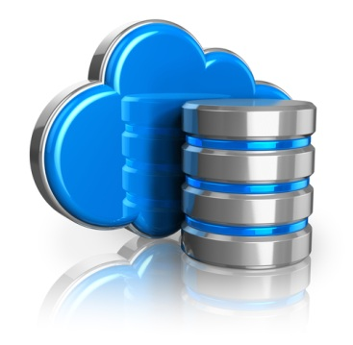
Then we can draw assess vendors against these criteria:
- Security
Fundamentally the biggest change here is one of mindset; you are moving your data beyond the immediate bounds of your own business, and so must ensure your existing security arrangements are adequate and will meet the demands of the outsourcing arrangement. You must also consider the security of your own data connections, how they impinge on your business and what you may need to do in case they were compromised.
  - Physical security of the data center
  - The provider’s DR plans.
  - Does the provider meet the requirements imposed by legal framework of your own industry?
- Performance
Key questions for the vendor:
- How is performance defined?
- What metrics are used?
- How does that definition of performance relate to customer satisfaction?
- What metrics can you share with me?
- How much of the network and system do you own?
- You need to see the data center and the system running.
- Who is support delivered?
- How are support staff qualified?
- Meet support staff!
Part of the assessment of performance needs to include addressing the following areas:
  - Availability
How critical is the service is to the business; regardless of the answer, it must be at least as good as the existing service set up. Typically financial, CRM, and business intelligence systems must be highly available which should be reflected in the SLA which in turn must provide penalties in the event of system outages.
  - Cloud Technical Interface
A major cloud computing benefit is that it is self-provisioning nature allowing the client to add and subtract users, change user access settings etc. so part of the process of assessing the product and the provider is ease of use.
  - APIs and Data Transformations
It may suit your needs to host your company’s infrastructure or applications in to the cloud rather than take an of the shelf product. Your provider will supply Application Programming Interface (API) which is the software interface allowing your infrastructure or applications to plug in to their cloud. These are seen as an important place for standardization and to enable you to build connections between its applications, internal data center and the cloud, standardized APIs are a must.
  - Data and Application Architecture
Your business’s demands will evolve requiring that internally developed services operate in the cloud. Consequently the provider must provide a system with sufficiently modular architecture to allow these services to migrate to and from the cloud.
- Capability and Cost of Changing Provider.
This choice of cloud provider is by necessity a long term relationship meaning you must be satisfied the provider deliver as your needs change as you adapt to your changing business environment. You must also take account of unforeseeable circumstances; which may sound like an oxymoron but what if the provider goes out of business, are acquired, changes in personnel etc? Your plan and the SLA must ensure you are not locked into them and can move your data and/or your applications to another provider should that prove necessary. Thus, part of your supplier/product assessment needs to include the question; what is the cost to the business if needed, to take your data elsewhere at some point in the future? What product or service alternatives are available? What barriers are there to doing so?
In short, the choice of cloud partner is vital to your business but must guarantee that this co-dependence does not threaten your company’s existence at any point.
- Customer Service
Right or wrong, personal choice comes into every business decision so you must be happy with the people you are dealing with. So, you must see their staff to understand their competence to support both you and their other clients; without whom they will cease to exist.
- Deliverables?
Vendor selection includes clarification of exactly what the support the vendor will deliver and will include numbers of engineers on hand, how they are qualified plus what they will and will not do on your behalf, response times etc.
- Billing and Accounting
Billing and account management are by definition automated in a cloud service enabling you to monitor what you are using and attendant costs.
- Costs and Pricing
Pricing structures are complex as they are based on a variety of cost factors, storage space required, clock cycles used, monthly traffic allotments, etc. A cynic might suggest that cloud providers were deliberately opaque about their pricing and make like for like comparisons problematic and to make matters worse, some service providers build in additional charges that are hidden deep in their service-level agreements (SLAs). We cannot look at this in too much depth but your assessment must arrive at a means of comparing one provider with another and more importantly arriving at the actual day to day costs of the service. An easier way to review pricing is to focus on the primary services offered and most providers divide services into three areas: servers in the cloud (real and virtual), cloud storage, sites and applications in the cloud, each with its own pricing formula.
- Service Level Agreement
Again we cannot look at this in too much depth but part of your product and vendor assessment will need to be a detailed review of the Service Level Agreement (SLA) on offer by each vendor. With most off the shelf service products, the vendor usually has a “boiler plate” document forming part of the sales process which is what you must assess. Otherwise the formulation of an appropriate SLA with the vendor will form part if the final negotiation; in addition to the obvious usual terms of payment details, the SLA will need to include the following:
- Security including penalties where the vendor is at fault.
- Availability including penalties for outages.
- Severance terms.
- Pricing structure specifically what you are paying for and when it is billable,
- Details of the support structure and where appropriate schedule the vendor will provide.

