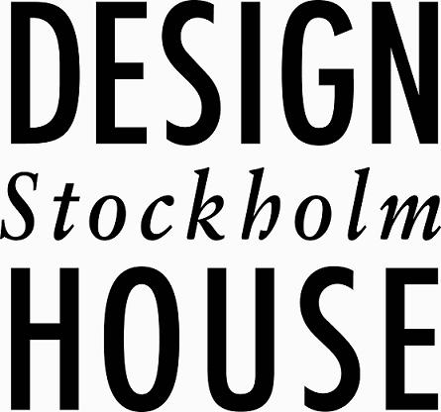

Stockholm den 4 december 2009

Pressrelease

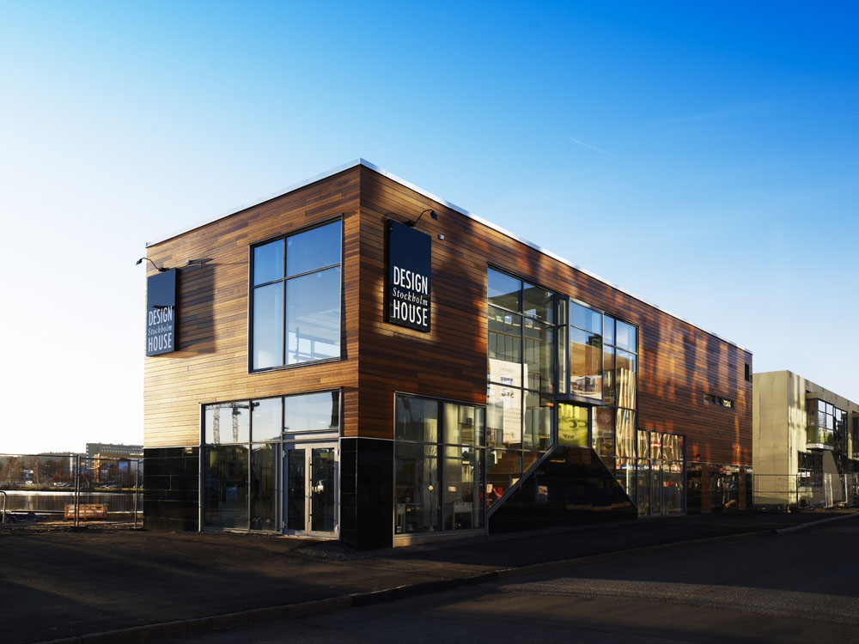 Design House Stockholms franchise butik i Jönköping.
Skandinaviskt Designtempel i Jönköping
Två entreprenörer, Åsa Fritz och Lena Damberg har slagit sig samman och öppnat Design House Stockholm franchise shop alldeles intill vattnet i centrala Jönköping. Över 60 formgivare samsas om 180 kvadratmeter säljyta för att visa något av det bästa vi har inom skandinavisk design.

För information var snäll och kontakta Stina Annerfelt på Design House Stockholms huvudkontor i Stockholm vx. 08-50908100, hk@designhousestockholm.com

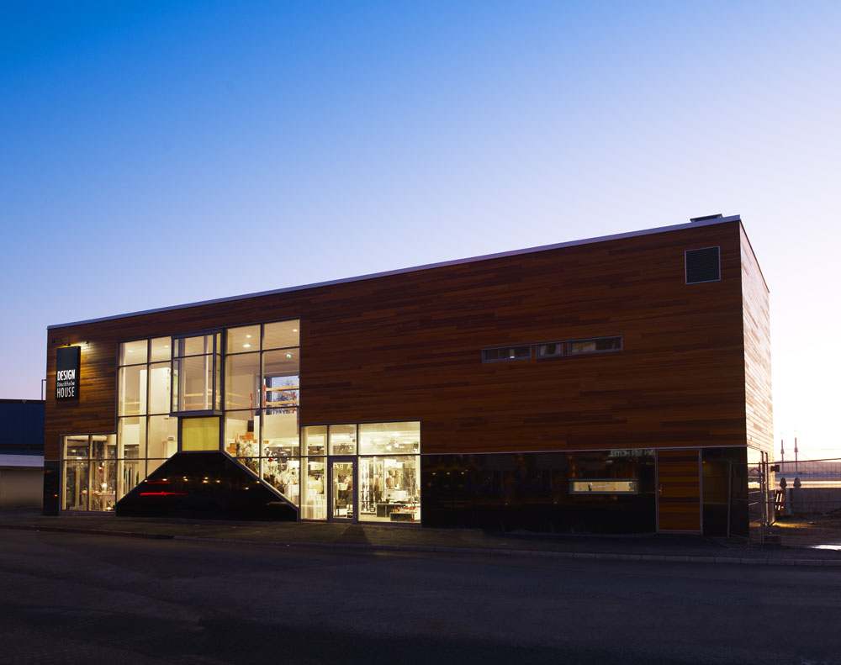

Design House Stockholm – Facts & Figures

Company founded 1992 by Anders Färdig
Owner Anders Färdig 69%, Gunnar Dahl 30%, Anders Nyrén 1%
CEO Anders Färdig
Board of directors Börje Fors (Chairman of the board), Anders Färdig,
Gunnar Dahl, Margareta van den Bosch & Curt Stiernlöf
Headquarters Stockholm
Employees Appr. 60 employees
Markets Europe, Asia, USA, Canada, Australia and New Zealand
Turn over 100 MSEK (retail value 220MSEK)

Design House Stockholm is one of the world-wide leading companies for Scandinavian Design. Design House Stockholm is acting as a publishing house for designers.
Collaborations with an extensive network of more than 60 designers

Brand philosophy “Don’t make something unless it is both necessary and useful; but if it is both necessary and useful, don’t hesitate to make it beautiful.”

Target group Open minded people with a mental age between 25 and 45 years and with a high interest in functional and beautiful design objects with a special Scandinavian touch.

Kind of products Living accessories, furniture, lighting and fashion

Price range High quality products at affordable prices

International fairs
Ambiente, Frankfurt & Maison et Objet, Paris & Accent on Design, New York

Retail Global distribution network consisting of 7 wholly owned Design House Stockholm stores, several shop-in-shop solutions and partner boutiques. 500 retail partners in Europe, 200 in USA and 100 in Asia.

Sales at prestigious stores
e.g. MoMA stores in New York, SF MoMA in San Francisco, Conran Shop in London, Colette in Paris, La Rinascente in Milan, Spazio Sette in Rome, Vinçon and Pilma in Barcelona and Madrid, R.G.Madden in Melbourne and Sydney, Louisiana Museum of Modern Art in Denmark, Actus and Isetan in Tokyo

Design awards
Several products have been given Excellent Swedish Design, Red Dot Award Germany, Accent on Design Award USA, Design Plus in Germany etc.

