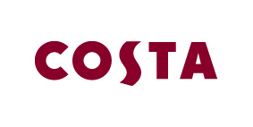
Monday 1st June 2015

Costa shakes up the nation’s streets with lenticulars

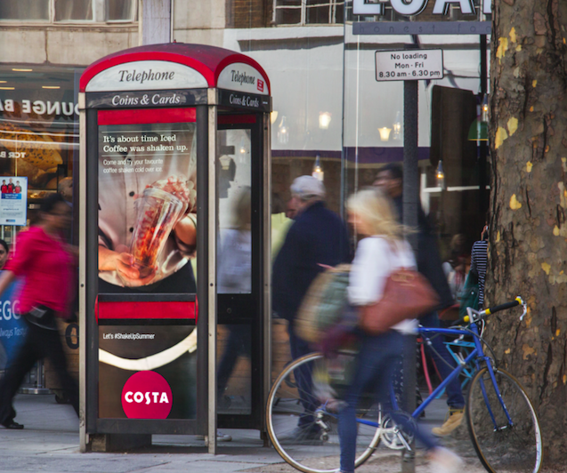

Costa, the nation's favourite coffee shop has launched a unique, tactical outdoor advertising campaign today with lenticular technology - a printing technique which creates the illusion of movement.

The technology, which will feature for the first time across StreetTalk sites, will encourage consumers to try their favourite coffee shaken over ice.

As the public walk past the new creative they will see a cup of refreshing, ice-cold coffee being shaken, tempting them to #ShakeUpSummer with Costa’s new over ice offering.

In partnership with JCDecaux, Costa is the first to integrate the technology into 500 StreetTalk sites which will appear in close proximity to Costa stores.

Kirstey Elston, Head of Marketing at Costa said, “We chose lenticular technology as it uniquely brings to life our shaken over ice product innovation to customers. We hope the distinct, moving creative really does turns heads in the lead up to Summer.”

Steven Dennison, Head of Creative Solutions at JCDecaux, said: “We are delighted to launch the first-ever lenticular StreetTalk campaign with Costa. By injecting a unique idea into this strategic campaign, Costa is reaching targeted audiences tactically, in a visually engaging way.”

StreetTalk, which features on phone boxes at key leisure and retail locations across the UK, targets a young urban audience whilst they are in a relaxed, positive and social mindset.

The campaign has been planned and booked with JCDecaux by ZenithOptimedia and Meridian Outdoor, it will run for two weeks from 1st June.

This unique formats part of Costa’s wider integrated Summer campaign which includes print, in-store, digital and PR.

-Ends-

For further information please contact the Costa Press Office at Costateam@onegreenbean.com or call 0207 017 1014

About Costa
Costa is the UK’s favourite coffee shop, having been awarded “Best Branded Coffee Shop Chain in the UK and Ireland" by Allegra Strategies for five years running (2010, 2011, 2012, 2013 & November 2014).

Winner of “Best Branded Coffee Chain in Europe” Allegra Strategies 2010, 2011, 2012, 2013 and 2014.

With over 1,800 coffee shops in the UK and more than 1,100 overseas, Costa is the fastest growing coffee shop business in the UK and the second largest coffee shop operator in the world. Founded in London by Italian brothers Sergio and Bruno Costa in 1971, Costa has become the UK’s favourite coffee shop chain and diversified into both the at-home and gourmet self-serve markets.

Costa employs over 12,000 people and is creating around 1,500 jobs this year and over 4,500 jobs in the next three years in the UK. We continue to be part of the Sunday Times Best Companies To Work For list.

Costa is committed to looking after coffee-growers. That's why we've established The Costa Foundation, a registered charity. The Costa Foundation's aims are to relieve poverty, advance education and the health and environment of coffee-growing communities around the world. So far, The Costa Foundation has funded the building of 42 schools and improved the social and economic welfare of coffee-growing communities.

