What is Cloud Computing; how does Cloud Computing Work?



Cloud computing is loose term encompassing a number of technologies all of which result in the delivery of computing as a service rather than a product. So, shared resources, software, and information are delivered to computers and other devices (such as smartphones, terminals etc.) as a utility, analogous to the electricity grid over a network, usually the Internet.

If you have used a Web-based e-mail service such as Hotmail, Yahoo! Mail or Gmail, then you have had some experience with cloud computing. Such systems work by the user logging into a Web e-mail account remotely instead of running an e-mail program on your computer. The software and storage for your mail do not exist on your computer, instead they reside on the service provider’s computer cloud.

Users access cloud based applications through a web browser or lightweight desktop/mobile app while their data and business software are held on servers at a remote location, typically a data centre. It is the goal of cloud application providers give the same or better service and performance versus software programs installed locally on end-user computers.

The term "cloud" is a metaphor for the Internet, dating back to the cloud depiction historically used to represent the telephone network, and more recently to represent the Internet in computer network diagrams.

Widespread adoption has been founded upon widespread availability of high bandwidth capacity networks, low cost computers and storage plus widespread adoption of virtualisation and service-oriented architecture.

Two terms are required to understand how “the cloud” continues its rapid adoption, firstly autonomic computing is where systems are self-managing. Secondly, utility computing, where computing resources, typically computation and storage are packaged as a metered service again analogous to traditional public utilities, such as electricity.

Cloud computing providers use three basic models: Infrastructure as a service (IaaS), platform as a service (PaaS), and software as a service (SaaS). IaaS is simplest and each higher model builds on features of the lower models.

# Provider Models.

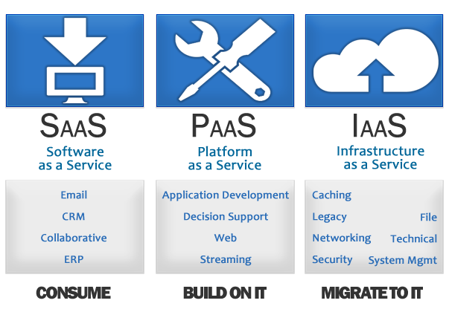

## Infrastructure as a Service (IaaS)

This is the most basic cloud service model where cloud providers offer computers physical or virtual machines, storage, firewalls, load balancers, and networks. Under IaaS these resources are delivered on demand from large pools installed in data centers. Local area networks plus IP addresses are part of the offer. For the wide area connectivity, the Internet can be used or dedicated virtual private networks can be configured.

To deploy applications, cloud users install operating system images on the machines plus their application software. Under this model, the cloud user is responsible for patching and maintaining the OS and application software. IaaS services are typically billed on a utility computing basis, so cost reflects the resources allocated and consumed.

## Platform as a Service (PaaS)

Under the PaaS model, cloud providers deliver a computing platform typically including OS, database, and web server. This allows application developers to run their software solutions on a cloud platform without the cost and complexity of buying and managing the underlying hardware and software. In some PaaS offerings, the available computing and storage resources scale automatically to match application demand meaning the cloud user does not have to allocate resources manually.

## Software as a Service (SaaS)

Here cloud providers install and operate application software in the cloud with cloud users accessing the software from cloud clients. A significant benefit is that users do not manage the cloud infrastructure or the platform running the application thus eliminating the need to install and run the application their own computers so simplifying maintenance and support. What differentiates a cloud application from other types of applications is its elasticity which is achieved by cloning tasks on to multiple virtual machines as demand requires it. Load balancers distribute the work over these virtual machines with this process being transparent to the user who sees simply a single access point. This leads to another characteristic of cloud computing which is that in order to accommodate large numbers of users, cloud applications can be multitenant, meaning any machine serves more than one cloud user organization. Commonly these types of cloud based application software are referred to generically as desktop as a service, business process as a service, Test Environment as a Service or communication as a service.

Typically the pricing model for SaaS applications is monthly or yearly flat fee per user.

# Deployment models

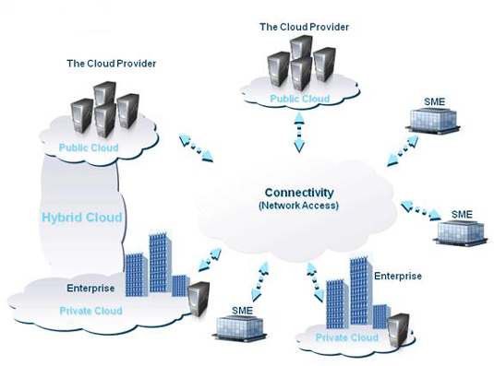

## Public cloud

In public cloud applications, storage and other resources are deployed to world at large by a service provider. Such services are free or pay-per-use. Generally, public cloud service providers like Microsoft and Google own and operate the infrastructure and offer access only via Internet and direct connectivity is not offered.

## Community cloud

Community cloud shares infrastructure between several organizations from a specific community with common concerns (security, compliance, jurisdiction, etc.), whether managed internally or by a third-party and hosted internally or externally. The costs are spread over fewer users than a public cloud (but more than a private cloud), so only some of the cost savings potential of cloud computing are realized

## Hybrid cloud

Hybrid cloud consists of two or more clouds (private, community or public) that each endure as separate entities but are bound together delivering the benefits of multiple deployment models. Utilizing "hybrid cloud" architecture delivers fault tolerance with locally instantaneous usability without being dependent on internet connectivity. Hybrid Cloud architecture requires both on-premise resource plus off-site (remote) server based cloud infrastructure.

Hybrid clouds lack the flexibility, security and certainty of in-house applications, but can deliver the flexibility of in house applications with the fault tolerance and scalability of cloud based services.

## Private cloud

Private cloud whether managed internally or by a third-party and hosted internally or externally is cloud infrastructure operated exclusively for a single organization. They are potentially open to criticism as users still need to buy, build, and manage them and thus do not benefit from less hands-on management essentially lacking the economic justification made for cloud computing as a rule.

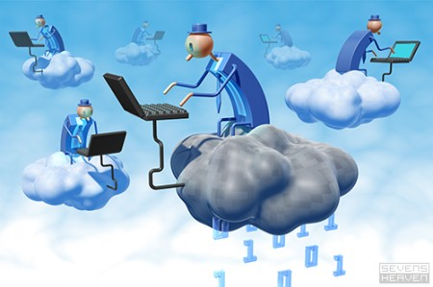

# Benefits of Cloud Computing

* Reduction in requirement for onsite IT. Outsourcing in this way means a lower skill set is required onsite as there much less internal infrastructure required.
* Reduction in hardware costs as little or no requirement for onsite servers for application deployment.
* Increase in organisational agility by increase in speed of adoption of new software and applications.
* Reduction in headcount by elimination or redeployment of IT staff to more productive work. A further benefit of outsourcing.
* Elimination of software licences and associated costs and limitations. Outsourcing applications means no need for the organisation to own software licences.
* Move of IT from high investment and capital expenditure cost, to a pay-as-you-go model. Deploying cloud computing means software and applications plus associated billing are turned on and off as required.
* BYOD (Bring Your Own Device) leads to elimination of hardware costs. Traditionally, organisations have sourced one machine per user plus per user software licences. These are replaced by an allowance paid to employees for them to purchase the device of their choice – typically a mobile (laptop/tablet).
* “Green computing” cloud computing users do not need the most powerful machines as they need to be able to browse the internet. Siting servers in data centres rather than onsite may also have environmental benefits but this is open to debate.
* Adopting cloud computing means end-users have no need for expertise in, nor control over the technology infrastructure "in the cloud" that supports them.

# Disadvantages of Cloud Computing

* Connectivity. Cloud computing requires access to the internet to function. Given that most organisations are now completely reliant on email, electronic order processing and potentially VoIP to run their business all of which need continuous access to the web this is less of a consideration.
* Security. Perceived security of cloud computing services is contentious and may be delaying its adoption. It is argued that physical control of the Private Cloud equipment is more secure than accessing equipment off site under someone else’s control. This physical control plus the ability to visually inspect data links etc. is required to ensure data links are not compromised and some parts of the private and public sectors unease lies in external management of security-based services. To balance this, cloud computing service providers prioritize building and maintaining strong management of secure services with their reputations and client base contingent on these practices.
* Physical location of the data. Certain vertical markets legal, insurance, banking etc. are heavily regulated with stringent regulations surrounding the location of their own and their clients’ data. This is dealt with by choice of provider and publication of the location of their data centres.
* Privacy. Cloud computing allows a client to log in from any location to access data and applications, so it seems possible the privacy could be compromised. Cloud computing companies protect client privacy using authentication techniques with user names and passwords and authorization format so each user can access only data and applications relevant to their job. Also cloud computing providers are completely reliant on their reputations for protecting client data; consequently they are focussed on the most advanced techniques available.
* Legal/philosophical issues. These relate to concerns over who actually owns the data; is it the property of the user or the cloud computing service provider? And is it possible for a cloud computing service provider to deny a client access to said data? These are the subject of debate in academic and legal circles relating to cloud computing.