Andreas Bäckman will represent Sweden in FIA Motorsport Games 2022
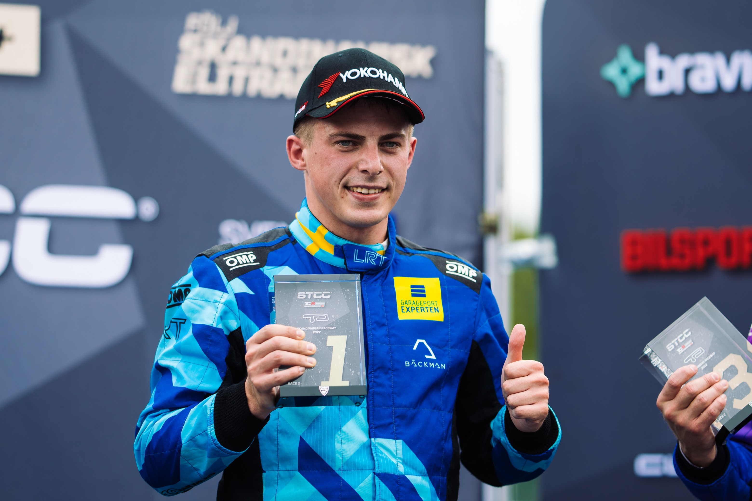
Andreas Bäckman is looking forward to competing in the FIA Motorsport Games and representing Sweden in the Touring Car category at the end of October at Circuit Paul Ricard in France.
Photo: Martin Öberg (Free rights to use the image)
Andreas Bäckman was today confirmed as one of the drivers in Team Sweden in the FIA Motorsport Games at the end of October in France. Bäckman will compete in the Touring Car category for Comtoyou Racing in an Audi RS 3 LMS TCR.
– Very happy and proud that I get the opportunity to represent Sweden in a large and prestigious competition such as the FIA Motorsport Games, Andreas Bäckman says.
The well-known Circuit Paul Ricard track, located near Marseille in France, will host the FIA Motorsport Games on October 26th-30th, which will be run for the second time since the first race was held at the Vallelunga circuit near Rome in Italy in 2019. A total of 17 different motorsport disciplines are run during these five days, with each country appointing a driver for each discipline and competing for their country and competing for gold, silver, and bronze medals. The competition is also usually called the "Olympics of motorsports" and, like the Olympic Games, it is also has opening and closing ceremonies. The opening ceremony takes place in the city of Marseille, where every country participates.
Today it was announced that the Sweden National Team driver Andreas Bäckman has been appointed by the Swedish Automobile Sports Federation to represent Sweden in the Touring Car category and will be part of Team Sweden's eight drivers. He will compete in an Audi RS 3 LMS TCR-car for the Belgian team Comtoyou Racing, and is looking forward to driving with the Swedish colours in the prestigious competition:

- It is a great honor to have the opportunity to represent Sweden in one of the world's biggest motorsport competitions in the "Olympics of motorsport" FIA Motorsport Games. After a season where I made a comeback in the STCC in Sweden after three years competing internationally on European and World level for TCR cars, it will be fun to come back and compete at an international level again, Andreas Bäckman says.
Andreas has spent the majority of his motorsport career competing internationally and is looking forward to returning to Circuit Paul Ricard, where he last raced in 2020 in the TCR Europe Championship.
- Circuit Paul Ricard is a track that I like a lot and have raced at before. It will be a new team for me, Comtoyou Racing, but it is the same type of car that I have raced with in this year's STCC season, so the adjustment will not be huge, although of course it will be important to get to know a new team and how they are working. The goal together with the team is to win and to take home the gold medal for Team Sweden, Andreas Bäckman says.
- We are really happy to represent Team Sweden in the FIA Motorsport Games and especially with Andreas who knows the Audi RS 3 LMS TCR really well by his experience from competing in STCC this year, Francois Verbist, Team Manager of Comtoyou Racing, says.
Andreas Bäckman made his competition debut in go-karting in 2006 as a 10-year-old and has since competed around the world with many national and international successes in go-karting. In 2018, Andreas made his debut in car racing after many years in go-karting and one year in rallycross.
Since his debut in car racing in 2018, he has over the years taken wins, pole positions and podiums in several TCR championships. In 2018, he got a win, a pole position, and several podium places towards a 3rd place overall in the TCR UK Championship, which is the British counterpart of STCC.
In 2019, he took the step up to the European Series TCR Europe for Target Competition in a Hyundai i30 N TCR car and finished in 4th place overall with one victory, two pole positions and two podium places during the season. In 2020, he also competed in TCR Europe and took home a win in Barcelona.
In 2021, Andreas competed in the World Cup series WTCR - FIA World Touring Car Cup, and in 2022 he made a comeback after three years of international racing to STCC together with Lestrup Racing Team in an Audi RS 3 LMS TCR car. During 2022 he claimed multiple wins, pole-positions, podiums and fastest laps and finished 3rd in the championship at the season finale last weekend at Mantorp Park in Sweden.

The competition structure of FIA Motorsport Games
The city of Marseille will host the Opening Ceremony on Wednesday, October 26th, and a spectacular display of every country and its team of drivers parading under their country’s flag near Vieux-Port at the Mucem in Marseille.
Then, over the next four days, the FIA Motorsport Games races are run, with the different classes' arenas spread out depending on the format of the race. The Touring Car category is contested at Circuit Paul Ricard, which is located in Le Castellet, Var, France near Marseille.
Since opening in 1970, the track has hosted the French Formula One Grand Prix 17 times, and the track has also hosted many other national and international racing series. The track is 5.842 km long with 15 corners and the track offers a total of 167 different possible track layouts.
For the Touring Car category, the competition starts with practice on Friday October 28th and Saturday October 29th. On Sunday October 30th there is a timed Qualifying, which determines the starting position for the Qualifying Race which is 25 minutes + 1 lap, and which in turn determines the starting position for the Main Race. The Main Race is 30 minutes + 1 lap and the first three drivers across the finish line win the gold, silver and bronze medals.

Wednesday October 26th:
- Opening Ceremonies in Marseille, France
Friday October 28th:
- Free Practice 1
Saturday October 29th:
- Free Practice 2
Sunday October 30th:
- Qualifying
- Qualifying Race (25 min + 1 lap)
- Main Race (30 min + 1 lap)
- Closing Ceremonies and Prize Giving at Circuit Paul Ricard

Information about the event:
fiamotorsportgames.com/
The event is broadcasted LIVE at TCR TV
The Touring Car category at the FIA Motorsport Games at Circuit Paul Ricard on October 26th-30th are broadcasted LIVE at: tcr-series.tv
Free rights to use the images.

Download press-photos here:
http://bit.ly/jabaeckman-photos
https://www.mynewsdesk.com/se/ja-backman/images

