**PRESS RELEASE 14 February 2018**

|  |  |  |
| --- | --- | --- |
| |  | | --- | | **CHARTCO WINS SMART4SEA E-NAVIGATION AWARD**  ChartCo, the leading global supplier of maritime digital data and compliance services, has been awarded the SMART4SEA E-Navigation Award during a prestigious ceremony at the Yacht Club of Greece in Athens.  Organised by SAFETY4SEA to coincide with their annual conference programme, the SMART4SEA awards spotlights initiatives and individuals that demonstrate outstanding performance within the scope of fostering smart excellence and sustainable shipping.  The recipient of the E-Navigation Award is recognised as providing a significant achievement, breakthrough or contribution in any aspect of e-navigation in shipping. ChartCo was awarded this year’s accolade in recognition of its accomplishments in facilitating the transition to digital navigation in commercial shipping by providing a range of software solutions for vessels and shore side operators.  Collecting the award, ChartCo’s Chief Commercial Officer, Howard Stevens said, “Receiving this prestigious award is humbling and we thank SAFETY4SEA for making it possible. Digital navigation is at the core of the ChartCo business, but we are also now looking at a much wider compliance perspective. Navigation, safety management, the ‘rightly’ increasing need to be environmentally aware and the need to make integrated decision grade information available to mariners - both on the vessel and shore side - in as simple and efficient a manner as possible, is driving our future.  We are dedicated to assisting the industry in making the transition towards an ever more complex digital navigation and compliance driven future a successful one, and our ability to make this a reality is in no small part down to the thought-provoking and hard-working team we have in the ChartCo business.  We like to imagine the possibilities of what we can accomplish together when we open our minds, broaden our perspective and think differently in an increasingly software-driven world. That is the effort and progress we are so proud to celebrate.”  Speaking on behalf of the award category sponsor, Palau International Ship Registry, Chief Executive Office, Panos Kirnidis, said, “The maritime industry knows that smart ships and smart technology is the way forward and yet there seems to be reluctance on the part of some owners to fully embrace the technology. ChartCo has been serving the shipping industry for many years and has played a key role in many of the innovations that have assisted ships’ captains to navigate safely. “ | | -Ends- | |

**ABOUT CHARTCO**

ChartCo is a global leader in digital navigation services and voyage compliance. We provide market-leading products and services that reduce the cost of ship operations, improve situational awareness to owners and crew and assist with the ever-increasing levels of regulatory compliance. Today we have more than 13,500 vessels purchasing our products and services each year. For more information visit [chartco.com](http://www.chartco.com)

**For press enquiries please contact:**

Mima Bridgman

Head of Marketing

+44 (0)1992 805478

[mima.bridgman@chartco.com](mailto:mima.bridgman@chartco.com?subject=ChartCo%20acquires%20Marine%20Press)

Images available for this press release:

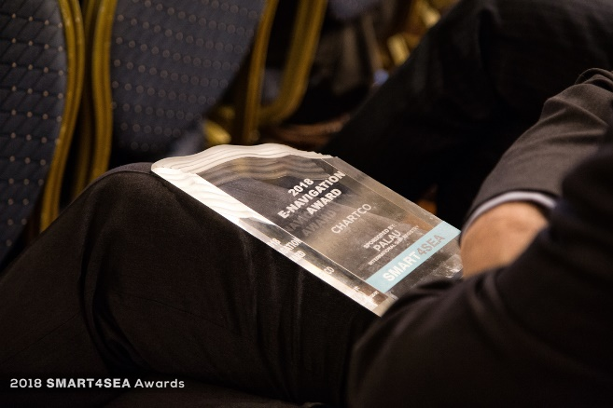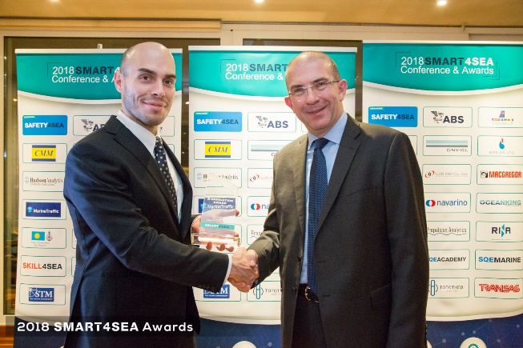

*Photo Caption: From left: Antonis Souras, Ship Registrar at Photo Caption: The 2018 SMART4SEA E-Navigation*

*Palau International Ship Registry presenting ChartCo’s CCO, Award presented to ChartCo*

*Howard Stevens with the 2018 SMART4SEA E-Navigation Award*

*ChartCo logo also supplied*