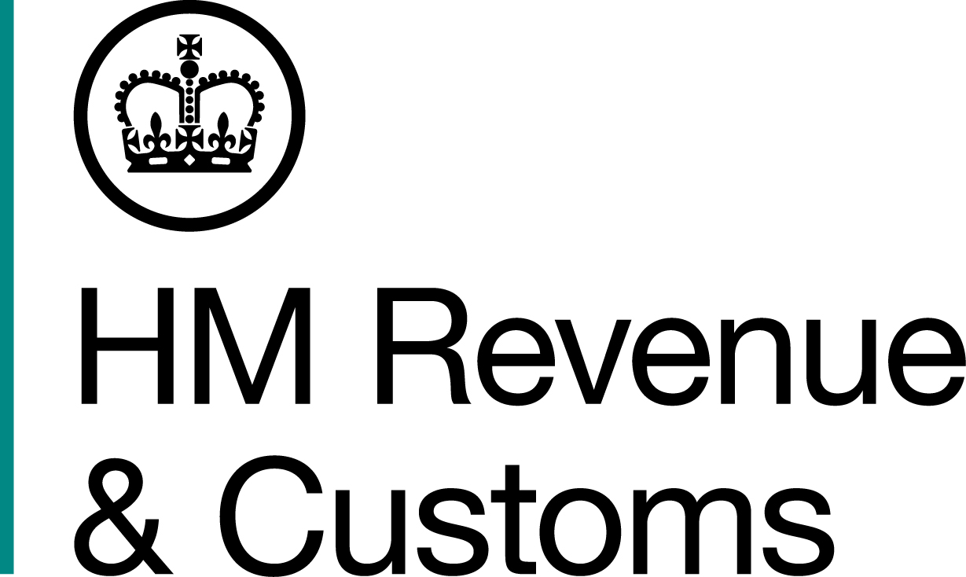
News Release

 | For the attention of News Desks |  | No. of pages: 4
 | Date: | 15/06/2018 | Ref: | NW 06/18

Fridge gang sent to the cooler for £12 million tobacco smuggling fraud

A gang who smuggled illegal tobacco hidden inside fridges, microwaves and vacuum cleaners to evade £12 million in tax, have been jailed for a total of 21 years and five months.

David Hilton, 49, of Bolton, was the last member of the 11-strong gang to be sentenced at Manchester Crown Court yesterday, with a three-year jail term.

It follows the sentencing of ringleader, Timothy Newman, 51, from Luxembourg, who was jailed for four years at Manchester Crown Court on 24 May 2018.

HM Revenue and Customs’ (HMRC) surveillance revealed the huge fraud was organised from Newman’s tobacco outlet in Marmer, Luxembourg. Investigators observed the smuggling ring at work in a large warehouse where hollow white goods, with no working parts, were being used to smuggle tobacco into the UK. After being emptied in the UK, the carcases were returned to the warehouse in Luxembourg to be re-filled with more illicit tobacco destined for the UK.

As well as Hilton and Newman, were nine accomplices from across the North West and Devon who co-ordinated the distribution, packaging and sales operation for the tonnes of tobacco being smuggled into the UK.

Tony Capon, Assistant Director, Fraud Investigation Service, HMRC, said:

“This was a sophisticated criminal network set up to smuggle, transport, store and sell illegal tobacco on a massive scale, purely to evade tax and line their own pockets. This gang took smuggling and tax evasion to the limits and made a serious assault on the UK public purse, stealing millions of pounds from the taxpayer, robbing public services of vital funding and undermining legitimate, local businesses.

“We want to create a level playing field for businesses and to protect the taxpayer. To help us do this I urge anyone with information about the trade in smuggled or counterfeit tobacco to contact us online or call our Fraud Hotline on 0800 788 887. If you’re ever offered cheap or dodgy-looking cigarettes or tobacco, contact us – don’t let the crooks get away with this type of fraud.”

HMRC, working with Border Force and international agencies, investigated the gang, tracking their illegal activities, the freight consignments, suspicious travel abroad and recorded their meetings in hotels and restaurants.

The other gang members were:

- Andrew Saxon, 38, of Bolton, was jailed for 18 months on 24 May 2018.

- Daryl Stringer, 50, of Bury, was jailed for nine months on 24 May 2018.

- Timothy Gibbs-Stringer, 55, of Wigan, was jailed for 26 months to run concurrently with another sentence on 13 October 2017.

- Kyle Langdon, 31, of Ivybridge, Devon, was jailed for two years on 21 March 2018.

- Isaac Duxbury, 30, of Bolton, was jailed for 12 months on 21 January 2017.

- Robbie Dunn, 23, of Wigan, was sentenced to 12 months in jail, suspended for 12 months, on 13 October 2017. He was also told to carry out 100 hours unpaid work.

- Richard Birtwistle, 56, of Wigan, was sentenced to eight months in jail, suspended for 12 months, on 13 October 2017. He was also told to carry out 100 hours of unpaid work.

- Raymond Hughes, 58, of Aughton, one of the key figures on the English side of the channel was previously jailed for six years on 9 December 2016 for his part in this £12 million tobacco smuggling scam and a further six years for a second £10 million cigarette smuggling fraud involving another criminal ring. For details see http://www.mynewsdesk.com/uk/hm-revenue-customs-hmrc/pressreleases/free-wi-fi-gang-sentenced-for-ps10m-smuggling-tax-fraud-1693900

- Andrew Carver-Trotter, 35, of Devon, was sentenced to one year in jail on 22 March 2018.

The amount of tax evaded in this case is estimated at £12,038,264. HMRC has started confiscation proceedings to recover the stolen tax from the gang members under Proceeds of Crime legislation.

Notes for Editors

- The men were convicted of Conspiracy to Cheat the Public Revenue (Common Law), contrary to s.1 (1) of the Criminal Law Act 1977.
- Timothy Newman, DOB 11/11/1966, of Marmer, Luxembourg, pleaded guilty to Conspiracy to Cheat the Public Revenue on 15 May 2017. He was jailed for four years on 24 May 2018.

- Raymond Hughes, DOB 24/07/1959, of Elmsfield Park, Aughton, Lancashire, pleaded guilty to Conspiracy to Cheat the Public Revenue on 17 October 2016. He was jailed for six years on 9 December 2016 for his involvement in this tobacco smuggling ring and six years for his role in a second cigarette smuggling gang. Both sentences are to run concurrently. For details see http://www.mynewsdesk.com/uk/hm-revenue-customs-hmrc/pressreleases/free-wi-fi-gang-sentenced-for-ps10m-smuggling-tax-fraud-1693900

- Daryl Stringer, DOB 17/06/1967, of Palace Street, Bury, was found guilty after trial to Conspiracy to Cheat the Public Revenue on 11 December 2017. He was jailed for nine months on 24 May 2018.

- Timothy Gibbs-Stringer, DOB 17/05/1963, of St Malo Road, Wigan, pleaded guilty to Conspiracy to Cheat the Public Revenue on 13 October 2017. He was jailed for 26 months to run concurrently with another sentence on the same day.

- Kyle Langdon, DOB 01/11/1986, of Torre Close, Ivybridge, Devon, pleaded guilty to Conspiracy to Cheat the Public Revenue on 10 November 2016. He was jailed for two years on 21 March 2018.

- Isaac Duxbury, DOB 28/05/1988, of Aldercroft Lane, Bolton, pleaded guilty to Conspiracy to Cheat the Public Revenue on 21 January 2017. He was jailed for 12 months on the same day.

- Robbie Dunn, DOB 05/06/1995, of Northcroft, Wigan, pleaded guilty to Conspiracy to Cheat the Public Revenue on 13 October 2017. He was sentenced to 12 months in jail, suspended for 12 months, on the same day. He was also told to carry out 100 hours unpaid work.

- Richard Birtwistle, DOB 21/06/1961, of Bold Street, Wigan, pleaded guilty to Conspiracy to Cheat the Public Revenue on 13 October 2017. He was sentenced to eight months in jail, suspended for 12 months, on the same day. He was also told to carry out 100 hours of unpaid work.

- David Hilton, DOB 30/06/1968, of Coal Pit Lane, Bolton, was found guilty after trial to Conspiracy to Cheat the Public Revenue on 11 December 2017. He was jailed for three years yesterday, 14 June 2018.

- Andrew Saxon, DOB 21/05/1980, of Belmont Road, Bolton, was found guilty after trial to pleaded guilty to Conspiracy to Cheat the Public Revenue on 11 December 2017. He was jailed for 18 months on 24 May 2018.

- Andrew Carver-Trotter, DOB 25/06/1982, of Tavistock Drive, Devon, pleaded guilty to Conspiracy to Cheat the Public Revenue on 17 October 2017. He was jailed for one year on 22 March 2018.

- Anyone with information about people involved in tobacco fraud can contact our HMRC helpline on 0800 788 887 or https://www.gov.uk/report-an-unregistered-trader-or-business
- Follow HMRC Press Office on Twitter @HMRCpressoffice
- Pictures are available on HMRC's Flickr channel: www.flickr.com/hmrcgovuk

Issued by HM Revenue and Customs Press Office
Press enquiries only please contact:

Will Lyon
07469 023 331
william.lyon@hmrc.gsi.gov.uk

Out of hours
Tel: 07860 359544

Website: www.gov.uk/hmrc

