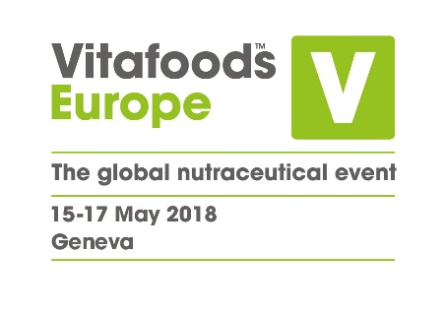

8th May 2018

**PRESS RELEASE**

**From Essential Oils to Ashwagandha:**

**Vitafoods Europe to highlight up-and-coming ingredients**

Emerging ingredients for health and nutrition will be a key focus at the 2018 edition of Vitafoods Europe which takes place in Palexpo, Geneva next week.

“Up and Coming?” is a new dedicated stream of R&D Forums in the event’s Education Programme. Among other emerging ingredients, it will examine the current science around Essential Oils, as well as their benefits and potential to meet industry trends.

The keynote speaker will be Dr Astrid Stuckelberger, lecturer at the University of Geneva and author of new e-book “The Science of Smell”. “There are many reasons to see essential oils as the new hip ingredient,” she said. “Growing urbanisation means consumers are looking for scents that have disappeared from their environment while ‘perfuming’ their lives with healing feel-good ambience. And with increasing distrust in pharmaceuticals, they want natural, pure products that appeal to the senses and are effective. From scent to oral or topical applications, essential oils offer numerous preventive health benefits and can be therapeutic on many levels – physical, mental and emotional. With the current boom in the global wellness industry, in particular spas and massage, demand is only going to rise.”

Industrial hemp and the potential of kombucha are also among the topics being explored in the “Up and Coming?” forums. Professor Rimantas Venskutonis of the Kaunas University of Technology will share studies about industrial hemp, described as an “old-new” source of functional ingredients, while Professor Miomir Niksic of the University of Belgrade will offer insights into the potential of kombucha and other ingredients from fungi.

On the main show floor there will be hundreds more opportunities to discover emerging new ingredients. One example is ashwagandha, an Ayurvedic herb which has been used for centuries but is now seeing worldwide growth thanks to a growing body of clinical evidence.

“Ashwagandha has an impressively wide range of health benefits,” said Karikeya Baldwa, Director of Ixoreal, which will be showcasing its KSM-66 ashwagandha. “It is one of the few herbs with significant effects on both psychological and physiological function. It has been shown to help decrease stress and anxiety, to improve cognitive ability, and to increase endurance, strength and muscle recovery rate. Ashwagandha meets a number of consumer trends, including the move away from the synthetic to the natural. Perhaps its greatest strength is that it combines solid scientific evidence with a long history going back thousands of years, both of which instil confidence and allow marketers to tell interesting stories.”

Ixoreal is working with American author and explorer Chris Kilham, also known as Medicine Hunter.  He will be at the company’s booth to educate people about the clinically proven benefits of KSM-66 ashwagandha.

Vitafoods Europe takes place between the 15th and 17th of May in Palexpo, Geneva. For more information visit: <https://www.vitafoods.eu.com/en/welcome.html>

**About Vitafoods Europe**

Vitafoods Europe is the global nutraceutical event, featuring exhibitors from all over the world in four key market areas: ingredients & raw materials; branded finished products; contract manufacturing & private label; and services & equipment. The event offers a range of visitor attractions, including an industry-leading Education Programme.

Vitafoods Europe is part of Informa Exhibitions’ Global Health & Nutrition Network (GHNN), which brings together a portfolio of events, digital media and publishing for marketers, manufacturers and formulators of nutrition and dietary supplements, healthy foods/beverages and personal care products. GHNN’s events include Vitafoods Europe, Vitafoods Asia, SupplySide West, SupplySide East and SupplySide China.

Natural Products INSIDER is the global media brand covering healthy ingredients and finished applications. Vitafoods Insights offers expert online content and a series of topic-specific digital magazines that bring highlights of the Vitafoods events to a global audience. [SupplySide](http://storefronts.supplysideshow.com/) Connect is the always-on directory of ingredients, products and services that provides in-depth information about the companies that supply to the market. For more information, visit [www.informaglobalhealth.com](http://www.informaglobalhealth.com/).

Informa’s Global Exhibitions Division organises transaction-oriented exhibitions and trade shows, which provide buyers and sellers across different industries and communities with a powerful platform to meet face-to-face, build relationships and conduct business. Informa has a portfolio of more than 150 exhibitions, serving a number of core verticals, including Health & Nutrition, Beauty, Property & Construction and Pop Culture.