**TENACIOUS D**

**In**

***Post-Apocalypto***

**Six-Part Animated Series Begins on YouTube on**

**September 28, 2018**

***New Album Out November 2, 2018 On Columbia Records***

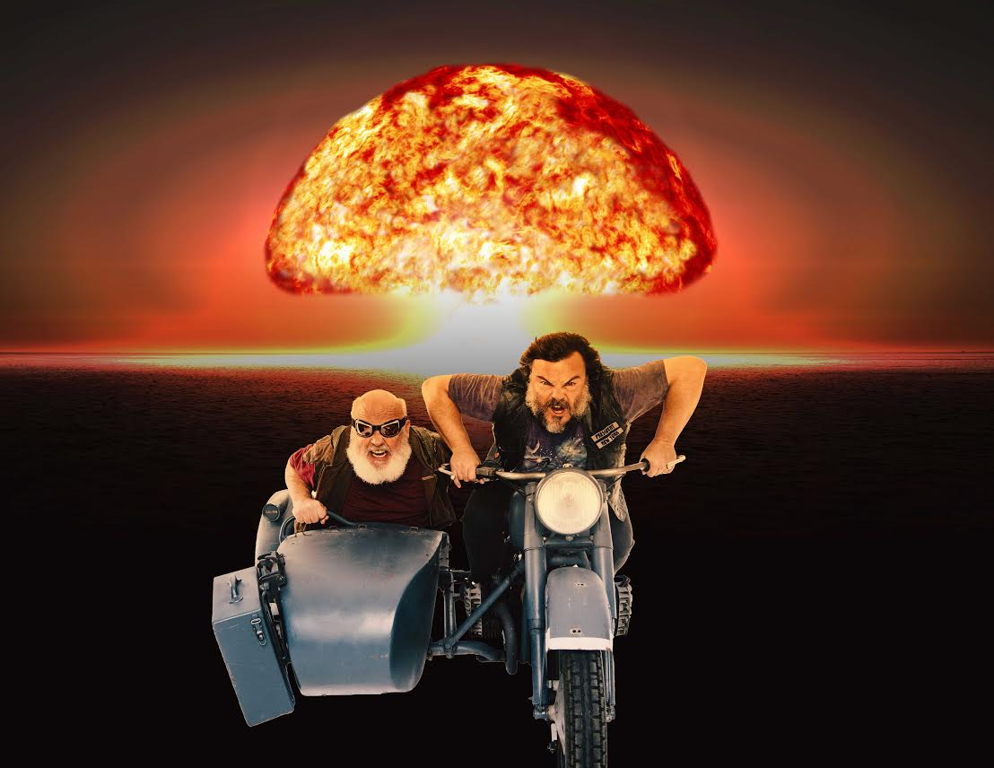

(Photo credit: Shane McCaughley)

Acclaimed rock duo and basically everyone’s favorite band ever **Tenacious D** -- comprised of **Jack Black** and **Kyle Gass** -- will release not one but TWO incredible works this fall. Both are called ***Post-Apocalypto***. Both are amazing. Here’s what you need to know:

*Post-Apocalypto* - THE SERIES - is an original, six-part animated video series from the minds of Tenacious D. Each frame of every episode was hand-drawn by Jack himself, with every character voiced by Black and Gass. The series begins rolling out on **September 28th, 2018**, via [Tenacious D’s YouTube page](https://www.youtube.com/tenaciousd), with a new episode every Friday after that.

[WATCH A PREVIEW OF *POST-APOCALYPTO* HERE](https://www.youtube.com/watch?v=jVUfKyGsG3k&feature=youtu.be)

All six episodes feature new Tenacious D songs, culminating in a new Tenacious D album -- also called *Post-Apocalypto* -- released on **November 2, 2018**. As each episode goes up, a song from that episode can also be heard via all DSP’s. Produced by John Spiker, and featuring long-time collaborator **Dave Grohl** on drums, *Post-Apocalypto* - THE ALBUM - is a genius addition to The D’s already scintillating catalogue of rock greatness.

True to the title, *Post-Apocalypto* finds Tenacious D thrust into a world of complete and utter destruction following the drop of an atomic bomb. Surviving the attack in classic cinematic fashion (a good old imperishable 1950’s refrigerator), the duo quickly learns that new forms of evil have spawned from the blast. One thing becomes apparent -- for humanity to prevail, Tenacious D must save the world.

With unimaginable twists and turns, an insane visit to the White House, a time machine, a space adventure, and the help of some tried and true daddy issues, *Post-Apocalypto* is as hilarious as it is political, and as brilliant and multi-faceted as its incredible creators. The songs are damn good, too.

**Some special insight to the series can be seen via the band’s newly-launched Instagram account - click** [**HERE**](http://www.instagram.com/tenaciousd) **to learn more.**

*Post-Apocalypto* (the album) will be available digitally, on CD, and on translucent green vinyl. There is also a limited edition *Post-Apocalypto* vinyl picture disc that will only be available on the band’s online store; click [HERE](http://www.postapocalypto.shop) to learn more.

[**PRE-ORDER POST-APOCALYPTO NOW.**](http://smarturl.it/postapocalypto)

*Post-Apocalypto* cover art:

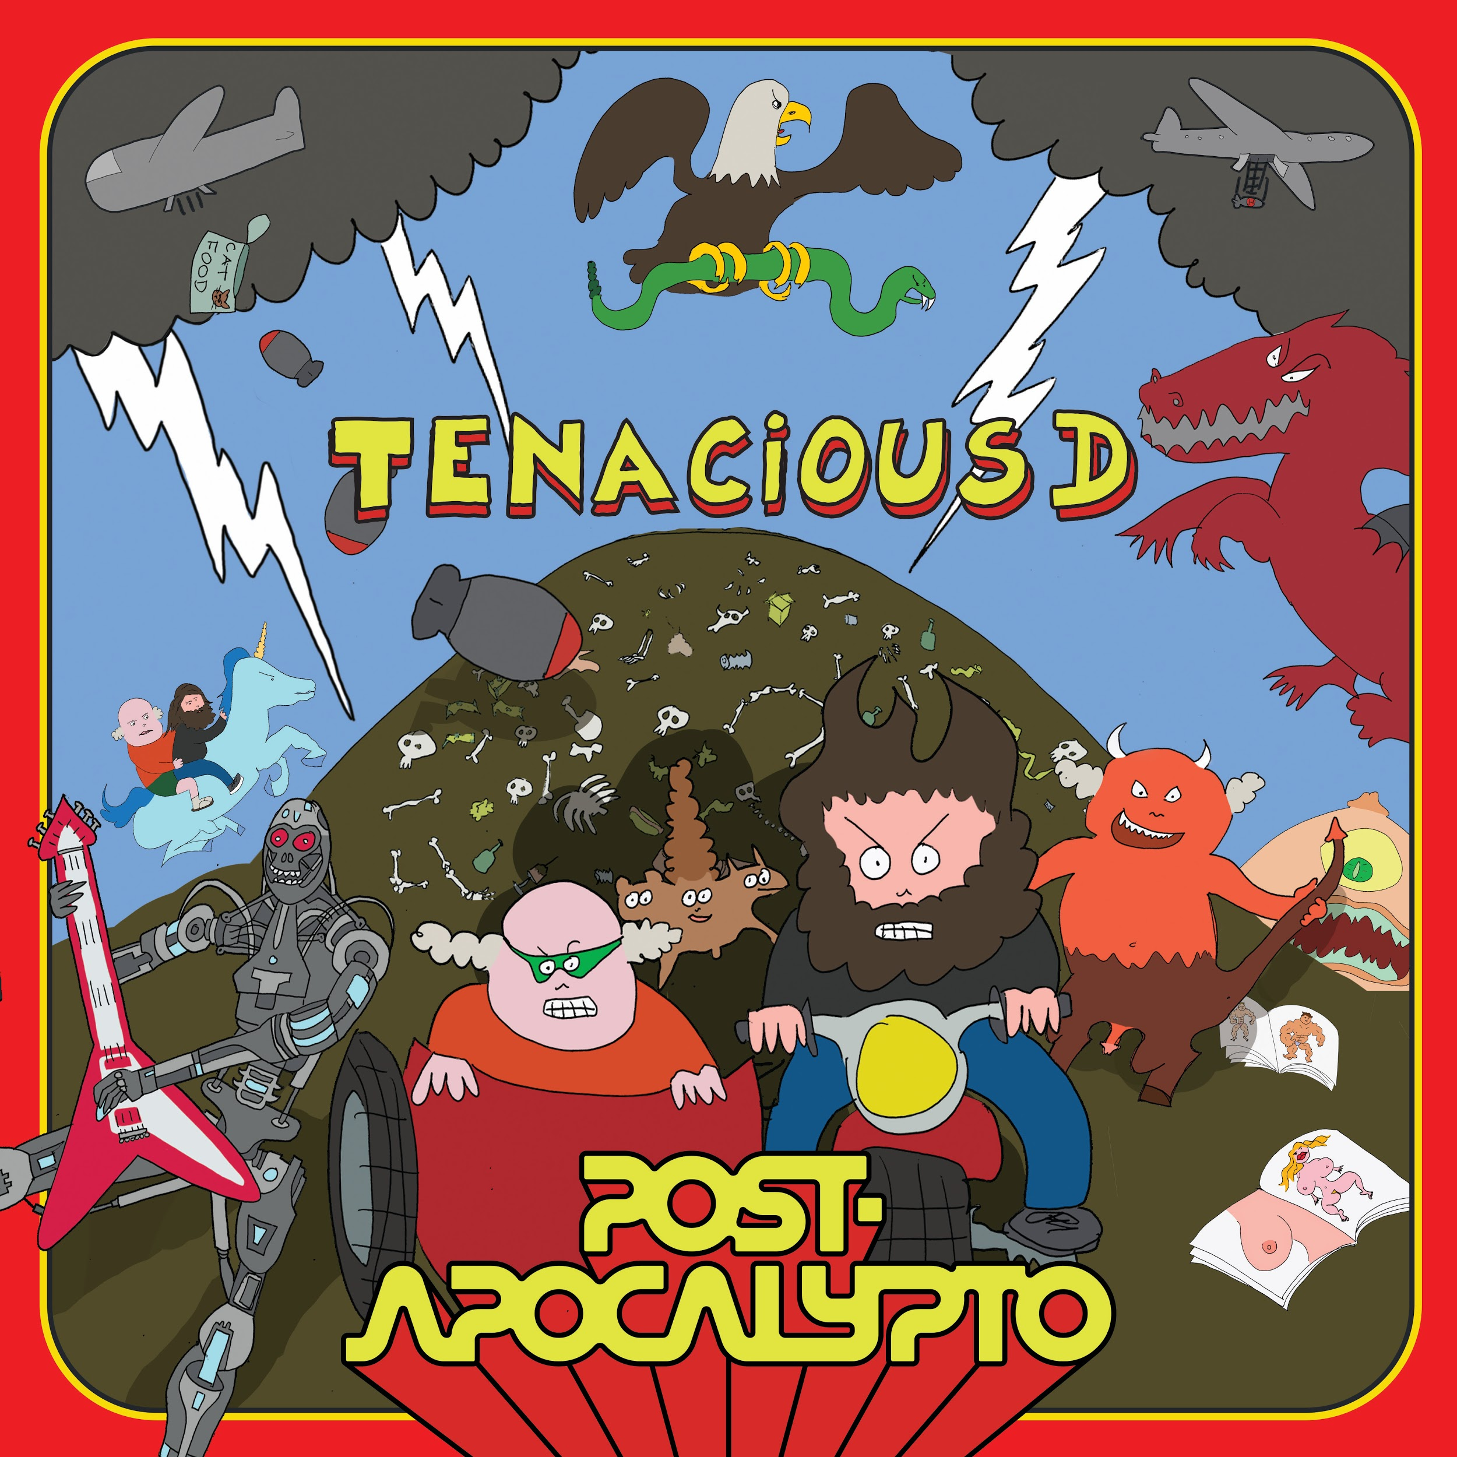

Tenacious D will be playing sold out shows across the country this fall. Tour dates are below.

The dates are:

10/6/18 San Bernardino, CA @ Cal Jam 18

11/3/18 Brooklyn, NY @ Kings Theatre

11/4/18 Brooklyn, NY @ Kings Theatre

11/5/18 Boston, MA @ House of Blues

11/7/18 Washington, DC @ The Anthem

11/8/18 Philadelphia, PA @ The Fillmore

11/9/18 Pittsburgh, PA @ Stage AE

11/10/18 Columbus, OH @ Express Live! Indoor Pavilion

11/12/18 Detroit, MI @ The Fillmore

11/13/18 Chicago, IL @ Riviera Theatre

11/14/18 Chicago, IL @ Riviera Theatre

12/10/18 Calgary, Canada @ Grey Eagle Resort and Casino

12/11/18 Edmonton, Canada @ Show Conference Centre

12/13/18 Vancouver, Canada @ Queen Elizabeth Theatre

12/14/18 Seattle, WA @ Moore Theatre

12/15/18 Portland, OR @ McMenamins Crystal Ballroom

12/17/18 Oakland, CA @ Fox Theater

12/31/18 Las Vegas, NV @ The Joint

**Tenacious D:**

[Website](http://www.tenaciousd.com/) * [Facebook](https://www.facebook.com/tenacious/) * [Twitter](https://twitter.com/realtenaciousd?lang=en)