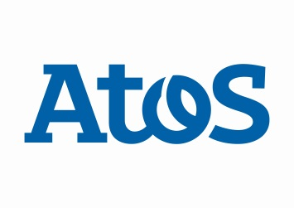
FOR IMMEDIATE RELEASE

Atos Appoints New Leadership for Australia and New Zealand

Australia, 2 December 2015. Peter Robertson joins Atos as Managing Director for the Australia and New Zealand locally incorporated practices.
Prior to joining Atos, Peter spent the last 27 years in global roles based out of Hong Kong and Singapore with Standard Chartered Bank (SCB) covering a combination of Information Technology and Chief Operating Officer (COO) roles. Peter’s IT career has included senior global roles in Information Systems, IT operations and Vendor Management and procurement.
Peter has an IT degree from Monash University and now lives in Melbourne with his family, where he also enjoys theatre, opera, gardening and many outdoor exercise activities.
About Atos
Atos SE (Societas Europaea) is a digital services leader with 2013 pro forma annual revenue of € 10 billion and 86,000 employees in 66 countries. Serving a global client base, the Group provides Consulting & Systems Integration services, Managed Services & BPO, Cloud operations, Big Data & Cyber-security solutions, as well as transactional services through Worldline, the European leader in the payments and transactional services industry. With its deep technology expertise and industry knowledge, the Group works with clients across different business sectors: Defense, Financial Services, Health, Manufacturing, Media, Utilities, Public sector, Retail, Telecommunications, and Transportation.
Atos is focused on business technology that powers progress and helps organizations to create their firm of the future. The Group is the Worldwide Information Technology Partner for the Olympic & Paralympic Games and is listed on the Euronext Paris market. Atos operates under the brands Atos, Atos Consulting, Atos Worldgrid, Bull, Canopy, and Worldline. For more information visit atos.net

Media Contact:

Rhoda Dinesen, rhoda.dinesen@atos.net

M: +65 91681146

