Jessica Bäckman takes on the legendary Nürburgring track
On August 5-7th, ADAC TCR Germany and its participants take on the legendary Nürburgring track in Germany. Sweden National Team driver Jessica Bäckman is ready for a new race weekend after the 6-weeks long summer break.
- Nürburging is yet another well-known Formula 1 track on the calendar, I would say it is the second nicest track after Red Bull Ring. I'm looking forward to jumping into the car again after the long break, says Jessica Bäckman.

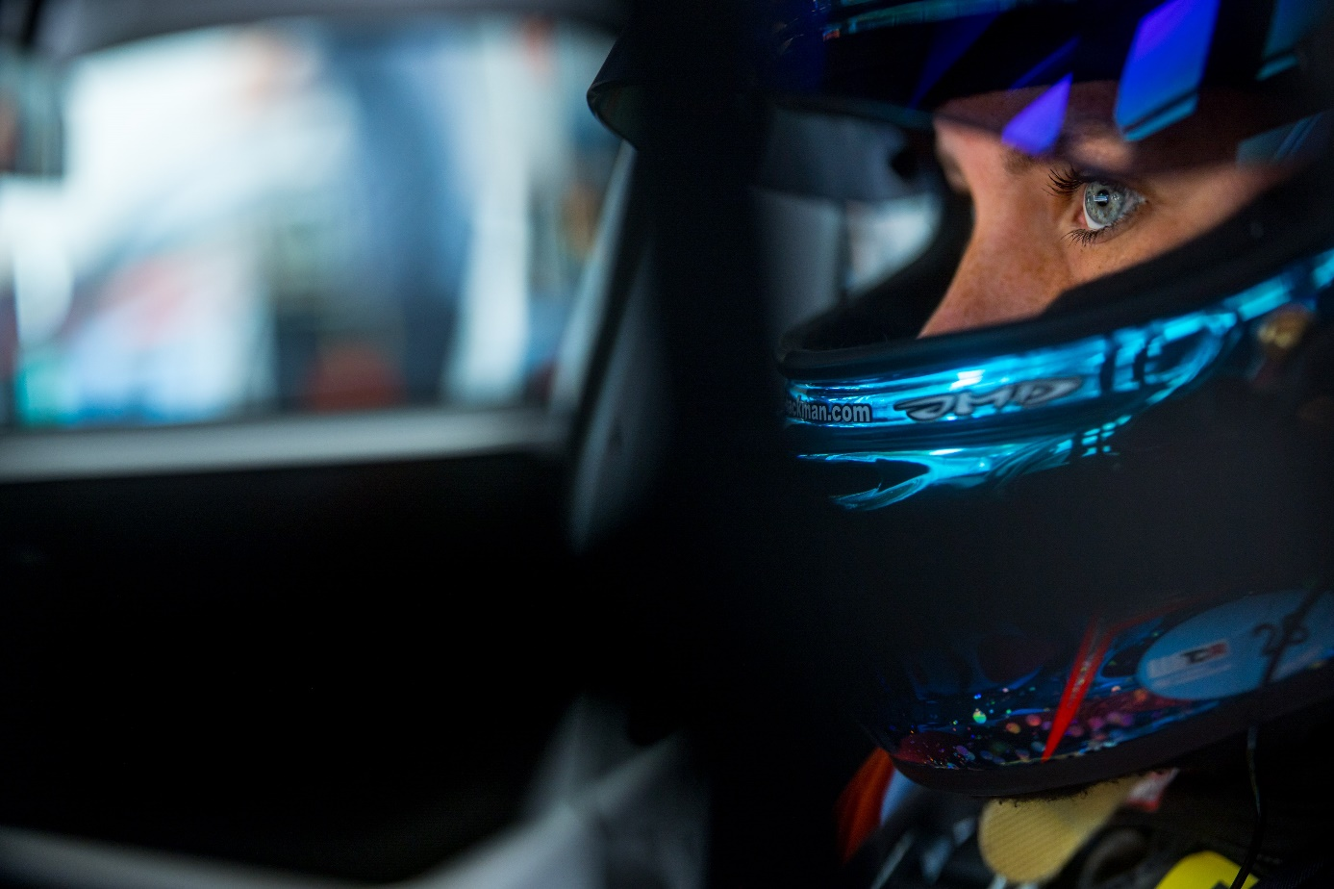
The Nürburgring circuit in Germany has a history and tradition with motorsport itself. The 'Green Hell', as Jackie Stewart described it, has been thrilling and terrifying for drivers in equal measure since 1927 and every event at the Nürburgring remains one of the biggest challenges on the sporting calendar. Although the entire Nürburgring Nordschliefe is only used for selected racing events, notably the annual 24-hour races and the regular 'Langstrecken' races, it remains an iconic venue that attracts enthusiasts from all over the world with the chance to drive the 26km track during "Touristfahrten" sessions.
The modern Grand Prix track is still in full use as an FIA Grade 1 track, with a full slate of events including Formula 1, DTM and ADAC GT Masters. Next weekend it's time for ADAC TCR Germany's fourth round to run. Jessica is looking forward to competing again after the long summerbreak.
- The first half of the season has been beyond expectations, I was aiming for my first win this season, but the fact that I have now already won 4 out of 6 possible races is unreal. Now I hope the trend continues and that I have less technical trouble for the rest of the season, Jessica Bäckman says.
Tough track with both fast and slow parts
Nürburgring is a track with both fast and slow sections, which makes it a tough track for the drivers.
- The Nürburgring circuit offers very tough parts, some parts you must attack hard while others you have to be patient and think one step further, so I think it will be a challenging weekend, Jessica Bäckman says.
Timetable for this weekend:
(all times in CET)
Friday August 5th:
12:05 Free practice 1
16:45 Free practice 2
Saturday August 6th:
10:15 Qualifying 1
16:50 Race 1 TV link for Race 1
Sunday August 7th:
08:05 Qualifying 2
11:35 Race 2 TV link for Race 2
Live-streming:
Both races can be watched at motorsport.tv
Race 1: Click to watch Race 1
Race 2: Click to watch Race 2
Both races can be seen on re-live at www.youtube.com/adacmotorsports and Motorsport.tv
Live-timing
All practice, qualifying and races can be followed through live-timing at https://www.adac-motorsport.de/adac-gt-masters/live-timing
About the track:
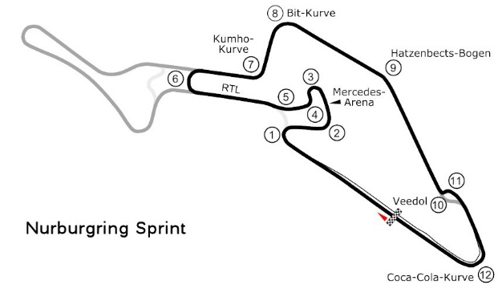
Place: Nürburg, Germany
Length: 3,629 km
Corners: 12
Race length: 30 minutes + 1 lap
ADAC TCR Germany Calendar 2022:
22–24th April - Oschersleben, Germany
20-22nd May - Red Bull Ring, Austria
17-19th June - Salzburgring, Austria
5-7th August - Nürburgring, Germany
19-21st August - Lausitzring, Germany
23-25th September - Sachsenring, Germany
21-23rd October - Hockenheim, Germany

Free rights to use images.

