Press Update
February 2021
February 2021 - Prime Gaming Monthly Update

Welcome to the February Prime Gaming press update! This month’s lineup of games and content includes:
- OVR Player Pick item and Rare Gold Player items for FIFA 21
- Exclusive content for Fall Guys: Ultimate Knockout, UFC 4, and Roblox
- Access to 30+ games this February, including two games to help you brush up on your romancing skills this Valentine's Day: Monster Prom and Table Manners
- Limited ad-free play for some of Voodoo’s most popular titles, including Helix Jump and Hole.io

All of these offers can be claimed by visiting: gaming.amazon.com/ and you can find all of this month’s assets here. Prime Gaming offers are available for a limited time, and some great content from games including Apex Legends, Fall Guys, and Madden NFL 21 will expire soon--so act fast!

You can find information on this month’s lineup on the Prime Gaming blog, which will serve as a one-stop-shop for the latest and greatest Prime Gaming news.

Read on below for a look at all of the great content and games coming in February!

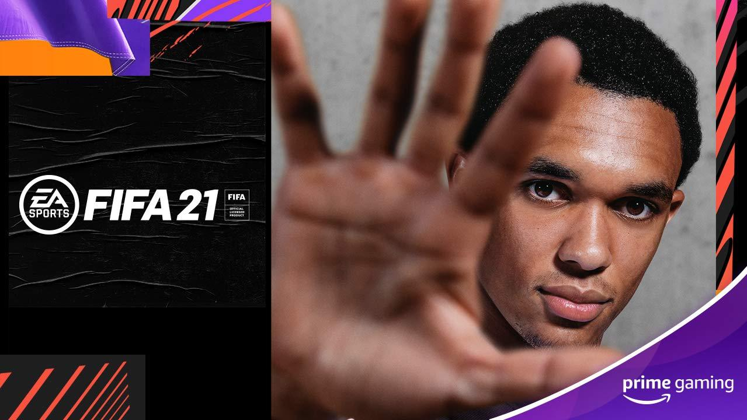
Score New FIFA 21 In-Game Content!
Now Available Help build your dream squad and dominate the pitch in FIFA 21 with unique Ultimate Team reward packs - exclusive for Prime members! Get started with the Prime Gaming Pack #1 with the following items available:
- 1x 81+ OVR Player Pick item
- 4x Rare Gold Player items
Make sure to claim these items before they’re gone on March 3!
Drop 1 of 8
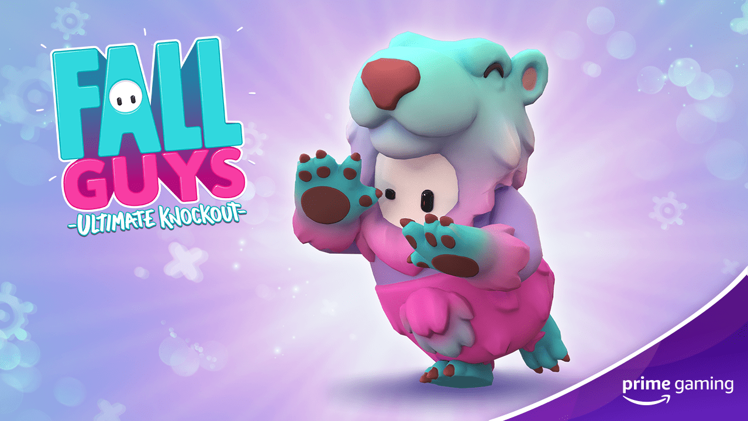
Slip and Slide with the Latest Fall Guys Bundle!
Now Available Deliver a flurry of mayhem with the Prime Gaming exclusive Slushie Bear Bundle for the hit battle royale game Fall Guys: Ultimate Knockout. Appropriately themed for Season 3: Winter Knockout, this new Fall Guys bundle includes:
- An adorably festive Slushie Bear Costume
- 6500 Kudos, to help players fast-track their way to the next in-game goodie.
Be sure to claim this bundle before it's gone on February 15!
Drop 2 of 6
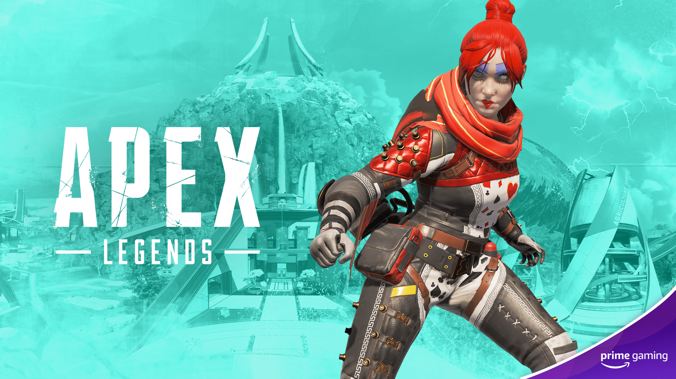
Show ‘em What You’re Made of in Apex Legends!
Now Available Break some hearts this Valentine’s Day with the unique Wraith Queen of Hearts skin for Apex Legends! This stylish new skin is the first in a new series of drops for the game, so be sure to claim it before it's gone on February 17.
Drop 1 of 12
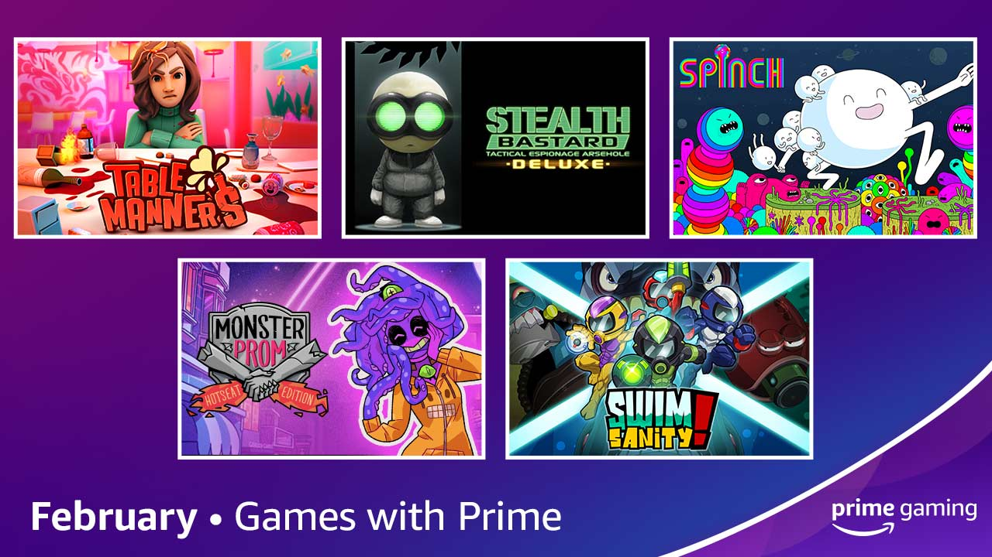
Build Your Game Library with More Games!
Add 30+ games to your library in february, including Swimsanity! and Monster Prom: Hotseat Edition
Available February 1 This February Prime Gaming is adding a new set of FIVE games to our library of 30+ games starting February 1! The lineup includes a variety of beloved indie darlings, ranging from multiplayer underwater shooter Swimsanity! to side-scrolling platformer Spinch. You can also practice your romancing skills just in time for Valentine’s Day with charming dating sims Table Manners and Monster Prom: Hotseat Edition.
Read on below for more details on the new titles coming to Prime Gaming in February
- Table Manners (Simulation) - Swipe right for the brand-new crazy physics-based dating simulator!
- Stealth Bastard Deluxe (Platformer) - Armed with only your wits and a pair of Stealthing Goggles, it’s your job to sneak your way through a deadly facility that’s determined to extinguish your fragile little life.
- Spinch (Platformer) - Transcend the material realm and assume your true form as Spinch in this side-scrolling, psychedelic platformer.
- Monster Prom: Hotseat Edition (Simulation) - You have 3 weeks to get a date for Monster Prom! Go through absurd and funny situations, raise your stats and seduce one of your classmates.
- Swimsanity! (Shooter) - Indulge in a multiplayer underwater shooter with action-packed Co-Op and Versus game modes, all supported by online and local play.
This lineup of games joins the already impressive library of games already available to Prime Gaming members, including 20+ classic arcade SNK titles. We rotate our collection to keep titles fresh, so check back each week to claim new games and grab others before they’re gone. As always, all games are yours to keep forever.
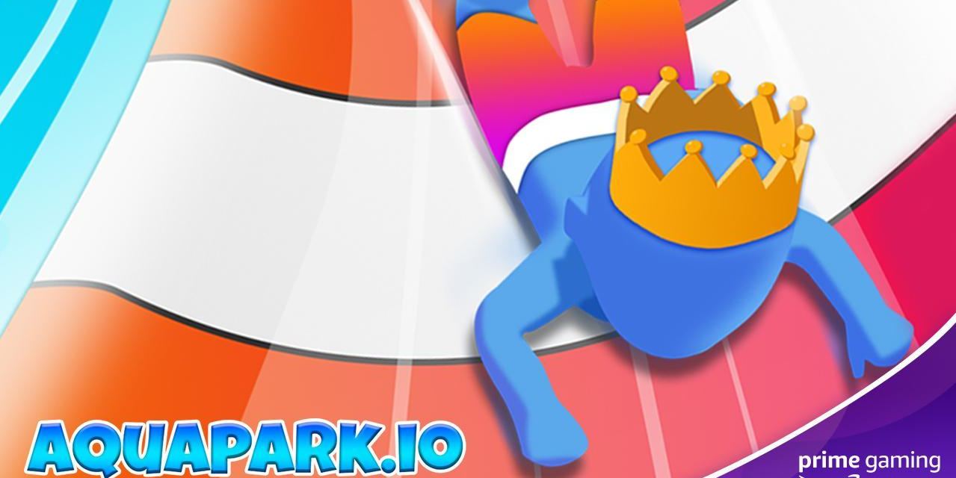
Enjoy Limited Ad-Free Play in Voodoo’s Widely Popular Games!
Enjoy ad-free play for a limited time in some of Voodoo’s wildly popular mobile games, including Aquapark.io, Cube Surfer, Helix Jump and Hole.io.
- Aquapark.io Now Available – Race to reach to the end of the water slide, while bumping other players in this colorful and sunny water slide game. Claim 14 ad-free days now, and come back February 8 for another 7 ad-free days!
- Cube Surfer Now Available – Players are challenged in this 3D arcade game to stack cubes to make a tower run and surf on the road to reach the finish line by making a color line. Claim 14 ad-free days now, and come back February 11 to claim 21 more ad-free days!
- Helix Jump Now Available – Enjoy 7 days of ad-free play in the addicting 3D game where players help a ball fall to the bottom of a spiral maze--and starting February 4, you can claim 21 more ad-free days!
- Hole.io Available February 4 – Players will have 14 days of ad-free play in Hole.io, where they’ll be tasked with absorbing everyone and anything into your black hole.
 | 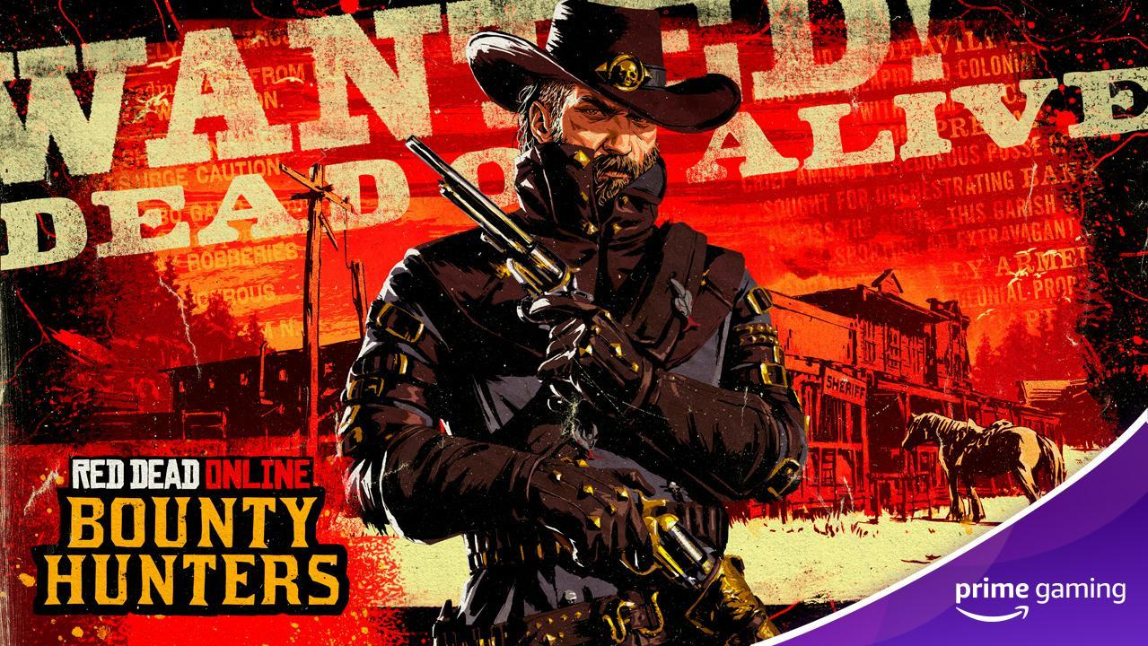 | 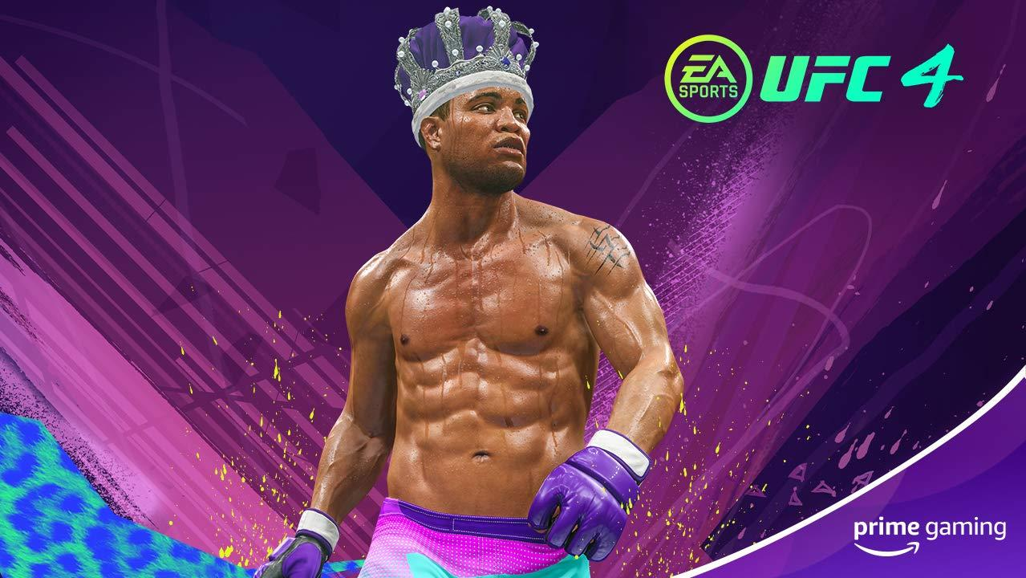
Grand Theft Auto Online  Available Now  Let’s ride! Grab the Kosatka Submarine Sonar Station and GTA$1,000, 000 for the wildly popular GTA Online. | Red Dead Online  Available Now  This month claim the following items:  - RDO $1,000 one-time sign-up bonus,  - Bounty Hunter License,  - Purple Bounty Wagon Tilt (Requires 3 Role tokens and Rank 25+ Bounty Hunter),  - 50% off a Poncho of your choice  - Off-Hand Holster  - 100 x High Velocity Revolver Cartridges  - 100 x Explosive Revolver Cartridges | UFC 4  Now Available  Upgrade your UFC 4 fighter this month with an exclusive Purple Crown, along with a new Player Card picture and background.  Drop 1 of 6
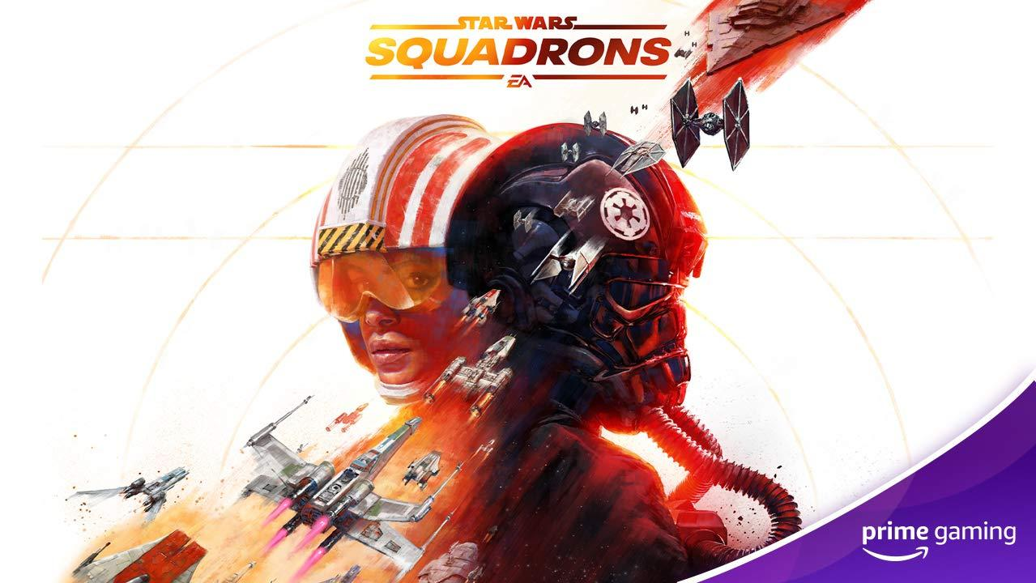 | 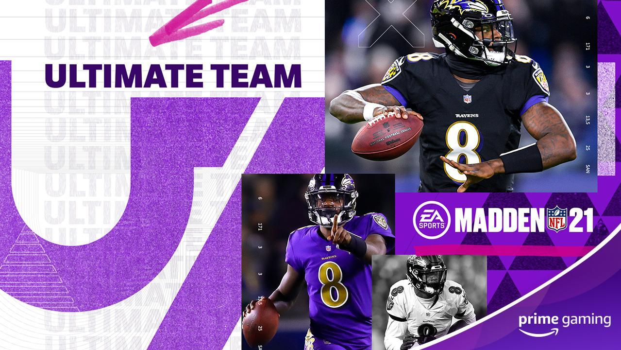 | 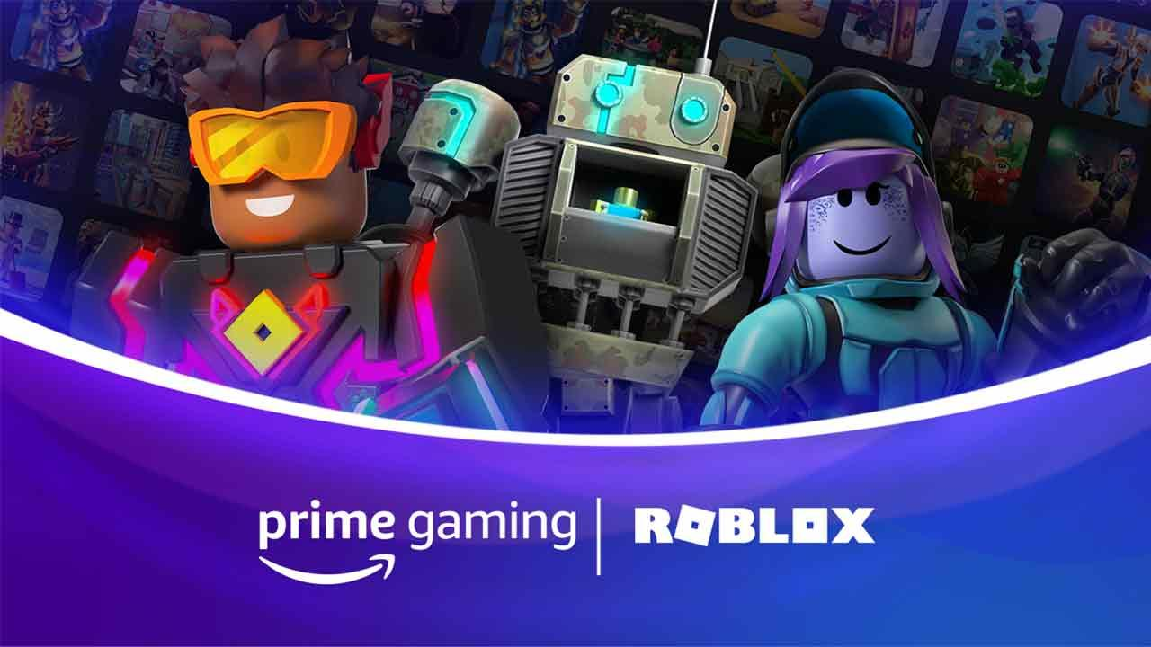
STAR WARS: Squadrons  Available Now  Fly in style with two new pilot helmets, available now.  Drop 2 of 4 | Madden NFL 21  Available February 5  Touchdown! Get ready for The Big Game with the Prime Gaming Superbowl Pack for Madden NFL 21.  Drop 6 of 11 | Roblox  Available February 12  Claim an exclusive PB&J hat for your avatar.  Drop 7 of 8
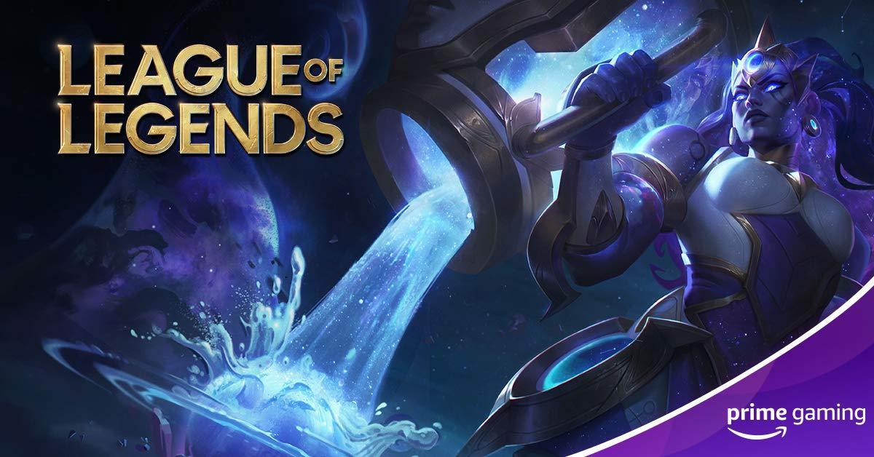 | 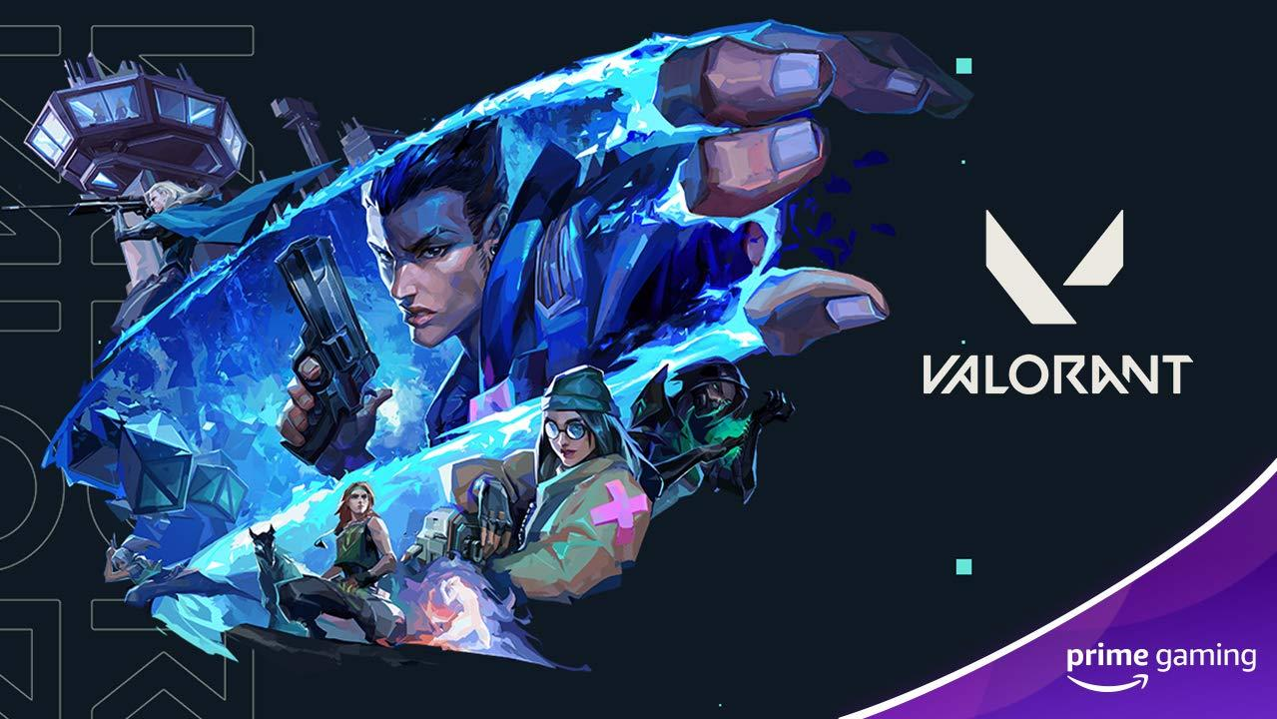 | 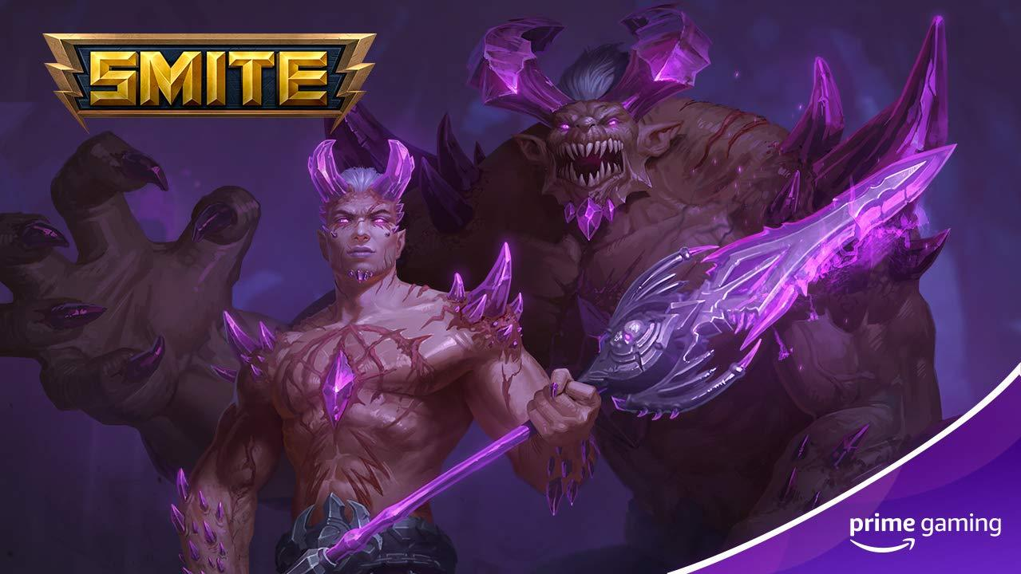
League of Legends  Drop 4: February 4  Drop 5: February 15  Drop 6: February 25  Unlock 3 mystery Skin Shards in League of Legends this month.  Drop 4-6 of 36 | VALORANT  Now Available  Unlock the Zoomer Pop gun in the popular 5v5 tactical-first person shooter.  Drop 2 of 3 | SMITE  Now Available  Be sure to grab a Fiendish Rage skin for Cu Chulainn in the ultimate Battleground of the Gods this month!  Drop 5 of 9
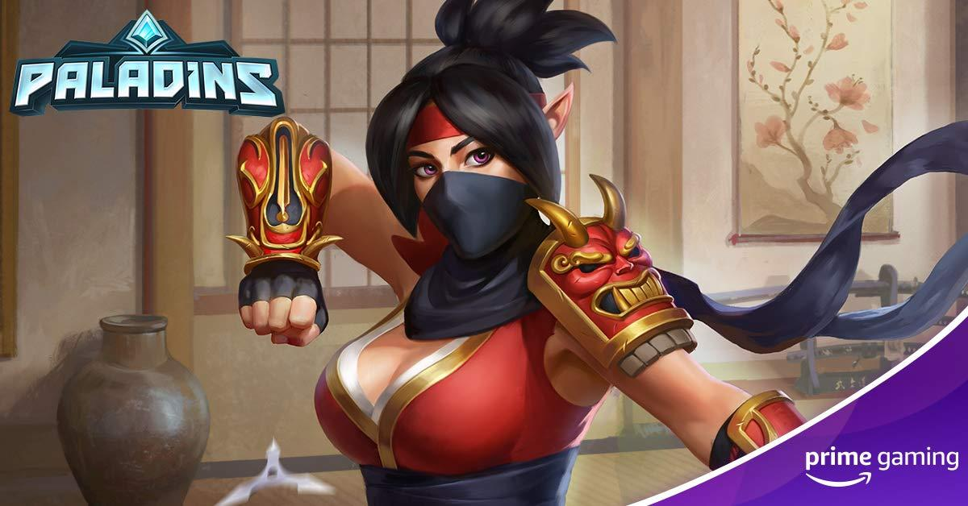 | 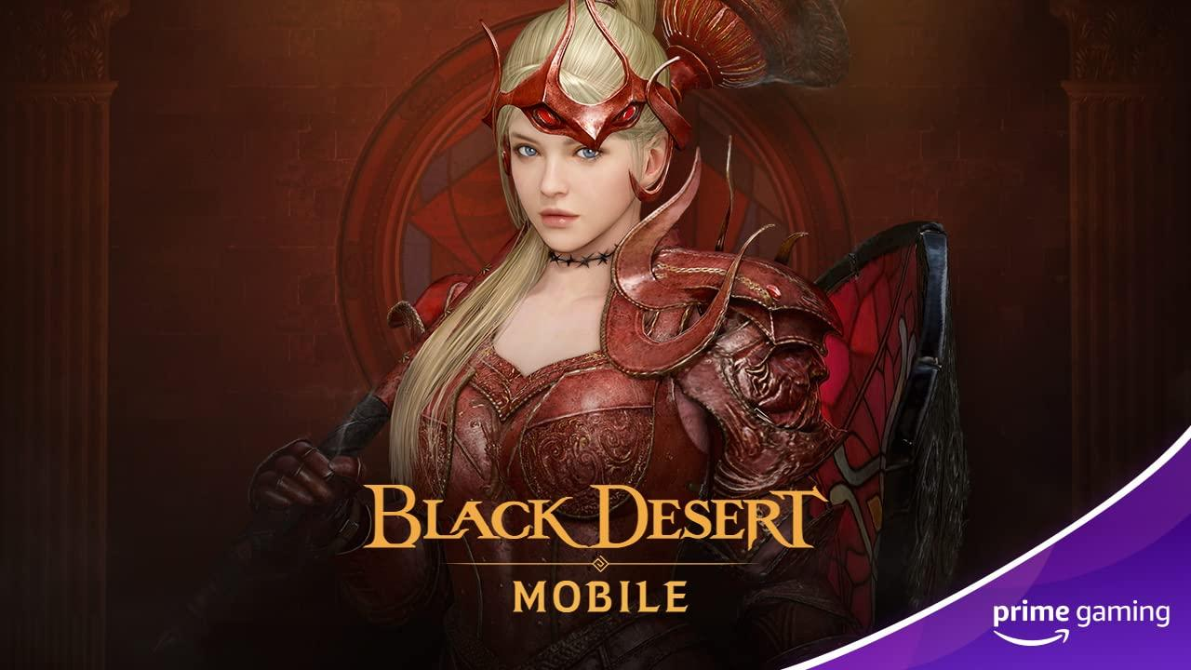 | 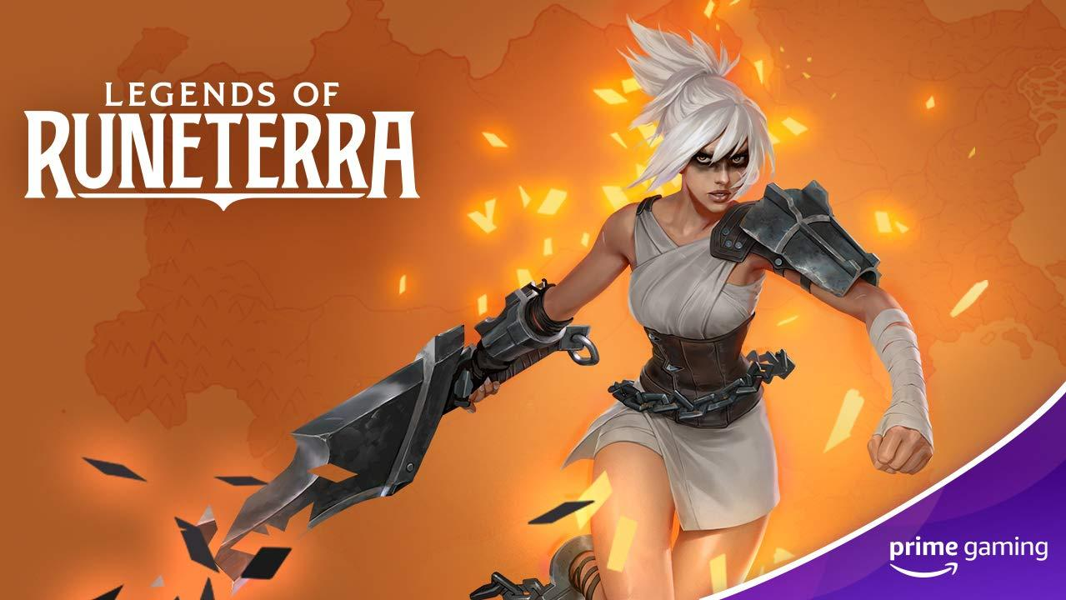
Paladins  Now Available  Paladins players, listen up! Claim a brand-new Kunoichi skin for Skye in the popular free-to-play shooter.  Drop 5 of 9 | Black Desert Mobile  Available February 2  Unlock a Large Totem Chest beginning on February 2. Act quickly, because this offer ends February 16.  Drop 8 of 13 | Legends of Runeterra  Available February 5  Pick up an Epic wildcard for Riot Games’ Legends of Runeterra.  Drop 2 of 12
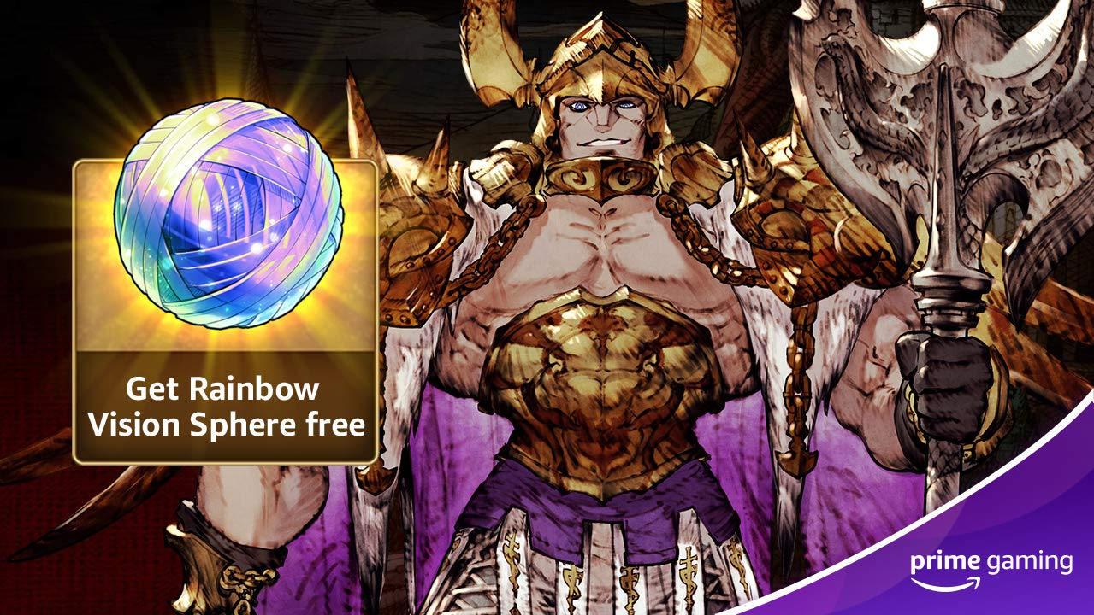 | 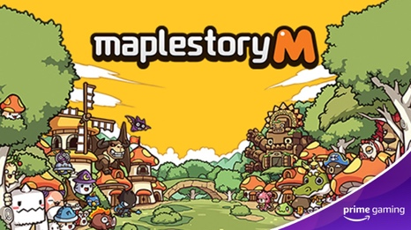 | 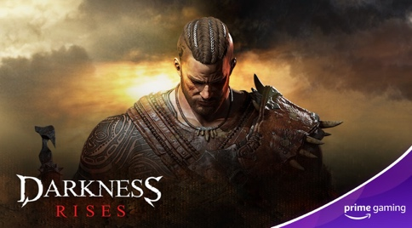
WAR OF THE VISIONS FINAL FANTASY BRAVE EXVIUS  Drop 6: February 3  Drop 7: February 17  Beginning February 3, players can claim a rainbow vision sphere in the FINAL FANTASY tactical RPG.  On February 17, players can pick up a MR+ guaranteed unit summon ticket A! | MapleStory M  Drop 1: February 9  Drop 2: February 23  Beginning February 9, pick up a Bellflower Root pet/Event buff pet for the nostalgic world of MapleStory on mobile!  And starting February 23, players can snag a Legendary Whetstone box, containing a mysterious weapon Whetstone Legendary x50 and mysterious armor Whetstone (Legendary x100). | Darkness Rises  Drop 1: Now Available  Drop 2: February 11  Drop 3: February 25  February brings plenty of new content for Darkness Rises! Players can now grab a rank S++ costume choice box.  Later on February 11, players can look forward to a rank S++ costume choice box and King's guard costumes. To round out the month, a rank S+++ costume choice box and Knighthood costume will be available on February 25.
Calendar February 2021
Now Available Apex Legends Drop 1
Now Available Aquapark.io Drop 1
Now Available Cube Surfer Drop 2
Now Available Darkness Rises Drop 1
Now Available Fall Guys Drop 2
Now Available FIFA 21 Drop 1
Now Available Grand Theft Auto Online
Now Available Helix Jump Drop 2
Now Available SMITE Drop 5
Now Available STAR Wars: Squadrons Drop
Now Available Paladins Drop 5
Now Available Red Dead Online
Now Available UFC 4 Drop 1
Now Available VALORANT Drop 2
February 1 Games with Prime - Table Manners, Stealth Bastard Deluxe, Spinch, Monster Prom: Hotseat Edition, Swimsanity!
February 2 Black Desert Mobile Drop 8
February 3 WAR OF THE VISIONS FINAL FANTASY BRAVE EXVIUS Drop 6
February 4 League of Legends Drop 4
February 4 Hole.io Drop 1
February 4 Helix Jump Drop 3
February 5 Madden NFL 21 Drop 6
February 5 Legends of Runeterra Drop 2
February 8 Aquapark.io Drop 2
February 9 MapleStory M Drop 1
February 11 Darkness Rises Drop 2
February 12 Roblox Drop 7
February 14 Aquapark.io Drop 3
February 15 League of Legends Drop 5
February 17 WAR OF THE VISIONS FINAL FANTASY BRAVE EXVIUS Drop 7
February 17 Cube Surfer Drop 3
February 23 MapleStory M Drop 2
February 25 League of Legends Drop 6
February 25 Darkness Rises Drop 3
For the latest on content, offers and sweepstakes, follow Prime Gaming on the official Prime Gaming blog, Twitter, Facebook and Instagram.

About Prime Gaming
With Prime Gaming, Amazon Prime members enjoy tons of content for their favorite PC, console, and mobile games. Plus, they can claim a collection of PC games every month that are theirs to keep forever, and a monthly Twitch channel subscription. Prime Gaming’s selection of in-game content and PC games is always growing and rotating to stay fresh, with new items and games added every month.

This is in addition to the many other benefits available with Prime, including the best of shopping and entertainment from Amazon, including fast, free delivery, along with exclusive savings, early access to deals, Prime Day, and so much more. Members enjoy unlimited streaming access to a vast collection of TV shows, movies, sports and more with Prime Video, ad-free listening of 2 million songs plus thousands of stations and playlists with Amazon Music, unlimited access to a rotating selection of more than 1,000 books and magazines with Prime Reading, and unlimited photo storage with Amazon Photos.

