FOR IMMEIDATE RELEASE

Stanley Black & Decker, Inc. Introduces the
STANLEY® Model 1 3D Printer

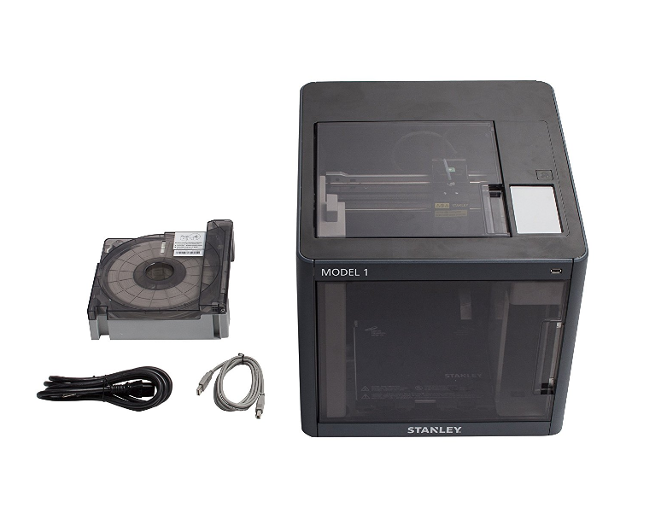
NEW BRITAIN, Conn., (March 29, 2017) – Stanley Black & Decker, Inc, a leader in delivering innovative solutions and jobsite tools for more than 174 years, has partnered with Sindoh to launch the new STANLEY® Model 1 3D Printer. This new licensed agreement is also STANLEY’s first 3D printer, which has been designed to deliver a convenient desktop experience to beginners and experienced users who are interested in prototyping designs, developing concepts, and bringing ideas in a 3D form to life.

The STANLEY® Model 1 3D Printer features proprietary and user-friendly features and is optimized for safety, quality, and reliability. All moving parts are enclosed within the (421 mm × 433 mm × 439 mm build envelope, generating a consistent temperature and delivering a safe operation with reduced noise for a quiet print experience. Additional features include:

Auto-Loading Filament System and Magnetic Extruder Head: The STANLEY® MODEL 1 3D Printer automatically loads and unloads the PLA and ABS printing filament. Depending on the height of the completed piece, users can layer colors using refillable cartridges, available in white, black, red, blue, gray, yellow and green. This feature sets the STANLEY® Model 1 3D Printer apart from other models in this price category where users have to manually cut, rewind and place filament into small openings. In addition, the Magnetic Extruder Head attachment, can be easily removed and replaced to support a build volume of 200 mm x 200 mm x 185 mm).

Touch Screen-Assisted Bed Leveling: The STANLEY® Model 1 3D Printer features a 5-inch color touch screen display to guide users through the print process from start to finish. A critical step is analyzing the print bed position to ensure a level position and accurate prints. The display provides instructions on how to adjust and level the bed by indicating increments for moving the adjustment wheels. The printer also supports manual leveling.

Web Monitoring: A built-in web camera and internal LED lighting allows users to watch the 3D printing process remotely on a network via PC or mobile device.

Connectivity: Users can connect and control the STANLEY® Model 1 3D Printer using a PC, the included USB cable or through your home network using Ethernet or Wi-Fi. It also supports USB thumb drive which users can simply plug into the printer and print their 3D models.

Heated Bed: The STANLEY® Model 1 3D Printer includes a heated bed, which maintains a consistent temperature of the extruded filament and helps prevent warping during cool down.

Customer Support: Stanley Black & Decker, Inc. has a customer service team available for STANLEY® Model 1 3D Printer users.

The STANLEY® Model 1 3D Printer will be available for purchase exclusively on AMAZON for $1,325 (MSRP) and is covered by a one-year STANLEY limited lifetime warranty. Accessories and additional STANLEY 3D Printer cartridges are available for $49.99/each (MSRP) and Refill Filaments are $29.99/each (MSRP).

About STANLEY®
STANLEY®, a brand of Stanley Black & Decker, Inc. is a diversified manufacturer of innovative tools and engineered solutions for professional, industrial, woodworking, construction, automotive repair, organizational, and do-it-yourself use. Since 1843, STANLEY® has consistently provided solutions that make life easier with reliable hand tools. Headquartered in New Britain, CT, STANLEY® produces a large variety of hand tools including tape rules, knives, blades, hand saws, screwdrivers, plastic storage, and accessories. The STANLEY® brand can be found internationally and has helped build America with a breadth of quality hand tools people can trust for over 170 years. For more information visit .www.STANLEYtools.com or follow STANLEY® on Facebook and Twitter.

###
Media Contacts:

Janette Baxter
Stanley Black & Decker, Inc.
(860) 406-9371
janette.baxter@sbdinc.com

Brian K. Felderstein, Esq.
BroadDesk, LLC.
(858) 519-8080 Ext: 101
brian@broaddesk.com

