CHARLOTTE GAINSBOURG RELEASES NEW SINGLE, “DEADLY VALENTINE,” PRODUCED BY SEBASTIAN, AND SELF-DIRECTED MUSIC VIDEO FEATURING
DEV HYNES (AKA BLOOD ORANGE)

Gainsbourg’s First Studio Album Since 2010, Rest, Out November 17 on Because Music

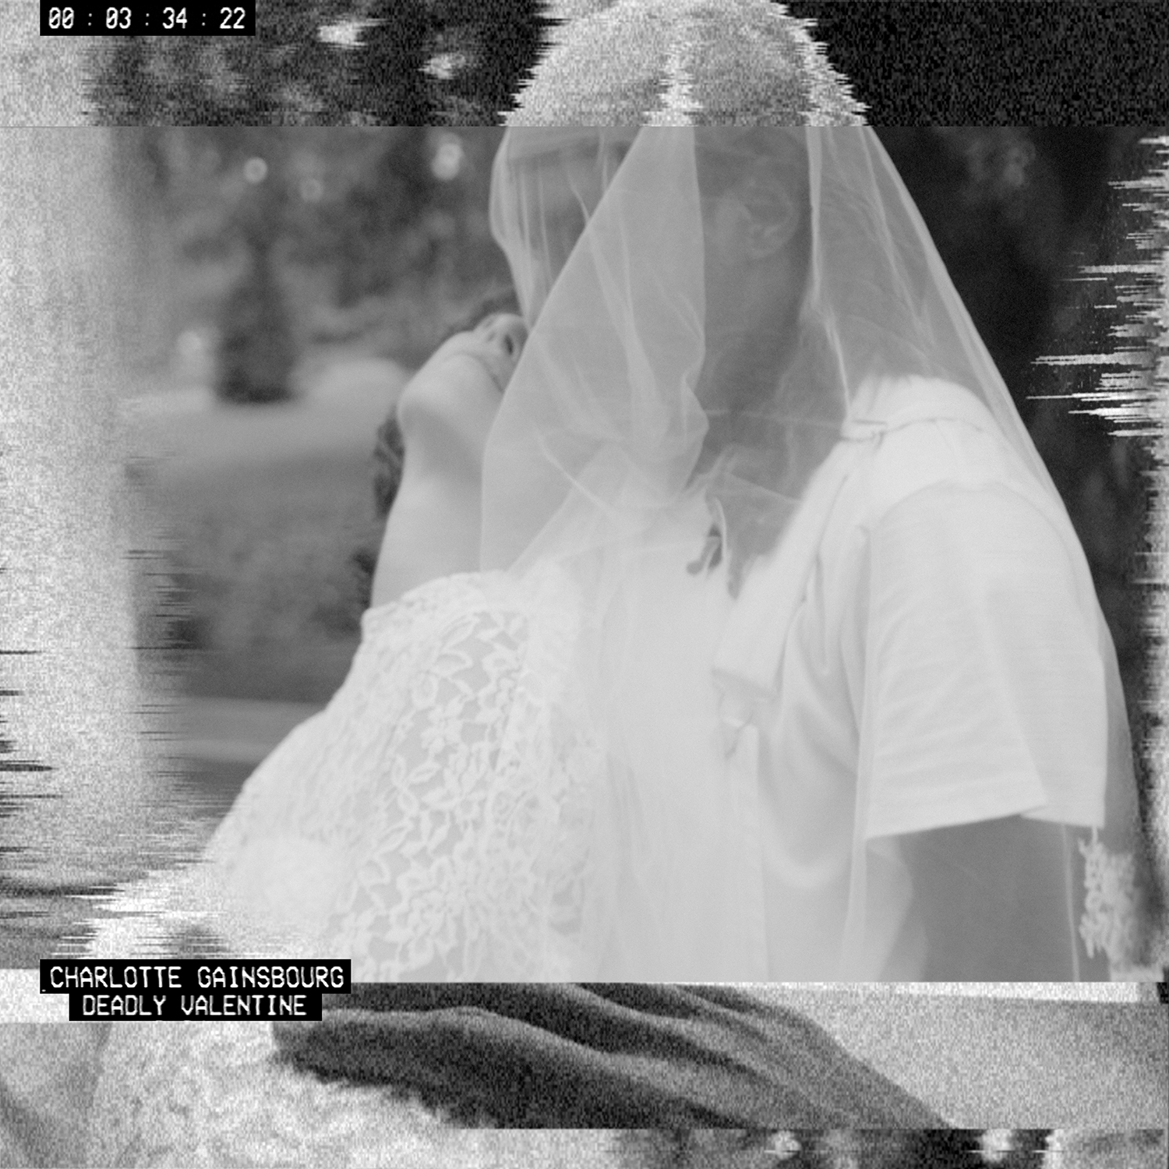
Charlotte Gainsbourg releases a new single, “Deadly Valentine,” today on Because Music. Taken from her forthcoming album Rest, produced by SebastiAn and out November 17 on Because, “Deadly Valentine” follows the debut single, “Rest,” released to international acclaim earlier this month. Also out today is the “Deadly Valentine” music video, directed by Gainsbourg and featuring Dev Hynes (aka Blood Orange)—unveiled as part of a Dazed & Confused online and print takeover. The video, which portrays romantic rites of passage with a dark twist, can be viewed here:
https://www.youtube.com/watch?v=LkyIVKbCfG8.

The “Deadly Valentine” video, like “Rest” before it, is part of a series of videos Gainsbourg directed in connection with the album. “Each video came from personal, resonating ideas,” she explains. “This song mixes wedding vows with an offbeat tone. I wanted to express the idea of a lifetime engagement; a couple running to church, from childhood to old age, a lifetime path. I asked my friend Dev Hynes if he would play my partner, and he very graciously agreed. It was fun finding our younger and older selves! For my part, I had all I needed at home (with their consent of course!). I nearly asked my mother, but in the end, didn’t dare…”

In a Best New Track review, Pitchfork described “Rest” as “a robot-disco banger turned inside out to suit Gainsbourg’s ghostly preoccupations.” In a stunning ten-page feature that hits newsstands this week, Dazed & Confused described the forthcoming album as “a chandelier made of strobe lights.”

Produced by SebastiAn (Frank Ocean, Kavinsky) and mixed by Tom Elmhirst (Adele, Lorde, David Bowie), Rest is Gainsbourg’s first studio album in seven years. It features collaborations with Sir Paul McCartney, Daft Punk’s Guy-Manuel de Homem-Christo, Connan Mockasin and Owen Pallett (Arcade Fire, Caribou).

The eleven songs on Rest are nothing if not sure-footed, proffering a compelling fusion of gleaming, string-emblazoned modern electro-pop and cinematically textured avant-chanson—their magical music box melodies kissed by bruised, introspective, occasionally disquieting lyrics. The album opens with the nursery rhyme enchantment of “Ring a Ring a Roses,” a hazy mosaic of nostalgic childhood snapshots, and ends with the electro-disco-flavored “Les Oxalis.” In between, there is “Lying with You,” whose busy drums and angular synths frame a lyric about Serge Gainsbourg’s death; the frank, self-examining “I’m a Lie”; and the Giorgio Moroder-esque “Deadly Valentine,” whose lyrics—essentially a string of uncannily delivered wedding vows—play out against a Euro-disco beat and soaring strings.

Sir Paul McCartney penned the song “Songbird in a Cage” for Gainsbourg. “We had a very nice lunch about six-and-a-half years ago,” she recalls. “I told him that if he ever had a song for me it would be a dream come true. A few weeks later he sent this track. It was a demo. I didn’t know what to do with it, because I wanted it to be part of the album. We had to reinvent it. Paul very sweetly came to Electric Lady. He did a bit of piano, some bass, a bit of guitar. It was incredible, just to see him work.”

The aides-de-camp may have played their role on Rest, but it remains undeniably the work of a singular artist. “This time it felt like flying on my own. I knew I needed the right collaborator, and SebastiAn was always there, but all the same, this time the album is really mine.”

Rest is available now for pre-order.

Rest Track Listing

1. Ring A Ring O’ Roses 7. Sylvia Says
2. Lying with You 8. Songbird in a Cage
3. Kate 9. Les Traits
4. Deadly Valentine 10. Les Crocodiles
5. I’m A Lie 11. Les Oxalis
6. Rest

