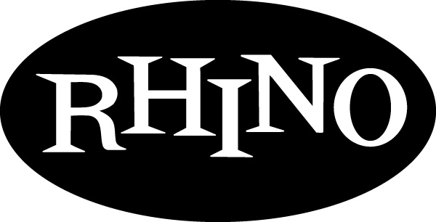
p r e s s r e l e a s e

THE QUEEN’S SOUL SESSIONS

Two-Disc Aretha Franklin Collection Uncovers Unreleased Demos, Outtakes, and B-Sides Featuring Vintage Aretha at Work in the Studio

Available October 3 From Rhino Records

LOS ANGELES – “Mr. Wexler, I’m Aretha Franklin.” That simple introduction, made in 1966, forever changed the course of soul music. Legendary producer Jerry Wexler struck a handshake deal with the young singer, marking the start of a new artistic direction for Aretha and heralding her 13-year reign at Atlantic Records as the Queen of Soul. Rhino bears witness to Sister Re’s renaissance with a two-disc collection of unreleased demos, outtakes, and B-sides that reveal prime Aretha at work in the studio. Writing in the collection’s detailed liner notes, Wexler says he was blown away by the high quality of the unreleased music. “We’ve discovered a treasure trove of vintage Aretha that’s nothing short of thrilling. Aretha’s outtakes are the sort of performances most artists would be proud to call first choices”

Featuring 35 tracks originally recorded between 1966 and 1973, the collection presents outtakes from sessions for eight albums; the B-sides “Pledging My Love/The Clock” and “Lean On Me”; and a duet featuring Ray Charles performing live with Aretha on a televised salute to Duke Ellington. The outtakes reveal Aretha’s artistic blossoming as she began working with Wexler, Tom Dowd, Arif Mardin and a rhythm section of bad-ass white boys from Muscle Shoals, Alabama.

The collection’s first disc follows Aretha’s rapid rise to stardom at Atlantic, where she erupted with seven studio albums in three years that contained some of her most enduring songs. Opening with a trio of demos from the winter of 1966, the collection begins with Aretha working through “Dr. Feelgood,” “Sweet Bitter Love,” and “I Never Loved A Man (The Way I Love You),” a song that would prove to be her breakout hit. The disc also includes a cover of The Beatles’ “Fool On The Hill” along with three unreleased songs—“You Keep Me Hanging On,” “Trying To Overcome,” and a masterful version of “My Way.” “For me,” Wexler writes, “this is one of the highpoints of the collection, a discovery of enormous value. Listening to it now, I forget about Paul [Anka] and Frank [Sinatra] and think only Aretha. It’s a masterpiece.”

The second disc begins with three songs recorded during the Young, Gifted And Black sessions, including the unedited version of “Rock Steady,” Aretha’s own composition and surely one of her finest moments. The collection draws heavily from the Hey Now Hey (The Other Side Of The Sky) sessions. Eight superb outtakes from this Quincy Jones-produced album are featured on RARE & UNRELEASED RECORDINGS FROM THE GOLDEN REIGN OF THE QUEEN OF SOUL, including Aretha’s stretched-out meditation on the Erskine Hawkins standard, “After Hours.” The set concludes as it began, with an unadorned demo featuring Aretha at her piano singing the bittersweet song “Are You Leaving Me.”

För mer information vänligen kontakta:
Jakob Ekendahl Warner Music Sweden
jakob.ekendahl@warnermusic.com
08-752 26 62

Track Listing

Disc 1
- “I Never Loved A Man (The Way I Love You)” – Demo
- “Dr. Feelgood (Love Is A Serious Business)” – Demo
- “Sweet Bitter Love” – Demo
- “It Was You” – Outtake
- “The Letter” – Outtake
- “So Soon” – Outtake
- “Mr. Big” – Outtake
- “Talk To Me, Talk To Me” – Outtake
- “The Fool On The Hill” – Outtake
- “Pledging My Love/The Clock” – B-Side
- “You’re Taking Another Man’s Place” – Outtake
- “You Keep Me Hangin’ On” – Outtake
- “I’m Trying To Overcome” – Outtake
- “My Way” – Outtake
- “My Cup Runneth Over” – Outtake
- “You’re All I Need To Get By” – Outtake 1
- “You’re All I Need To Get By” – Outtake 2
- “Lean On Me” – B-Side

Disc 2
- “Rock Steady” (Alternate Mix)
- “I Need A Strong Man” – Outtake
- “Heavenly Father” – Outtake
- “Sweetest Smile And The Funkiest Style” – Outtake
- “This Is” – Outtake
- “Tree Of Life” – Outtake
- “Do You Know” – Outtake
- “Can You Love Again” – Outtake
- “I Want To Be With You” – Outtake
- “Suzanne” – Outtake
- “That’s The Way I Feel About Cha” – Outtake
- “Ain’t But The One” – with Ray Charles
- “The Happy Blues” – Outtake

- “At Last” – Outtake
- “Love Letters” – Outtake
- “I’m In Love” – Outtake
- “Are You Leaving Me” – Demo

# # # #

