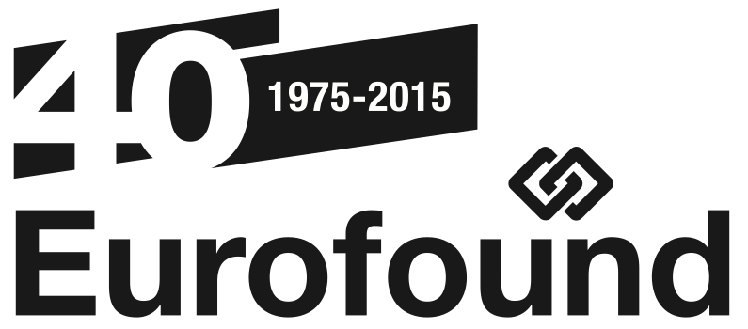
News Release

2 February 2015
---------------------------------------

www.eurofound.europa.eu @eurofound

A spotlight on statutory minimum wage levels in Europe in 2015
(Dublin, Ireland): The minimum wage levels have begun to increase over the past two years, following years of no change. The latest quarterly update from EurWORK presents the most recent data on statutory minimum wages in Europe, applicable on 1 January 2015, and an overview of the discussions leading to the final settlements made in 2014.
Most EU Member States have a statutory minimum wage, which sets the lowest legal amount of pay for all employees. Some Member States also have specific lower minimum levels for certain groups of workers, mainly younger ones.
During the economic crisis, minimum wage levels have been mainly frozen, with only moderate increases in some countries. However, over the past two years, the minimum wage levels have begun to increase, and this first EU wide compilation of minimum wage levels in Europe shows a marked change in trends.
Coupled with low levels of inflation, statutory levels of minimum wage will increase considerably in most countries, and slightly in some.
Germany introduced minimum wage on 1 January 2015, as part of a wider reform on collective bargaining. This has triggered some debate in those countries which have minimum wage levels set within collective agreements. The implementation and enforcement of the German legal minimum wage will have impacts not only at national level but even, as already seen through the discussions raised in the road transport sector, at pan-European level, especially with regard to the posting of workers.
The introduction of a German minimum wage has not only been a substantial change in industrial relations in Germany, but has had an effect in related areas in other Member States, such as posted workers legislation. The report argues that it will affect sectors which previously did not have a universal wage floor.
The research covers 22 EU Member States with statutory minimum wage. There is no statutory minimum wage in Austria, Denmark, Finland, Italy, Norway and Sweden.
Read the full report here http://www.eurofound.europa.eu/observatories/eurwork/articles/working-conditions/eurwork-topical-update-pay-q4-2014-statutory-minimum-wages-in-2015

For further information, contact Mr Måns Mårtensson, Media Manager, Eurofound, on email: mma@eurofound.europa.eu, telephone: +353-1-204 3124, or mobile: +353-876-593 507.

ABOUT EUROFOUND
The European Foundation for the Improvement of Living and Working conditions (Eurofound) is a tripartite European Union Agency, whose role is to provide knowledge in the area of social and work-related policies. Eurofound was established in 1975 by Council Regulation (EEC) No. 1365/75.
Update your contact details and subscription preferences with Eurofound here.
For more information about Eurofound and its work, and free access to all our data and findings, visit our website and follow us on these social media channels: Twitter, LinkedIn, Facebook, Google+, YouTube, or Flickr.

