For Immediate Release

Do a Double Take at Clarke Quay’s 2020 Countdown Party

Press Release 28 November 2019, Singapore - Let’s get the party going and ring in the New Year at Clarke Quay’s 2020 Countdown party at the iconic Fountain Square 31st December, from 8:30pm till late. Let your hair down and vivid imagination take over at this year’s Vision theme that will have you do a double take - double the lights, double the fun.

Be in the here and now and make your way to Clarke Quay via Tan Tye Place and be drawn into a psychotropic world where a three-dimensional 2020 photo backdrop awaits those looking to capture great insta-worthy pictures. Need more double vision enhancements? Pick up a pair of complimentary ChromaDepth 3D glasses and dive into a psychedelic realm full of colours and patterns.

The vision of your future is lit at the fountain square’s main stage. Eye-opening LED visuals and decorations that will transform according to the music are some of the mesmerising optical displays to expect at the 2020 Countdown party at Clarke Quay.

Back by popular demand for a third time round, enigmatic local band Shirlyn + The UnXpected will once again create a rousing atmosphere with their electrifying brand of rock and pop. Together with Kimberly Wang and Gerald Koh of Mediacorp 987FM, who will both be returning again this year as show hosts for the night, will lead party-goers through stage games, lucky draws and entertainment all the way past midnight.

For the early birds, catch the pre-party warm up at 8.30pm with a kickoff dance set by DJ HardBreaker presented by Le Noir Clarke Quay.

At midnight, the multi-sensory party will move into full swing with the customary countdown, confetti shower and the time-honoured singing of Auld Lang Syne. The party continues till the wee hours all around Clarke Quay’s myriad bars and clubs such as Zouk, Yang, F.club x Attica and Get Juiced.

Clarke Quay invites all to their 2020 Countdown Party 31st December, 8:30pm onwards. Admission is free.
#####
*Every effort has been made to ensure that the information here is accurate at the time of publication. However, changes to the information may have occurred since going to press. Please check www.clarkequay.com.sg for the latest information.

Page 1
Media Contact: Yvonne Phua | Empower Marketing Asia | mob: 9236 5356

High resolution images are available at this link: http://bit.ly/2020VisionCountdown

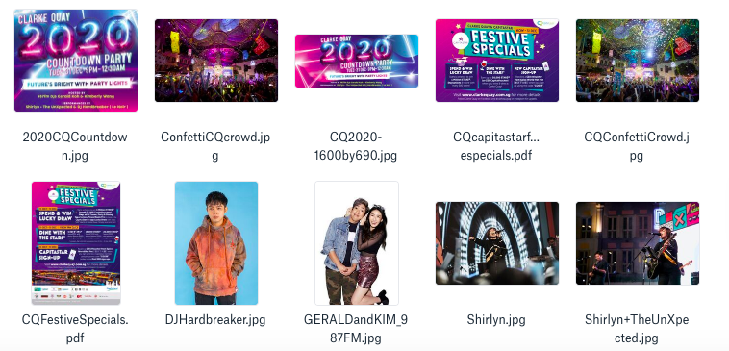

About Clarke Quay
Clarke Quay is a unique conserved landmark located along the Singapore River. It is within walking distance of Clarke Quay and Fort Canning MRT Station, making it accessible by public transportation. Comprising five blocks of restored shophouses and warehouses, Clarke Quay plays host to more than 60 restaurants, wine bars, and entertainment spots. Day and night, you can savour a mix of international cuisines at established dining concepts. When the sun goes down, have drinks at the widest selection of bars with live music or party at some trendiest nightspots in Singapore.
Experience wine, dine and good times only at Clarke Quay.
Website: www.clarkequay.sg
Like us on Facebook: http://www.facebook.com/ClarkeQuay
Follow us on Instagram: http://www.instagram/clarkequaySG

Page 2
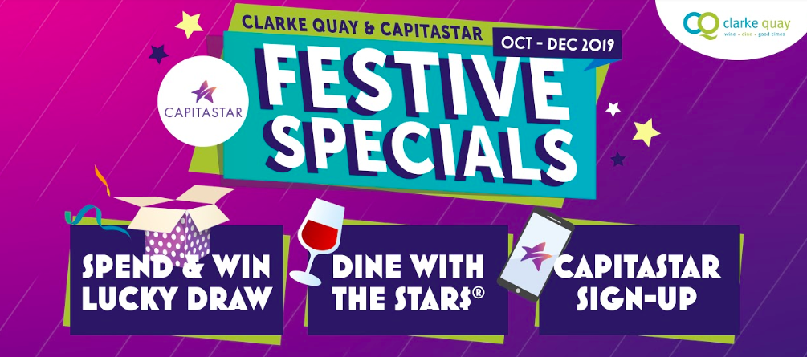
Festive Promotions with CapitaStar
Spend and Win Lucky Draw
Duration: 31 October to 31 December 2019
Stand a chance to win 1 million STAR$® (worth $1,000 CapitaVouchers), staycations at lyf Funan, Party Experience Package at Yang Club and ZOUK, Power Beats Pro and complimentary dining treat at Octapas Spanish Tapas Bar, Talay Thai & more in the CapitaStar in-app Lucky Draw with every $80.00 spent at Clarke Quay, simply scan and win!

Dine with the STAR$®
Seeing STARS? Earn up to 20,000 STAR$® when you wine & dine at Clarke Quay! From 3pm daily
- Receive 5,000 STAR$® (worth $5 CapitaVoucher) when you spend $80.00 and above (below $150) in a single receipt.
- Receive 15,000 STAR$® (worth $15 CapitaVoucher)when you spend $150.00 and above (below $200) in a single receipt.
- Receive 20,000 STAR$® (worth $20 CapitaVoucher) when you spend $200.00 and above in a single receipt.

CapitaStar New Member Sign-up promotion
Duration: 31 October to 31 December 2019
Receive a $38 e-voucher from Spice World Hot Pot 香天下火锅 when you sign up to be a CapitaStar member using the promo code "CQS38". Limited to the first 500 sign ups.

On-going Promotions

Lunch by the Quay
Lunch along the Singapore River with over 25 deals of set lunches for under $25. You can receive 5000 STAR$® when you scan 2 lunch receipts (between 12pm to 3pm) from 2 different Clarke Quay outlets within a month via the CapitaStar Mobile App or earn 2x STAR$® or lunch receipts scanned in Clarke Quay.
Details: https://www.capitaland.com/sg/malls/clarkequay/en/Lunch-by-the-Quay.html

Sunday Play Dates
On the first Sunday of every month, kids get to eat for free for every 2 paying adults at selected restaurants (Fremantle Seafood Market, Hot Sones, McGettigan’s and Talay Thai) and enjoy playing at the bouncy castles, inflatable slides and children’s games around the Fountain Square from 12pm to 5pm.
Details: https://www.facebook.com/events/376873729737254/

Page 3

