**The Bäckman siblings begins the season with guest appearance in GT4 Europe at Monza**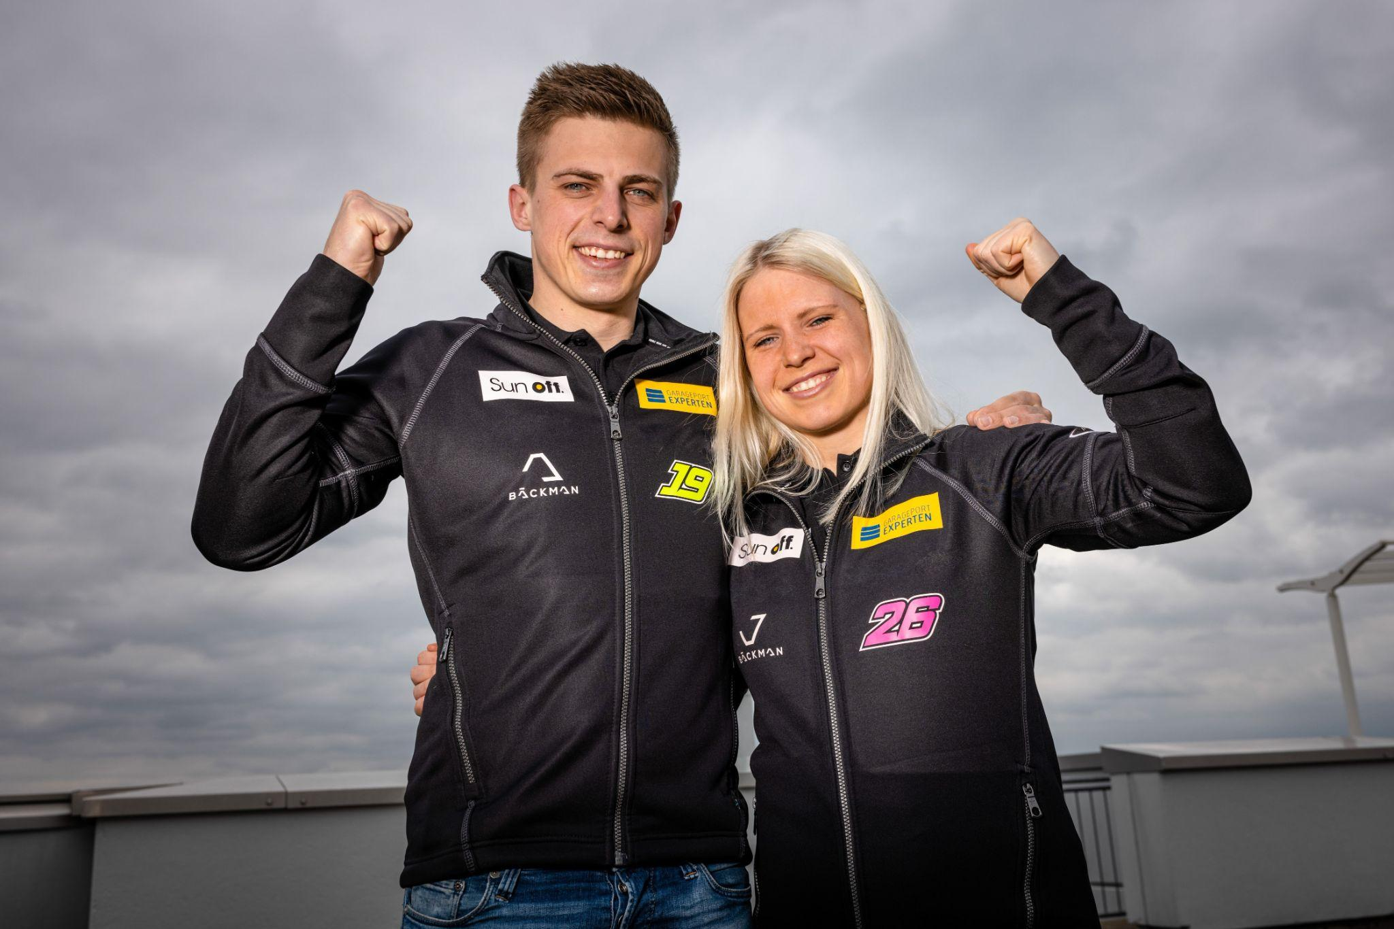Andreas and Jessica Bäckman are ready for their first race together in GT4.  
Photo: FIA WTCR (Free rights to use the image)

**Andreas and Jessica Bäckman announced today that they will make a guest appearance in the GT4 Europe series this weekend at the Monza track in Italy. It will be the first competition that the siblings run together and will prepare them for the German series ADAC GT4 Germany season, which begins in May.  
- It will be good to get a race before the season opener in Germany, Andreas Bäckman says.**

Since the siblings made the step to car racing five years ago, they have competed in Touring Car Racing in TCR cars. The previous season, Andreas competed in the Scandinavian Touring Car Championship (STCC) and finished third overall in the championship with three wins, two pole positions, seven podiums and three fastest laps. Jessica was competing in the ADAC TCR Germany Championship, which is the German equivalent of the STCC, Jessica finished second overall in the championship with four wins, nine podiums, two pole positions and three fastest laps.

For this year's season, the siblings have chosen to go a completely different route and steps into GT racing. Throughout Andreas and Jessica's motorsport career, they have competed individually in each car. For this season, they will share a car with each other and race together in an Aston Martin Vantage GT4 car. The races are one hour long, with a mandatory driver change midway through the race, which will be something completely new for Jessica and Andreas to adjust to.

- It will be fun to try something completely different for this season by competing in GT4, and it feels exciting to be able to share a car with Jessica. We will have a lot to learn during the season, but we still aim high and want to be able to challenge at the top, **Andreas Bäckman** says.

**The Bäckman siblings begins the GT4 season at Monza**A few weeks ago, the siblings announced that they will change direction and focus on GT racing instead of TCR which they have competed in the last few years with impressive results. Now the siblings announce that they will make a guest appearance in GT4 Europe this weekend with a total of 52 cars on the starting grid.

It will be the siblings' first competition together, where they enter with the attitude of watching and learning to be more prepared for the season opener in the ADAC GT4 Germany, which begins at the end of May.

- It will be very exciting to finally get to drive the first race with Andreas. We have been to some tests, and we work very well together, it will be fun now to see how we stack up against our competitors. But we are humble about the debut as we will face 51 other drivers who are the best from all over Europe, it will be a good test to see what we need to work more on, we are here to give everything, **Jessica Bäckman** says.  
  
**The structure of the GT4 Europe series**GT4 Europe consists of six races around Europe. The series is considered one of the toughest GT4 series in the world and has a high status among the drivers who come from several different countries around Europe. The start of the season will take place this weekend at the well-known Monza track in Italy also called the “Temple of Speed” and will end at the well-known Formula 1 track Barcelona in Spain. In addition to Barcelona and Monza, the world-famous Formula 1 tracks Paul Ricard, Spa, Hockenheim and Misano will also be on the calendar in 2023.

Each competition consists of two free practice sessions, two timed qualifying’s and two 60-minute races where there is a driver change halfway through the race. Points are awarded to the fastest car in the time qualifying’s and the top 10 in each race. The drivers in the car with the most points after the last race in Barcelona will together take home the driver's title "GT4 Europe Drivers Title '' in the GT4 Europe series.

Andreas and Jessica Bäckman are looking forward to competing together in 2023, which they believe they can benefit from by helping each other forward. It will be a tough start to the season where the siblings will give everything they have to master a brand new car model in a new championship. The season kicks off this weekend April 21st-23rd at the Monza track in Italy.

- It will be fun and exciting to make my debut race in GT4 this weekend, it will be good to get a race before the season opener in ADAC GT4 Germany at the end of May, **Andreas Bäckman** says.

**Time schedule for this weekend’s races (GT4 Europe Round 1):**(all times in CEST)

**Friday April 21st:**10:10 Free Practice 1 (60 min) – LIVETIMING  
<https://www.gt4europeanseries.com/watch-live#live-timing>  
12:45 Free Practice 2 (60 min) – LIVETIMING  
<https://www.gt4europeanseries.com/watch-live#live-timing>  
  
**Saturday April 22nd:**11:10 Qualifying 1 & Qualifying 2 (20 min x 2) - LIVE TV  
<https://www.gt4europeanseries.com/watch-live>  
12:10 Race 1 (60 min) – driver change after half of the race - LIVE TV  
<https://www.gt4europeanseries.com/watch-live>  
  
**Sunday April 23rd:**  
14:25 Race 2 (60 min) – driver change after half of the race - LIVE TV  
<https://www.gt4europeanseries.com/watch-live>

**About the track (Monza):**  
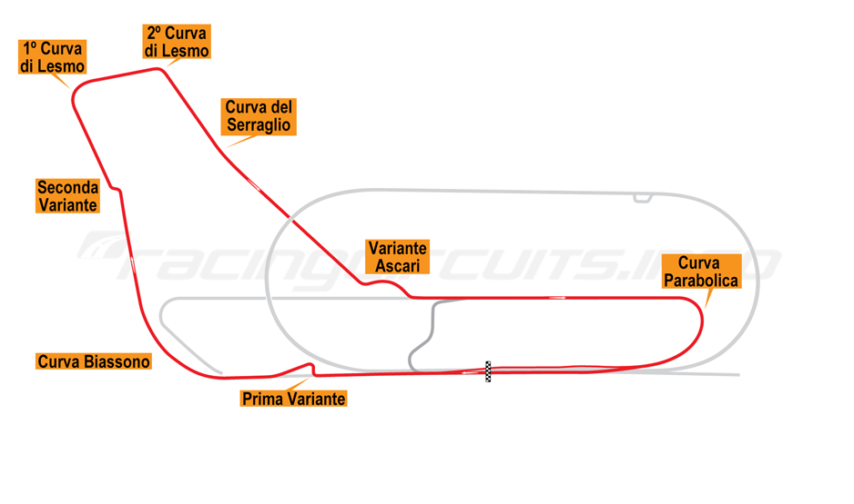  
**Location:** Monza, Italy  
**Length**: 5,793 km  
**Corners:** 11

**GT4 Europe Calendar 2023:**

***April 22nd-23rd*** - Monza, Italy ***June 2nd-4th*** - Paul Ricard, France  
***June 29th-July 2nd*** - Spa, Belgium ***July 14th-16th*** - Misano, Italy ***September 1st-3rd*** - Hockenheim, Germany ***September 29th-October 1st*** - Barcelona, Spain

***Free rights to use the images.***

***Download press-photos here:***[***http://bit.ly/jabaeckman-photos***](http://bit.ly/jabaeckman-photos)[***https://www.mynewsdesk.com/se/ja-backman/images***](https://www.mynewsdesk.com/se/ja-backman/images)

