**YANMAR TECHNICAL TRAINING SCHOOL**

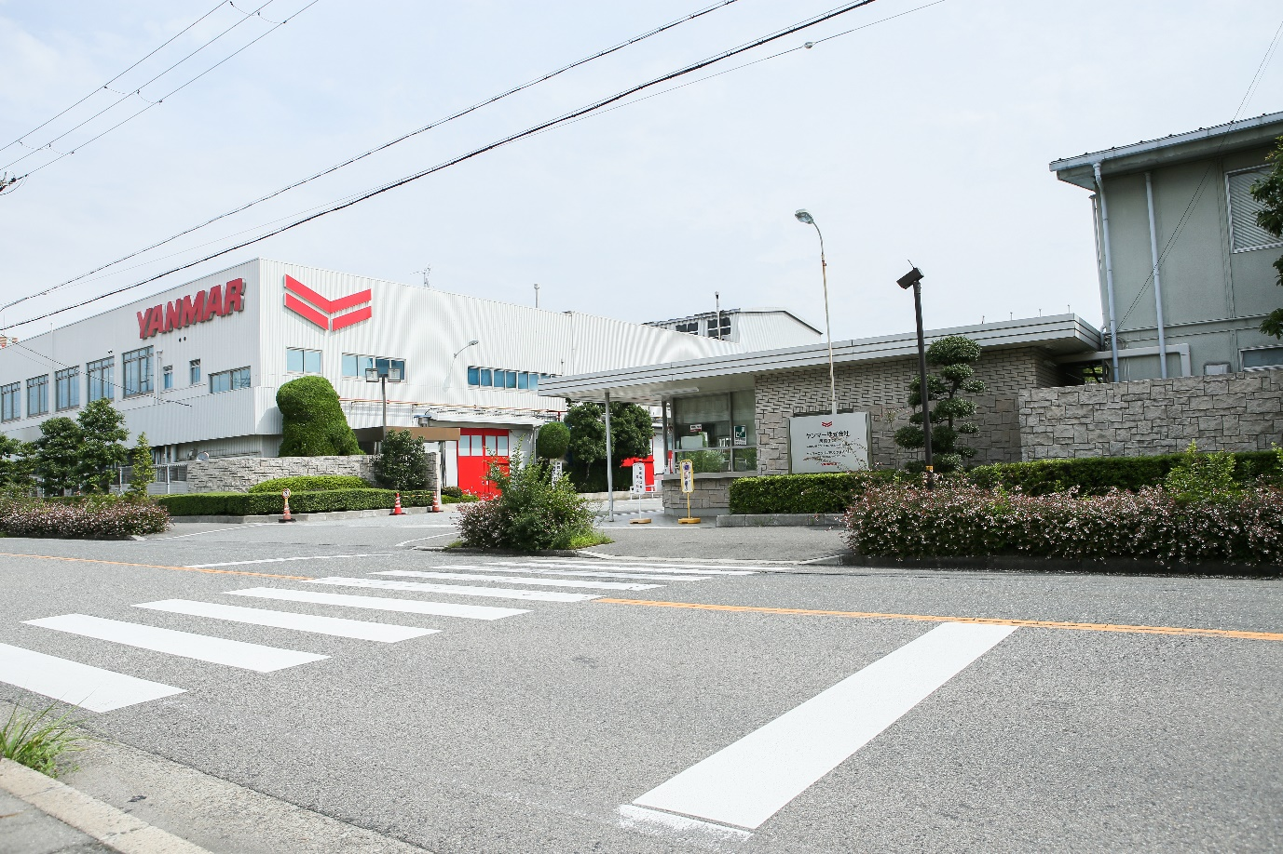

The Yanmar Amagasaki Factory produces large marine engines and is home to the Technical Training School

**Backbone of the Global Economy**

Marine transport plays a crucial role in the global economy with world seaborne trade estimated at 10.7 billion tons in 2017, an increase of 411 million tons from 2016. [1]

This was an increase of four per cent, the highest in five years, and illustrates a global economy highly vulnerable to market forces, with narrow margins.

Supporting this crucial global network is an unassuming building, tucked away on the Yanmar Amagasaki Factory near Osaka, Japan, a major large engine manufacturing facility. Here, the [Yanmar Technical Training School](https://www.yanmar.com/global/about/company/ye/tt_school/) (TT School, TTS) of [Yanmar Engineering Co., Ltd.](https://www.yanmar.com/global/about/company/ye/) is helping to ensure safety, efficiency and of course, profitability for ship owners and support the global economy.

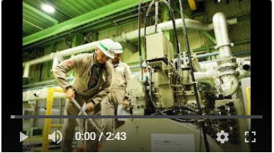

Technical Training School Video

**Major Maritime Vessel Types**

The billions of tons of international sea cargo are carried by a relatively small variety of often very large vessels. From the container ships and bulk carriers that transport bulk commodities and heavy cargo, to the tanker sector that makes up one third of all world tonnage, most of these large vessels are powered by diesel engines with propulsion and power needs met by large propulsion and auxiliary engines.

[Yanmar’s 6EY and 8EY](https://www.yanmar.com/global/about/ymedia/product/8lv_engine.html) engines are found as both propulsion and auxiliary engines in container ships, bulk carriers, and tankers and are also found on a range of smaller marine commercial vessels such as fishing vessels, tugs and tenders. As such, the engines play a crucial role in global trade and the marine industry. The engines have long lifecycles and, with proper maintenance, can last for decades

**Yanmar Technical Training School**

This is where Yanmar’s Technical Training School comes in. The school exists to help customers use Yanmar’s products safely and efficiently. Accepting trainees, from beginners to experienced engineers, from countries all around the world, the school helps customers maintain Yanmar engines, and keep them running.

Tsukasa Harako is the school manager. ‘Technical Training School was established 40 to 50 years ago, to train Yanmar engineers. From around 20 years ago we started training customers, shipping companies and Yanmar product users who request to join to the TT School for technical training.’

In Amagasaki, approximately 70 per cent of the trainees are Japanese and 30 per cent come from overseas, mainly and from North and South America and Europe.

The absence of trainees from other territories points to Yanmar’s service stretching its reach further and further around the globe.

‘We operate [five TT Schools worldwide](https://www.yanmar.com/global/about/company/ye/tt_school/overseas_training01_facilities.html); Amagasaki and Tsukaguchi in Japan, Clark in the Philippines, Dalian in China and Mumbai in India. ‘In Japan we host trainees from North and South America and Europe because we have the branches in China, the Philippines and Mumbai.

‘We hope to open more TT Schools, and actually we have a small TT School in South America. The next ones may be in Singapore or Europe.

The total number of trainees for the five schools is currently around 800 per year. TTS intends to continue to broaden the curriculum to respond to customer needs.

The main aim of the TT School is to help customers maintain Yanmar engines and keep them running. Yanmar sees the after-sales service as essential to achieve this. It not only helps sell the engines but adds value throughout the engine life cycle.

Tsukasa: ‘Nowadays, I think the engine life cycle depends on fuel oil. If the diesel engine uses good fuel, there is very rarely any trouble. But if a heavy fuel were used, maintenance time is very short and the lifetime of the engine also becomes short. Some countries still request spare parts for engines over 50 years old, so it very much depends on the running conditions and what kind of fuel they use.’

The schools also provide Yanmar with a way to get feedback from actual users

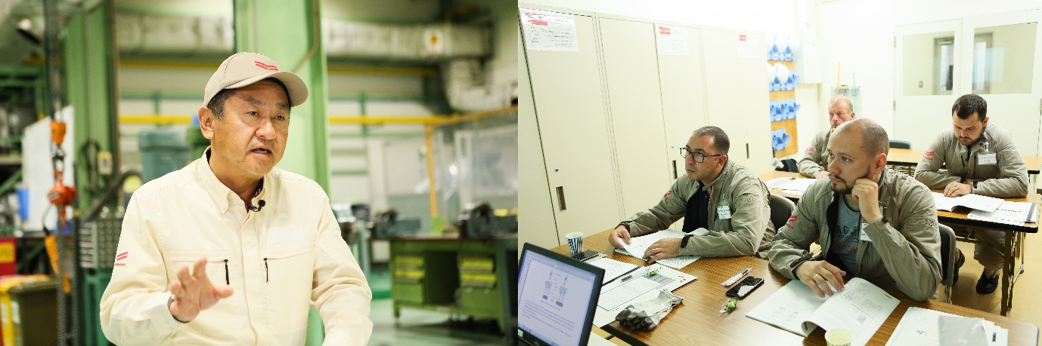

Left: School manager Tsukasa Haruko; right: Trainees learn in the classroom and the workshop.

**Preventative Maintenance Better Than Cure**

When ships breakdown, their owners start to incur losses. The sooner it’s repaired, the sooner it can be back out at sea, earning money. Better still it is properly maintained to minimise breakdowns.

This is the focus of the school and the training.

Over five days, both in the classroom and most importantly, with hands-on experience in the workshop, trainees receive an outline of the company, a tour of the factory and a full explanation of Yanmar engines.

Trainees get to disassemble and assemble the engines themselves, as well as devices attached to the engine. They receive training in the operating principles of the turbo charger and major parts, and all the technical knowledge required to help them do mmaintenance as quickly as possible, minimizing downtime and keep engines running 24/7, helping fulfil the company’s broader mission.

One of the trainees, Audin Jarle Solheim, grew up in small town called Florø, in Norway, 476 kilometres northwest of Oslo. The oil industry and shipbuilding are an important source of income for Florø, having largely replaced the herring fishing industry that was its foundation.

Solheim recalls, ‘I first heard about Yanmar engines when I was a little boy. They had Yanmar engines in the small boats fishing the coast of Norway and they were very happy with them. They had a great reputation as being very reliable.’

Solheim works as a marine engineer with Anlegg og Marine Service AS, and travels all over the world, working on engines of all kinds.

Commenting on the training he took part in at TTS, Solheim is taken aback: ‘After 20 minutes, we’re taking the cylinder apart. It’s ridiculous. It’s so easy to work on. Everything is just there.’ He gestures to the 6EY18 training engine. ‘The cylinder head is here, it’s easy to open. Very easy to understand. Very easy to work on.’

Solheim adds, ‘You have to follow the manufacturer’s instructions. Here they teach us how important it is to follow the factory instructions for oil change, service, inspection and overhaul. If you follow those, you should have an engine that will last for many, many years.’

Solheim goes on to explain how he and his company will benefit from the training. ‘It will help service customers. How to dismantle, take the required measurements, see what’s good, what is bad and how to put the engine back together correctly.’

In the training session we observe, there are four trainees, Solheim and three Russians, 2 from RPA “DONTECHCENTER” Ltd., a large company in the south of Russia, and a third from Ru. Sea, a marine services company.

In a country ranked 49th in the world for English proficiency, and only 12th in Asia, International English is the order of the day. The instructor gives loud directions in a noisy workshop, demonstrates on big wheel and draws diagrams on a whiteboard.

‘Compression check, number three. Ratios, compression, degrees.’

All is easily understood, and one Russian trainee translates for his team when needed.

Vladimir Druzhinin is a manager in the technical department and works with clients, coordinating mechanics and other staff.

‘I know Yanmar has a program for the Black Sea and for Turkey. We work with Turkish shipyards and the Black Sea area between Turkey and Russia, so the training will be very useful in the future. Our company sent us here because we have more and more Yanmar engines in our market.’

On passing the course, trainees receive a certificate for their time at the TT School. Druzhinin is sure the certificate will be useful back in Russia.’

‘Our customers expect quality work, and, as is typical for Russia, good prices. Good quality work comes first, of course, because the speed of cargo trans-shipments depends on quality work. The training here will help the company meet our customers’ expectations.’

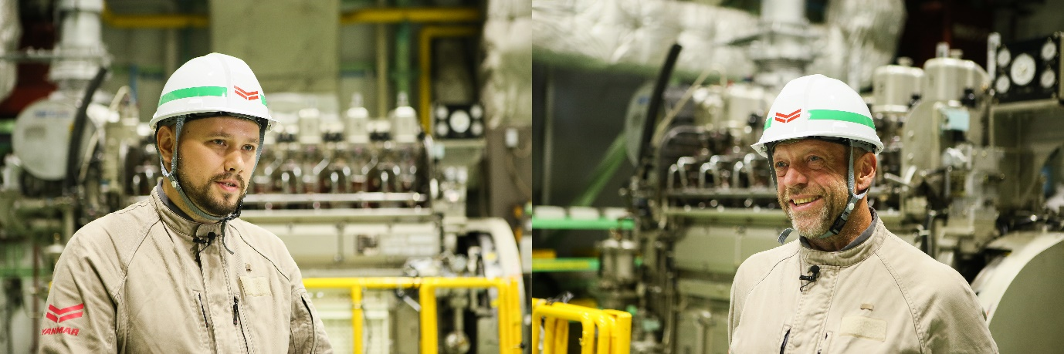

Trainees Vladimir Druzhinin (left) and Audin Jarle Solheim.

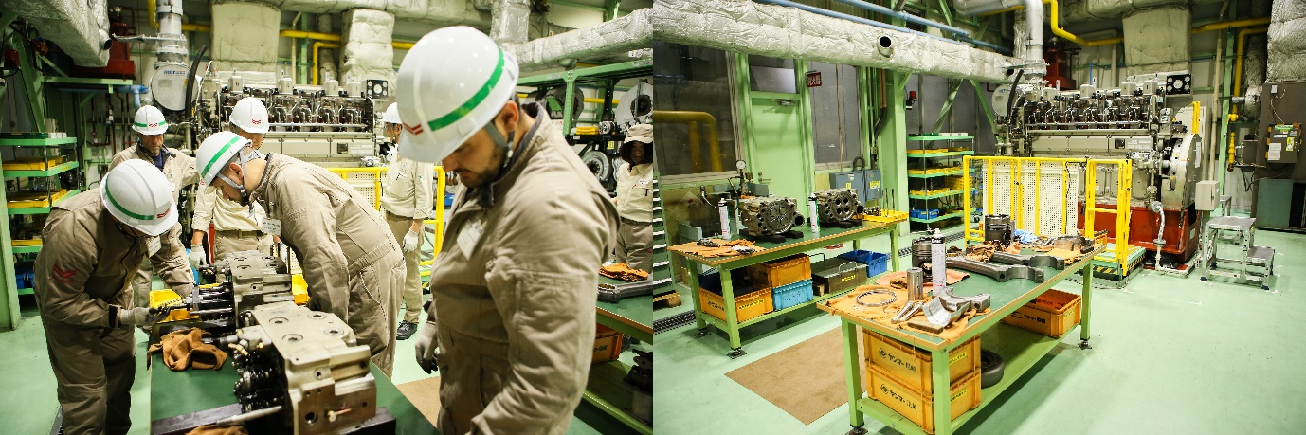

Left: Trainees disassemble the engine; Right: The workshop space.

**Keep Your Motor Running**

The knowledge gained at the TT School will be shared once the trainees return home.

Druzhinin: ‘I don’t have so much experience repairing with my own hands because I am a manager, so all of this is interesting for me. I’ve had real hands-on training.’

‘I need some special knowledge about Yanmar technologies, then I can use it at work back home. My colleagues and I will teach our other mechanics all this and we can all use our knowledge. This is my first experience with Yanmar engines, but I know they are very good quality engines and it’s a very nice company. I can see that here.’

‘Ships must go out and earn more money for their owners, so the engines must run 24/7. The main part of our work is to enable that. I think this training will help us to keep the engines running 24/7.’

For Solheim, his relationship with Yanmar, which began a lifetime ago, as child half a world away, continues.

‘The TT School has a good reputation back home in Norway. One or two guys at my company have been here for training, and they were very happy with it.

‘I will contact TTS if I have questions and there will be new Yanmar engines in the future. We can continue the relationship and keep the engines running for as long as possible.’

1: United Nations Conference on Trade and Development (UNCTAD) 2019 publication, Review of Maritime Transport

