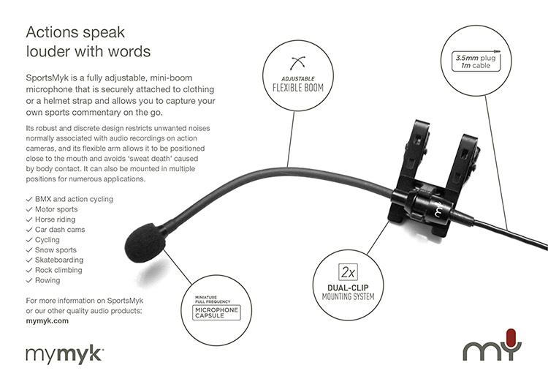

Specification
Microphone Capsule Back Electret Condenser
Pick up Pattern: Omnidirectional
Frequency Response: 20Hz - 20Khz
Sensitivity: -45dB ±3dB(0dB=1v/pa at 1KHz)
Output Impedance: 1KΩ±30%
Power requirement: 1.5-10V DC
Product Weight: 26g
Product Colour: Black with mymyk logo
Accessories: Foam windscreen
Connector: 3.5 mm TRS wired dual Mono

Flexible 105mm Boom
Mount – Dual Independent grip system
Cable length 1.15 m
3.5mm TRS Stereo plug wired dual mono

