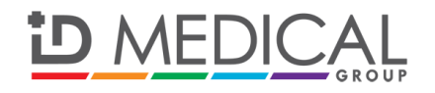

**PRESS RELEASE**

**For immediate release: Monday 7th October**

**Milton Keynes-based recruiter ID Medical scoops top prizes in Barclays and Recruitment International golf competitions**

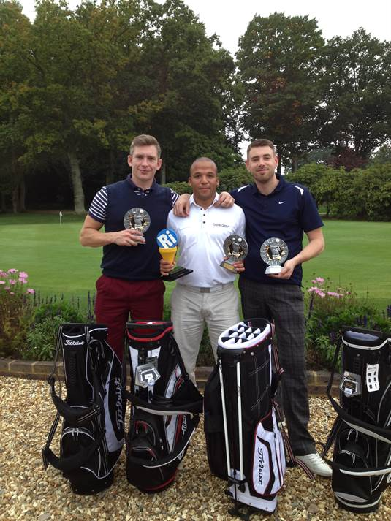

*Winners of the Recruitment International Charity Golf Day 2013 pictured: Stefan Thygesen, David Newton and Simon Nightingale (Not pictured: Deenu Patel)*

### ID Medical, one of Milton Keynes most successful recruitment organisations, took the top prizes in two national golf competitions organised by Barclays and Recruitment International (RI).

### Barclays Corporate Golf Day took place on 26 September at the prestigious yet tricky West Course at Wentworth, which is played by Europe’s top professionals every year. The match comprised 6 four-balls, with ID Medical’s managing director, Deenu Patel and his team winning the competition.

### Barclays longstanding partnership with ID Medical spans over a decade, with the bank being the provider of choice with its sales finance facility. Barclays has presented suitable funding to enable ID Medical to increase its capacity to supply high calibre medical professionals to nationwide NHS Trusts.

### The following week on 1 October, Woking Golf Club played host to the Recruitment International Charity Golf Day in aid of the learning disability charity, Linkable. As a team, managing director Deenu Patel, director David Newton, head of learning and development Stefan Thygesen and Simon Nightingale, client services, carded the best score overall, meaning debutants ID Medical took the unique RI trophy back home to Milton Keynes.

### Recruitment International, the leading source of global recruitment news, organises the charity golf competition on an annual basis and ID Medical will be back in 2014 with the aim of retaining its 1st place position.

**ENDS**

**Caryn Cooper**

head of marketing

Description: markdes

ID MEDICAL - ID House - 1 Mill Square - Wolverton Mill South - Milton Keynes - MK12 5ZD  
**t:** +44 (0) 1908 555 498 **f:** +44 (0)1908 552 825

**w:** id-medical.com   **e:** [caryn.cooper@id-medical.com](mailto:caryn.cooper@id-medical.com)

[](http://www.linkedin.com/company/id-medical)  [](http://www.facebook.com/IDMedical)  [](http://www.twitter.com/idmedical)  [](https://plus.google.com/104338735298043774830/posts)

**Notes to editors**

**About ID Medical**

Award-winning, multi-discipline healthcare recruiter ID Medical was formed in 2002 and is a superior quality supplier of locum doctors, nurses, allied health professionals and clerical staff to over 90% of NHS hospitals and private medical sector organisations.

From its headquarters in Milton Keynes as well as its central London office, ID Medical provides practical, cost-effective and innovative workforce solutions, supplying more than 3 million hours to the NHS per annum. Crown Commercial Service (CCS), HealthTrust Europe (HTE) and London Procurement Partnership (LPP) framework approved, ID Medical supplies medical staff into over 38,000 available shifts per month in hospitals nationwide.

Within each of its professional divisions, the workforce solutions provider has dedicated client and candidate teams covering the multitude of medical specialties and roles to ensure every valued customer receives its premier level service, ultimately ensuring patients are always put first. Further to this, ID Medical School was launched in 2014 to offer candidates Continuing Professional Development accredited courses and workshops to enhance their medical careers.

Since its foundation, the company has earned itself industry-wide accreditation and success with an amounting collection of accolades. These include the Recruiter FAST 50, Real Business Hot 100, Recruitment International Top 250 and The Sunday Times Virgin Fast Track 100. Most notably, through an abiding focus on employee satisfaction, ID Medical was crowned Recruitment International’s ‘Best Recruitment Company to Work for 2013’ and made its debut in The Sunday Times Best Companies to Work for 2014 at list position 33. ID Medical is delighted that for the second year running it features in The Sunday Times Best Companies to Work for 2015.

For more information please visit our website at [www.id-medical.com](http://www.id-medical.com/), view our[Facebook](https://www.facebook.com/IDMedical) page or follow us on Twitter [@IDMedical](https://twitter.com/IDMedical).