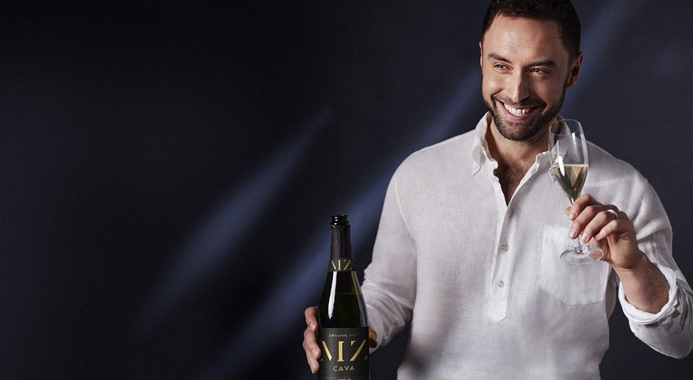

**Popular artist Måns Zelmerlöw launches own Cava**

Music artist, tv host and winner of the Eurovision Song Contest Måns Zelmerlöw launches his own Cava: Hola MZ Cava by Måns Zelmerlöw – a dry, crisp and fruity Cava that is both organic and vegan. As of Feb. 10, the Cava will be available in Systembolaget’s order assortment.

Launching a Cava was an obvious choice for Måns, as Spain is his great source of inspiration when it comes to both food and wine. For a while, Måns lived parttime in Barcelona where he spent a lot of time writing music and enjoying the culture, the weather, the relaxed lifestyle and the people. In Spain, his already great interest in food and drink developed even further.

*– After a few weeks in Barcelona, I began finding my way to restaurants that the locals went to, and I had my first “real” tapas experiences. We would sit there for hours and order dish after dish, drinking Cava late into the night and just enjoying ourselves. With an enormous love for Barcelona in particular, as well as its surrounding nature, I find it incredibly exciting to have had the opportunity to create a Cava together with Hermansson & Co and the producer Barcelona Brands S.L, says Måns Zelmerlöw.*

Cava is made with same traditional method used to produce champagne in France, which means the secondary fermentation takes place in the bottle. In Spain there are six regions that produce Cava, and the grapes used are Macabeo, Parellada and Xarel-lo. Barcelona Brands S.L is a renowned wine producer with a focus on origin, craftsmanship and sustainability. The vines in Penedes grow some 500 meters above sea level and the grapes are harvested by hand.

**Vegan and organic brut**

Hola MZ Cava by Måns Zelmerlöw combines the freshness of white fruits, such as apple, pear and citrus, with a finely tuned toasty bread scent that is a result of the Cava resting on lees for 18 months. The Cava has a rich mousse with persistent bubbles. Hola MZ Cava by Måns Zelmerlöw is a brut with a sugar content of only 9.2 g/l that is both organic and vegan. The Cava may be enjoyed as it is, with or without food, but is best served at 5-6 degrees C as a social drink or paired with seafood dishes.

*– Working with Måns has been incredibly fun. We knew of his connection to Spain but were really impressed by his knowledge and interest in both food and wine. Putting your signature on a wine is a commitment, and this is a complex, delicious and tasty Cava that represents Måns’s Barcelona, says Malin Lindberg, Senior Brand Manager at Hermansson & Co.*

Hola MZ Cava by Måns Zelmerlöw (no. 50260) costs SEK 99 and is available in Systembolaget’s order assortment.

*– I am extremely happy with my Cava. It is absolutely delicious! Not too sweet, not too dry, and it goes well with almost everything, whether as a social drink or paired with a feast, Måns concludes.*

/facts/

**Hola MZ Cava by Måns Zelmerlöw:**

Article no: 50260

Alcohol: 11.5 %

Grapes: 30 % Xarel-lo, 40 % Macabeo, 30 % Parellada

Color: A clear, light yellow color. Lots of persistent bubbles

Aroma: An extremely fruity, crisp and intense aroma with notes of green apples, pears, minerals and citrus. There are also hints of a finely tuned, toasty and bready aroma, which is a result of the Cava resting on lees for 18 months.

Taste: A fresh, appetizing and balanced taste. Intense fruity notes with hints of green apples, pears, minerals and citrus. Rich mousse and lots of lasting bubbles.

Suitable for: Best served at 5-6 degrees C, as a stand-alone social drink or paired with seafood dishes.