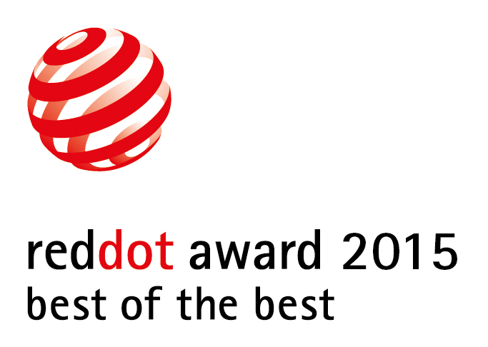

Plotagon wins international Red Dot Award 2015 – “Best of the Best” for its innovative social communication’s app

Stockholm, Sweden—November 9, 2015—Plotagon has been awarded an international Red Dot Award 2015 Best of the Best Award in Communication Design for its one-of-a-kind animation app.

The Plotagon app is all about being creative, having fun and expressing yourself in different forms – through, animated selfies, messages, personal emojis, greetings, short stories (plots) and maybe most importantly, with your own characters (+6M combination and growing), then you share those creations on social media. It runs on iPhone, iPad, Mac and PC and will shortly be available on Android.

For decades, the Design Zentrum Nordrhein Westfalen in Essen, Germany (one of the oldest design institutions in Europe) has been awarding the coveted Red Dot to recognize excellence in design. Plotagon was named one of 80 Best of the Best winners out of 7,451 entries submitted from 53 countries.

The statement by the jury reads: “Plotagon is an outstanding tool with a very easy-to-use interface for creating instant movie sequences and then sharing them. It even allows for creating and editing films together with other users, which is additional fun and augments the experience of creative collaboration. Telling great stories and being able to access free content offered by other users in doing so, opens up an innovative approach towards sharing and collaboration.”

This is Plotagon’s fourth major accolade since the app debuted in July 2014. Most recently, in November 2015, Plotagon was featured on the Apple App Store as one of the “Best New Apps” in 24 countries. In addition, Plotagon was immediately upon launch in 2014, named one of the “Best New Apps” by the Apple App Store in over 100 countries. In October 2014, it was recognized in the Fast Company 2014 Innovation By Design Awards alongside brands such as Disney, Google, and Nike for creating “innovative and disruptive design solutions.”

Plotagon has continued to innovate, adding many new items in the Character Creator, scenes and features. Recently, Plotagon added a very sought after feature, Voice Recording, making videos even more fun by allowing users to record their own voices. Boosting the personal experience, user may use their own animated characters in videos and messages that they have built in the Character Creator, by choosing from a variety of facial features, hair, clothing and more. Users can even create themselves as animated characters with fun expressions and share them as selfies or avatars.

-more-

Plotagon’s consumer app is free to download and it includes several characters and scenes, along with the Character Creator and Voice Recording. Music, sound effects and character emotions are free as well. Additional scenes and characters may be added via in-app purchases; the majority at only $.99 to $1.99 each.

Plotagon was founded in 2011. It is headquartered in Stockholm, Sweden.
###
Read The Red Dot Award 2015 full presentation: http://red-dot.de/cd/de/online-exhibition/work/?code=11-00610&y=2015&c=204&a=0

Download Plotagon’s app at: https://plotagon.com/download

Photos, video and background information: http://bit.ly/plotagonnews

Plotagon and Plotagon Education support users and share ideas at:
Twitter.com/Plotagon
Facebook.com/Plotagon
Instagram.com/PlotagonOfficial
Plotagon.Tumblr.com
Google+

