
News Release
Allison Transmission Asia Pacific
Communications
Shanghai, China

Allison changes transport patterns at Boral

Boral Transport benefits from reduced trip times and improved reliability with Allison fully automatic transmissions in their new fleet of heavy duty Western Star trucks.
Sydney, Australia - One of Australia’s largest building products companies, Boral Limited, is using Allison fully automatic transmission technology to lower trip times, improve truck uptime and operate more efficiently.
“Our Allison fully automatic equipped trucks are proving to be better in city traffic than automated manuals, with improved trip times coming as a result of quicker acceleration off the mark and an ability to keep up with traffic flow,” comments Merv Rowlands, Boral Transport’s fleet engineering manager.
“We can have two identically laden trucks leave a quarry 100km north of Sydney at the same time travelling together on the F3 Freeway. When they hit the edge of the metro area at Hornsby, the Allison equipped truck really shows its acceleration advantages, leaving its competitor behind,” he added.
Boral operates hundreds of heavy trucks across Australia in a range of configurations including prime movers hauling tippers, powder tankers, bitumen tankers, tipper dog units, and concrete agitators. The company has historically specified Allison transmissions in its large fleet of concrete agitators; however, it had never used Allison equipped heavy duty trucks with gross vehicle weights in excess of 42 tonnes.
In 2009, Boral purchased three Western Star 4800FX tipper dog vehicles equipped with Allison 4500 Series transmissions to trial the trucks in day to day city-based operations. The availability of the Allison 4500 series as a standard option with Western Stars was a significant factor in their choice by Boral as a preferred supplier of heavy vehicles. Following the success of those trials, the company has added five more Allison equipped Western Star tipper dog vehicles in the first six months of this year.
Rowlands notes that problems with the reliability of automated manual gearboxes in its truck fleet also gave the company reason to look at the latest generation of fully automatic Allison transmissions for heavy trucks.
“We were eager to try Allison transmissions in city-based vehicles because of our extensive experience with them in agitator trucks over many years and the great success we had with a recent retrofit into a tipper & dog vehicle,” said Rowlands.
“We always wanted to run these trucks with two different shift patterns to allow us to maximise efficiency when the vehicles were running unladen. Initially we did this by interfacing with our onboard load sensing equipment which could identify whether the truck was loaded or not and switch the shift program accordingly,” he added.
“Allison’s engineering team then suggested we try the LBSS program, and it worked well, which has led us to use it across all of our Allison equipped trucks.” Allison’s LBSS (Load Based Shift Scheduling) adjusts the transmission shift schedule to best match the current vehicle load and operating conditions. This is achieved by monitoring vehicle throttle/engine torque demand and the vehicle acceleration rate. When light load conditions are identified, shifts are adjusted to ensure engine RPM is maintained at the most efficient point. When load is increased or grades are encountered, the shift schedule is adjusted to provide the operator with maximum performance.
A large segment of the Boral tipper dog fleet is based in the western suburbs of Sydney, but this part of the fleet operates all across the metropolitan area and travels to and from quarries up to 100km from the city, meaning that a flexible and versatile shift pattern is vital for efficiency.
”Reduced trip time, zero downtime, improved driver comfort and safety and outstanding performance both laden and unladen are all advantages with the Allison equipped trucks,” concludes Mr. Rowlands.
August, 2010
Overview: Western Star 4800FX, year of manufacture 2009
Type | Western Star 4800 FX
Engine performance | 350 kW (475 PS)
Gross vehicle weight | 48 tonnes
Registration date | 01.06.2009
Mileage (as at July 2010) | 94,100 kms
Operating hours (as at July 2010) | 2,330 hours
Transmission | Allison 4500 Series
Maximum input torque gross | 2237 Nm
Maximum input power gross | 372 kW (505 PS)
About Boral Limited
Boral is one of Australia’s largest building products and construction materials companies, with many divisions and businesses. Boral Concrete operates more than 700 company owned agitator trucks around Australia, the majority of which are equipped with Allison automatics while the Boral Transport’s NSW fleet alone numbers some 140 tipper dogs and tanker prime mover units.

A vertically integrated business sees Boral producing it own cement and quarry products that supply its concrete and asphalt operations. Boral Transport is a transport and logistics business that delivers most of these bulk raw materials between the businesses sites in addition to servicing a wide range of third party customers.

About Allison Transmission, Inc.
Allison Transmission, Inc. (Allison) is the premier global provider of commercial duty automatic transmissions and hybrid propulsion systems. Allison products are specified by over 250 of the world’s leading vehicle manufacturers and are used in many market sectors including bus, refuse, fire, construction, distribution, military and specialty applications. Founded in 1915, the Allison business is headquartered in Indianapolis, Indiana, U.S.A. and employs approximately 3,000 people. Regional headquarters with dedicated support staff are located in China, The Netherlands, Brazil, India and Japan. With a global presence in 80 countries, Allison has over 1,550 distributor and dealer locations. More information about Allison is available at www.allisontransmission.com.

###

Media Enquiries

Jon Thomson or Paula Chen
Thomson Produtions Pty Ltd Allison Transmission
5 Christopher Place Beacon Hill NSW 2100 Asia Pacific Communications
Australia Beijing, China
Phone: +61(2) 9452-3390 Phone: +86 (10) 6468-6800-8805
Email: info@thomsonpr.com.au Email: paula.chen@allisontransmission.com

Photographs
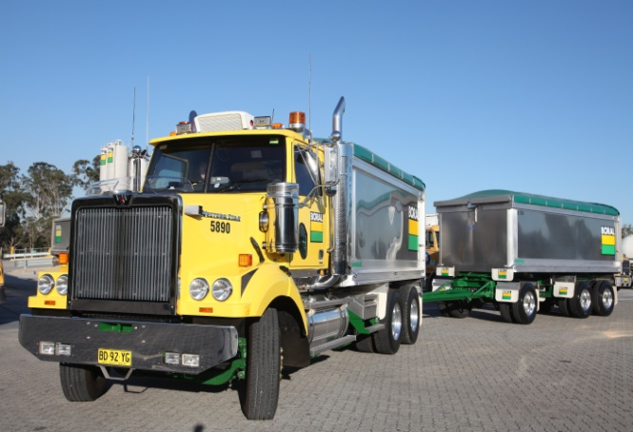  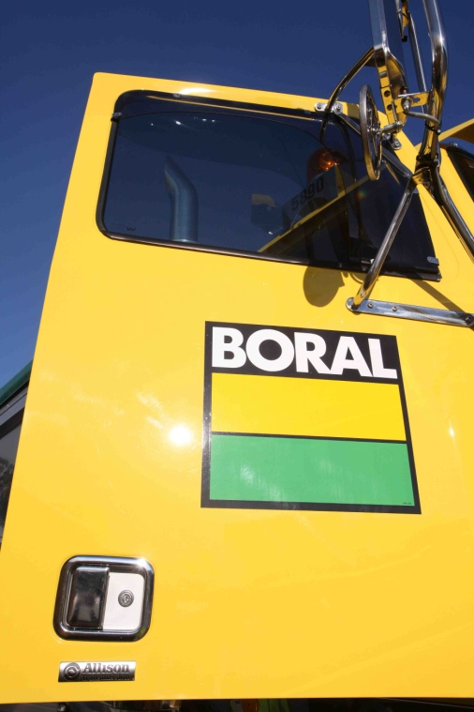 | Boral Transport chose the Western Star 4800FX because it offers the Allison 4500 Series fully automatic transmission.  Boral has utilised Allison’s technical support to implement Load Based Shift Scheduling (LBSS) to ensure the most efficient operation of the truck whether it is loaded or unloaded.

