Expansion of the global long-distance bus network: FlixMobility acquires Greyhound in the US

++ Addresses significant opportunity from increased U.S. demand for affordable, sustainable, collective mobility
++ Recent funding round paves way for FlixMobility to lead global green mobility revolution

Dallas/Munich (October 21, 2021) – FlixMobility (“the Company”), global mobility provider of the FlixBus and FlixTrain brands, announced today it has acquired Greyhound Lines, Inc. (“Greyhound”), the largest provider of long-distance bus transportation in the United States, from FirstGroup plc. This acquisition marks another important step in FlixMobility’s vision to provide easy-to-use, affordable, and environmentally friendly travel for consumers across the globe.

The FlixBus Global network serves over 2,500 destinations in 36 countries outside US with 400,000 daily connections. Greyhound currently connects approximately 2,400 destinations across North America with nearly 16 million passengers each year.

Long-distance buses are crucial for a sustainable mobility revolution worldwide thanks to their excellent environmental performance in terms of CO2 emissions. FlixMobility's recent funding round is a clear sign of its commitment to a green future. Through the acquisition of Greyhound, FlixMobility is moving significantly closer to its vision of making green and affordable travel accessible to everyone.

André Schwämmlein, Founder and Chief Executive Officer of FlixMobility, said, “Consumers across North America are increasingly seeking affordable, comfortable, smart and sustainable mobility solutions. A compelling offering will draw significantly more travelers away from private cars to shared intercity bus mobility. Together, FlixBus and Greyhound will meet this increased demand. As our business continues to recover from the effects of the pandemic, we will replicate the success that we have already achieved in 37 countries with our innovative and customer centric approach.”

Jochen Engert, Founder and Chief Executive Officer of FlixMobility, commented, “The continuous expansion of our network through partnerships and acquisitions has always been an integral part of our growth strategy to build our global presence. The acquisition of Greyhound is a major step forward and strengthens FlixBus´ position in the US. The FlixBus and Greyhound teams share a common vision to make smart, affordable and sustainable mobility accessible to all."

David Martin, Executive Chairman, FirstGroup plc said: “The sale of Greyhound to FlixMobility is part of our portfolio rationalization strategy to refocus FirstGroup on its leading UK public transport businesses. The strength of Greyhound is its people, and I would like to thank them for their unwavering commitment to their customers and communities. As part of FlixMobility, I am confident that Greyhound will be well placed to continue to grow and develop their iconic services for many years to come.”

FirstGroup has reached agreement with Neptune Holding Inc. (the 'Buyer'), a corporation 100% controlled by FlixMobility, to sell Greyhound Lines, Inc., the US Greyhound operating business (including its vehicle fleet, trademarks, and certain other assets and liabilities) for an enterprise value on a debt-free / cash-free basis of c.$46m plus unconditional deferred consideration of $32m with an interest rate of 5% per annum.
https://www.firstbus.co.uk/

Over the past eight years, the company has demonstrated significant success, with FlixBus growing to become Europe’s largest intercity bus network, helping more than 62 million people in 2019 reach their destinations. The acquisition of Greyhound marks a significant milestone in FlixMobility’s global expansion strategy, a critical driver of the Company’s future growth.

FlixBus USA launched in 2018 with destinations across the Southwest, including Los Angeles, CA, Las Vegas, NV, and Phoenix, AZ. Since then, the Company has expanded its operations to facilitate travel between additional cities in the Southwest, South, Northeast and Pacific Northwest.

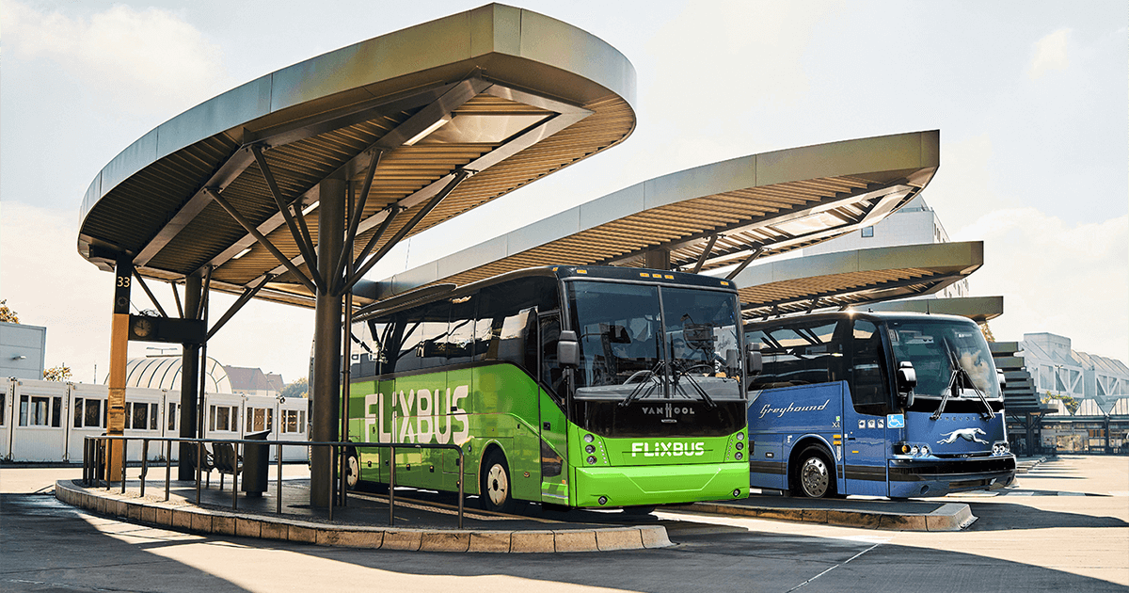

About FlixMobility

FlixMobility is mobility provider, offering new alternatives for convenient, affordable and environmentally friendly travel via the FlixBus and FlixTrain brands. With a unique approach and innovative technology, the company has quickly established Europe's largest long-distance bus network and launched the first green long-distance trains in 2018 as well
as a pilot project for all-electric buses in Germany, the US and France. Since 2013, FlixMobility has changed the way hundreds of millions of people have traveled throughout Europe and created tens of thousands of new jobs in the mobility industry. In 2018, FlixMobility launched FlixBus USA to bring this new travel alternative to the United States.

From locations throughout Europe and the United States, the FlixTeam handles technology development, network planning, operations control, marketing & sales, quality management and continuous product expansion. The daily scheduled service and green FlixBus fleet is managed by bus partners from regional SMEs, while FlixTrain operates in cooperation with private train companies. Through these partnerships, innovation, entrepreneurial spirit, and a strong international brand meet the experience and quality of tradition. The unique combination of technology start-up, e-commerce platform and classic transport company has positioned FlixMobility as a leader against major international corporations, permanently changing the European mobility landscape. For more information, visit https://corporate.flixbus.com/

###

