HUGIN AUV scoops top-three Technology & Innovation category prize in the 2020 AUVSI XCELLENCE Awards
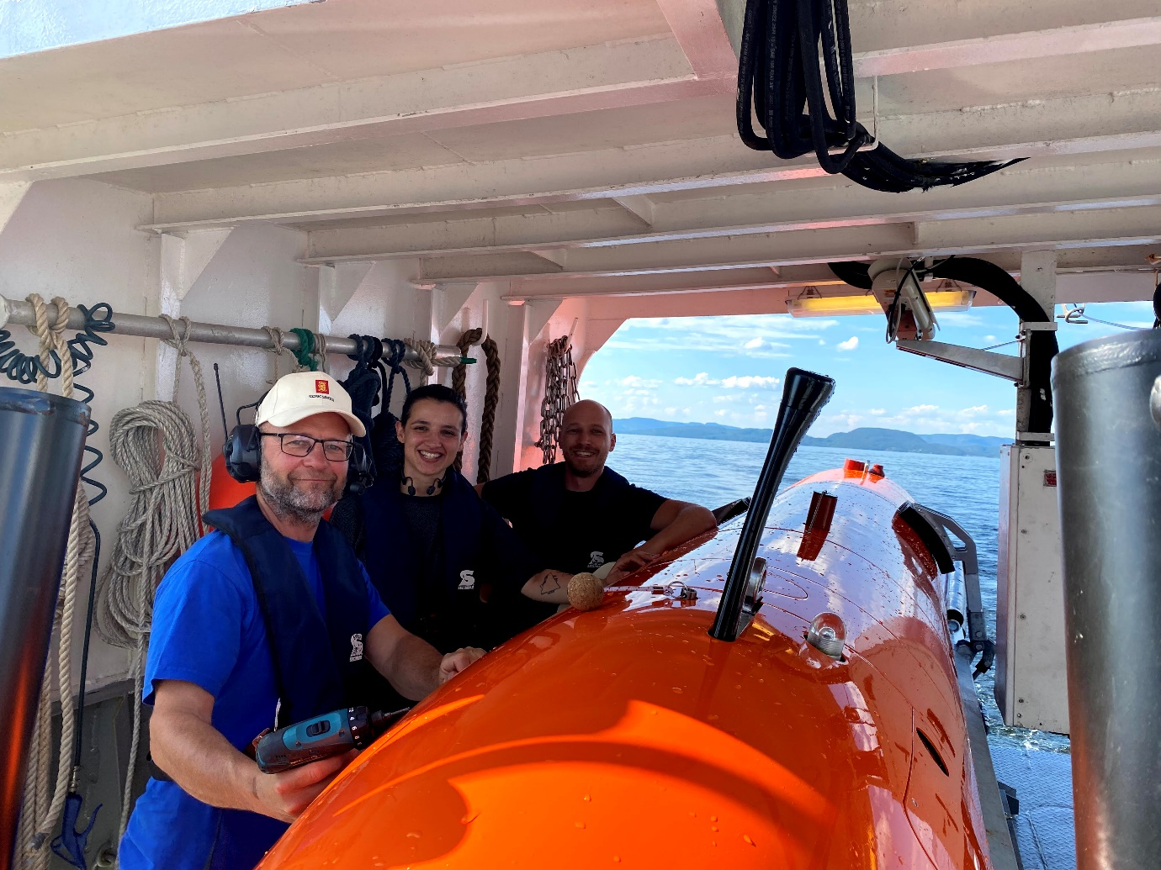
The Kongsberg Maritime team with the HUGIN AUV, a worthy 2020 AUVSI XCELLENCE third-prize winner
Kongsberg, Norway, 5th October 2020 – Kongsberg Maritime (KM) is happy to announce that its HUGIN AUV (Autonomous Underwater Vehicle) has scored a significant top-three prize in the 2020 AUVSI XCELLENCE awards.
Highly prized throughout the maritime industry, the AUVSI (Association for Unmanned Vehicles Systems International) XCELLENCE awards recognize “…innovators committed to advancing autonomy, leading and promoting safe adoption of unmanned systems, and developing programs [using] these technologies to save lives and improve the human condition.” KM’s HUGIN AUV accordingly came a commendable third in the Hardware – Platform group award in the Technology & Innovation category. A special AUVSI XPONENTIAL award presentation will be streamed via the show’s immersive virtual event platform on Tuesday, October 6.
Originally shortlisted back in June 2020, the next-generation HUGIN Superior AUV is the result of almost three decades of evolution, refinement, modifications and collaborative input from active users. In the intervening years since the first HUGIN dive took place in May 1993, these highly adaptable multipurpose sensor platforms have surveyed more than a million line kilometres of subsurface environments for a variety of scientific, commercial and defence applications across the globe. Capable of carrying and managing a payload consisting of more than 10 imaging, profiling and acoustic mapping sensors simultaneously, the HUGIN AUV’s common hardware routinely fulfils a variety of complex duties ranging from geophysical surveying, inspection of undersea structures and environmental impact studies to ISR (Intelligence, Surveillance & Reconnaissance) and MCM (Mine Countermeasures) tasks.
With its rewritten and enhanced in-situ navigation algorithms, the HUGIN Superior AUV is rated to depths of 6,000m and features advanced adaptive autonomy capabilities that enable it to react to its immediate surroundings, avoiding obstacles and/or altering protocols as it tracks along its mission path. Fitted with more high-quality sensors than ever before, it can cover up to 4.5 square kilometres per hour, producing imagery and bathymetry with better than 5 x 5cm resolution, and provides the best-possible data capture and transfer functionality. Meanwhile, in-mission processing of this data reduces post-mission workload and turnaround times. Requiring less supervision and boasting a 30% increase in mission endurance, the HUGIN Superior’s specifications contribute to an overall improvement in productivity and reduce the total cost of ownership.
“Winning a top-three placing in this AUVSI XCELLENCE award category is not just a welcome vindication of the HUGIN Superior AUV’s abilities, but also of its implications as a key ally in the ongoing custodianship of our oceans,” says Richard Mills, VP Marine Robotics Sales, Kongsberg Maritime. “In addition to the assistance it will provide to various organisations in support of the Seabed 2030 mission to map every inch of the ocean floor within the next decade, the detailed data it accumulates is indispensable for reinforcing the long-term security and sustainability of marine environments. We’re very grateful to have achieved this recognition from AUVSI.”
“The HUGIN Superior AUV amply deserves its status as one of the leading products in the Hardware – Platform group," adds Brian Wynne, President and CEO of AUVSI. “This year’s challenging circumstances have only highlighted the importance of deploying the highest-quality research tools to build understanding of the precarious, interconnected ecosystems which govern our world, and ways in which we can limit our impacts upon them.”
For more information about XPONENTIAL and the AUVSI XCELLENCE Awards, visit xponential.org.
Ends

For further information, please contact:
Gunvor Hatling Midtbø, VP Communication
Kongsberg Maritime
Tel: +47 9921 4209
gunvor.hatling.midtbo@km.kongsberg.com
David Pugh
Saltwater Stone
Tel: +44 (0)1202 669244
d.pugh@saltwater-stone.com

About Kongsberg Maritime
Kongsberg Maritime is a global marine technology company providing innovative and reliable ‘Full Picture’ technology solutions for all marine industry sectors including merchant, offshore, cruise, subsea and naval. Headquartered in Kongsberg, Norway, Kongsberg Maritime has manufacturing, sales and service facilities in 34 countries.
Kongsberg Maritime solutions cover all aspects of marine automation, safety, manoeuvring, navigation, and dynamic positioning as well as energy management, deck handling and propulsion systems, and ship design services. Subsea solutions include single and multibeam echo sounders, sonars, AUV and USV, underwater navigation and communication systems.
Training courses at locations globally, LNG solutions, information management, position reference systems and technology for seismic and drilling operations are also part of the company’s diverse technology portfolio. Additionally, Kongsberg Maritime provides services within EIT (Electro, Instrument & Telecom) engineering and system integration, on an EPC (Engineering, Procurement & Construction) basis.
Kongsberg Maritime is part of Kongsberg Gruppen (KONGSBERG), an international, knowledge-based group that celebrated 200 years in business during 2014. KONGSBERG supplies high-technology systems and solutions to customers in the oil and gas industry, the merchant marine, and the defence and aerospace industries.
Web: Kongsberg Gruppen | Kongsberg Maritime
Social media: LinkedIn | Twitter | Facebook
About AUVSI
The Association for Unmanned Vehicle Systems International (AUVSI)—the world's largest non-profit organization dedicated to the advancement of unmanned systems and robotics—represents corporations and professionals from more than 60 countries involved in industry, government and academia. AUVSI members work in the defense, civil and commercial markets. For more information, visit AUVSI.org.
About XPONENTIAL
AUVSI XPONENTIAL is the largest, most significant event for the unmanned systems industry. The 2020 exhibit hall will showcase hundreds of cutting-edge companies from around the world and the conference will feature educational programming by unmanned systems experts, providing information about the future of policy, technology and business solutions and trending topics.

