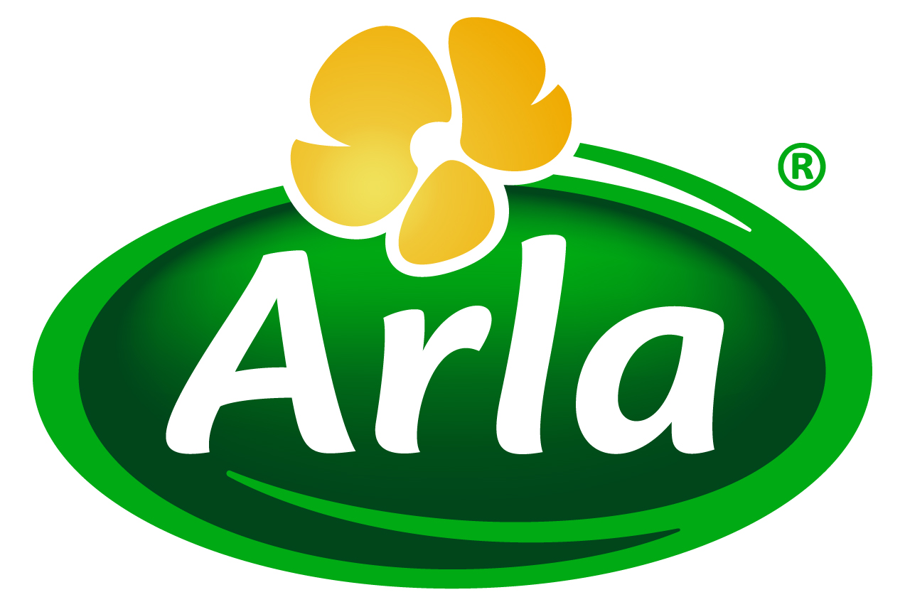

24 September 2013

PRESS RELEASE – FIE 2013 PREVIEW

Arla Foods Ingredients puts Natural Improvers
for bakers in the spotlight
Food Ingredients Europe, Messe Frankfurt, 19-21 November 2013 – Stand 8C01

Arla Foods Ingredients’ Nutrilac® Natural Improvers for bakers will take centre-stage at the forthcoming Food Ingredients Europe 2013.
Nutrilac® Natural Improvers are a ground-breaking ‘toolbox’ of natural improvement solutions offering bakers optimised production processes, better quality end-products, reduced waste and cleaner labels – all at the same time.
The Nutrilac® Natural Improvers range is an innovative portfolio of multi-functional ingredients offering targeted benefits for producers of bread, cakes, biscuits & cookies and bakery fillings. All are made from natural and functional proteins derived exclusively from milk and can be listed on-pack simply as ‘milk protein’.
The new ingredients are designed to provide industrial bakers with smoother and more efficient processes, promising easier handling of dough, batters and fillings. They also provide excellent stability, with the ability to lock in the air whipped into batters and the water kneaded into dough, resulting in optimum freshness, texture and resilience throughout a product’s shelf life.
There are four launch products in Arla Foods Ingredients’ Nutrilac® Natural Improvers toolbox, each offering specific benefits designed to meet the majority of bakers’ needs:
- Nutrilac® CH-4650 – ensures a much more stable batter with better mixing tolerance, enhances cake surfaces by reducing stickiness, improves colour and appearance in cakes, and optimises creaminess by imitating fat in custard cream and other types of filling.
- Nutrilac® IM-5566 – provides softness in bread without reducing crumb resilience or elasticity, offers increased strength in cakes for better slicing quality, and stabilises aerated batter systems for higher volume and stability.
- Nutrilac® IM-7042 – offers improved mixing tolerance, produces a more stable batter and provides superb emulsification properties in a whole range of wheat-based baked goods, including bread.
- Nutrilac® IM-8027 – a high-gelling protein designed to create excellent structure and strength in baked goods, providing optimum viscosity in most batter systems, greater water retention and excellent emulsification.
Allan Vangsgaard, Technical Sales Manager at Arla Foods Ingredients, said: “Our new Nutrilac® Natural Improvers offer bakers a huge variety of benefits that meet a comprehensive range of production needs, including optimised processes, better product quality and reduced wastage. They will appeal to consumers, too, because they will result in a healthier product with a cleaner label, free of the e-numbers and chemical names used for other improvement additives.”
He added: “Nutrilac® Natural Improvers are truly innovative and the first ingredients of their kind. As such, they offer bakers the opportunity to produce perfect products every time and gain a genuine edge over the competition.”
Exhibiting on Stand 8C01, Arla Foods Ingredients’ friendly and knowledgeable representatives will be on hand to discuss with visitors how dairy proteins can enhance their products and processes and give them a significant edge on their competitors.

ENDS

For more information, images or to arrange an interview with an Arla Foods Ingredients representative on this subject, please contact:

Miranda Mills, Ingredient Communications
Tel: +44 207 193 4167
Email: Miranda.mills@ingredientcommunications.com

About Arla Foods Ingredients
Arla Foods Ingredients is a leading developer and supplier of nutritional and functional milk-based ingredients to the global food industry. The company operates production facilities in Denmark, Sweden, Argentina and Germany, application centres in Denmark and Argentina, and a worldwide network of sales offices. Arla Foods Ingredients is a subsidiary of Arla Foods, one of Europe’s principal dairy groups.

RSS Feed
Visit our website at www.arlafoodsingredients.com/news and sign up to our News RSS feed for all the latest developments – updated regularly.

Twitter
Follow us on twitter for all the latest updates @ArlaIngredients

