TREKKING WITH HAGLÖFS’ EDGE EVO ANORAK

(Stockholm August 2019) For more than a century, Haglöfs has developed outstanding outdoor products that combine a strong sense of Swedish heritage with a commitment to sustainability and innovation. For Fall / Winter 2019 there’s no exception, in the new collection we find the perfect trekking piece, Edge Evo Anorak.

Edge Evo Anorak continues to build on the brand’s promise to never settle and keep improving their products. The anorak is built to a truly iconic design, with extra length for added protection and loaded with technical features.

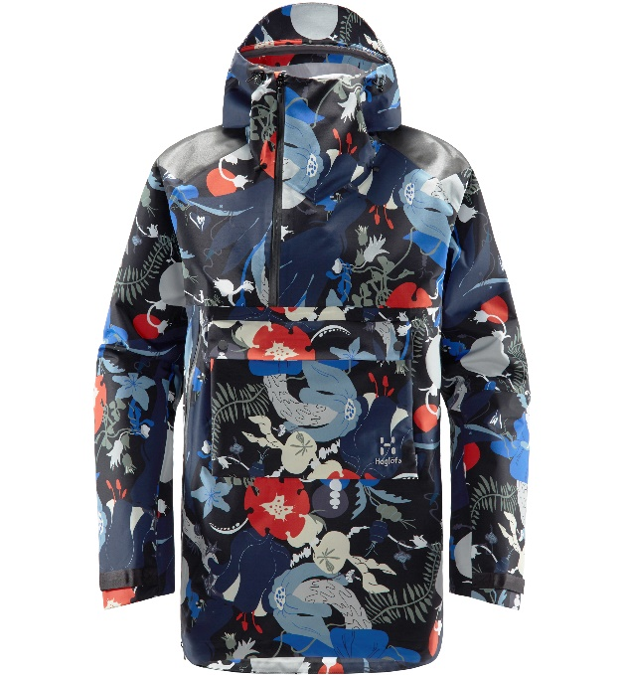It is made from a robust and protective 3-layer PROOF™ ECO fabric. that protects you from the elements with its full water- and wind proofing. The Edge Evo Anorak can easily transition from the rugged outdoors to the everyday urban commute.

The Edge Evo Anorak also embodies the brands heritage, available in three different colorings, ‘Dense blue’, ‘True black’ and a limited edition with the Kurbits inspired pattern. Kurbits is a traditional folk art found in Dalarna, Sweden – which is the birthplace of Haglöfs’ founder and where the first stiches of a Haglöfs product were made. The range’s color palette was developed with the local artist Carl Larsson in mind.

The implementation of their own PROOF™ membrane and smart details makes this heritage piece also an outstanding performance jacket. Haglöfs’ PROOF™ ECO fabrics is made from fluorocarbon free materials that are bluesign® approved and/or recycled. The Edge Evo Anorak delivers balanced performance, a lower impact on the environment and good wearer comfort throughout the day.

The Edge Evo Anorak comes in a unisex size range S-XXL and will be available from early Fall 2019, in Haglöfs’ own stores and online, as well as through selected retailers worldwide. Estimated retail price is 330 €.

For more information, please contact:

Lisa Grübb  
Publishing Coordinator  
[lisa.grubb@haglofs.se](mailto:lisa.grubb@haglofs.se)  
+468 121 362 61

EDGE EVO ANORAK – FACT SHEET

* Fabric: PROOF™ ECO 3-layer 100% recycled Nylon, rugged, dull, big-square ripstop weave face, laminated to a microporous Polyurethane membrane and a tricot backer 187 g/m², bluesign® approved
* Hydrostatic head: >15,000 mm; Moisture Permeability (inverted cup): >15,000 g/m²/24h
* Treated with a fluorocarbon-free DWR to protect from water and dirt
* Reinforced shoulders for extra durability while wearing backpack
* Adjustable hood for great protection against rain and wind
* VELCRO® brand adjustable cuffs Long front and side zipper - easy to get on and off
* Elastic cord waist adjustment for a customized fit
* Large front pocket with zipper and flap
* Cord-adjustable lower hem
* Centre back length 84.8 cm (men's size L)
* Weight: 675 G (SIZE L)