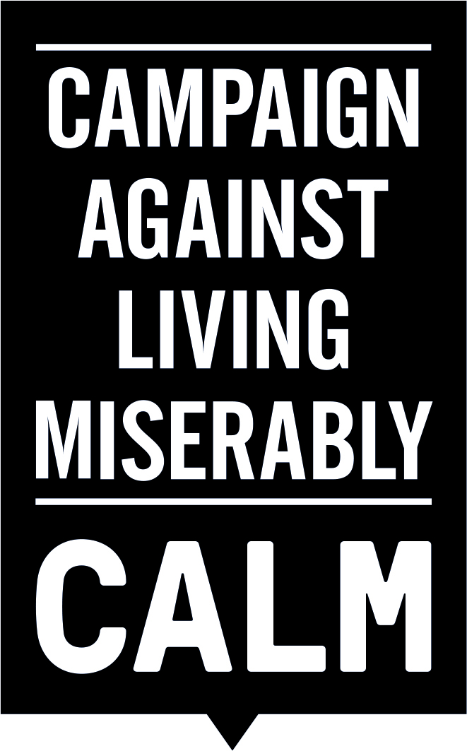

Press Release from CALM
Release time: Immediate

Government failing to tackle male suicide, warn more than 30 top charities

- More than 30 Suicide prevention charities urge Government to adopt four point plan
- MPs mark International Men’s Day with historic Commons debate
- Suicide biggest single killer of men aged under 45

The Government is failing to tackle the male epidemic, warn top suicide prevention charities.

The warning comes ahead of an historic Parliamentary debate to mark International Men’s Day on Thursday 19th November.

The three-hour cross-party debate, secured by veteran MP Philip Davies, will see issues that adversely affect men, such as male suicide debated in the House of Commons for the first time.

The charities are calling on the Government to overhaul how suicides are prevented in the UK and urge them to treat suicide as a major public health issue.

Writing to Members of Parliament ahead of the debate, the charities said: “We believe that four simple changes can make a difference to what are preventable deaths:-

- Count – We need timely and accurate information to enable agencies to respond better. At the moment it can take up to two years to obtain an estimate of suicide numbers. We have a significant concern these are under-reported.
- Contain – According to the World Health Organisation and over 50 research papers, there is a strong element of contagion with regard to suicide. We should treat it so and respond and support those impacted by suicide to prevent further loss of life, consequent illness, family breakup and job loss.
- Enforce – All local authorities need to develop and implement a suicide prevention plan. Those that do not should be named and shamed.
- Accountability – If national and local suicide prevention plans are to be effective there must be accountability.

The document, prepared by the Campaign Against Living Miserable is backed by more than 30 leading suicide prevention charities including Samaritans, National Suicide Prevention Alliance, Rethink Mental Illness, Papyrus Prevention of Young Suicide, Suicide Bereavement Support Partnership, Movember, The Helplines Partnership and British Psychological Society.

Jane Powell, Chief Executive of CALM, commented: “Every year thousands of men take their lives, more than 4,600 last year alone. Yet the way we respond to each incident has change little over the last four decades.

“It can take up to two years to get a national picture, and even then we are concerned about under-reporting. The issue of contagion is well-documented, but there are no national plans to act to ‘contain’ the issue and support those impacted by or enforce suicide prevention plans across the country.”

Parliament’s decision to hold the debate comes in the wake of a major new poll, which laid bare the scale of this “suicide epidemic” affecting men. The poll found that more than four in 10 men (42 per cent) say they have had suicidal thoughts, with two fifths (41 per cent) never talking to anyone about their problems.

The YouGov survey of more than 2000 men found half (49 per cent) of those who did not seek help “didn’t want people to worry about me”. While a third (32 per cent) felt ashamed, nearly four in 10 (37 per cent), did not want to make a fuss and four in 10 (43 per cent) didn’t want to talk about their feelings.

The debate will take place today in Westminster Hall, House of Commons, to mark International Men’s Day (19th November) starting at 1.30pm.

Ms Powell concluded: “We hope that Members of Parliament will use this historic debate to raise awareness of this problem, in discussing the solutions and breaking down the stigma that prevents too many men from seeking help.

“A good start would be adopting the four simple changes we have outlined in our briefing document we have just published. These changes would start the revolution we need if we are going to finally tackle male suicide.”
ENDS

Notes to editors:
About CALM

The Campaign Against Living Miserably, CALM, is an award winning charity dedicated to preventing male suicide in the UK. Founded in 2006 the charity seeks to prevent suicide by providing a service for men who are down or in crisis, and by fomenting cultural change so that any man considering suicide feels able to seek help.

CALM supporters and advocates include the likes of David Baddiel and Professor Green, Dizzee Rascal and Frank Turner, and its offbeat brand and challenging advertising have proven effective in reaching men across the UK. In the past 12 months, CALM has taken over 40,000 callers via its helpline and webchat. CALM’s free, confidential accredited helpline and webchat service are available every day of the week from 5pm to midnight, staffed by professionals, on 0800 585858 (national) 0808 802 5858 (London) and www.thecalmzone.net.

CALM is reg. charity no. 1110621

YouGov interviewed 2,142 UK men aged 18-45 years of age. All YouGov fieldwork was undertaken between 14th - 20th October 2015 and between 15th-16th October 2015. The surveys were carried out online. The figures have been weighted and are representative of all UK adults (aged 18+) and of all GB adults (aged 16+).

For further information on the campaign, interviews or case studies please contact Grace Henwood or Nikki Guest at W: CALMxLYNX@wcommunications.co.uk // 07813 156 965 // 07828 040 605 or Alistair Thompson at Media Intelligence Partners // Alistair@mippr.co.uk //07970 162 225

Or visit www.biggerissues.co.uk or www.thecalmzone.net

