

**THE BLACK KEYS ANNOUNCE 11th STUDIO ALBUM,**

***DROPOUT BOOGIE*,OUT MAY 13 ON NONESUCH**

**FIRST SINGLE “WILD CHILD” + VIDEO OUT TODAY**

***Dropout Boogie* Features Collaborations with Billy F. Gibbons, and Greg Cartwright**

**32-DATE NORTH AMERICAN HEADLINING TOUR ON SALE NOW**

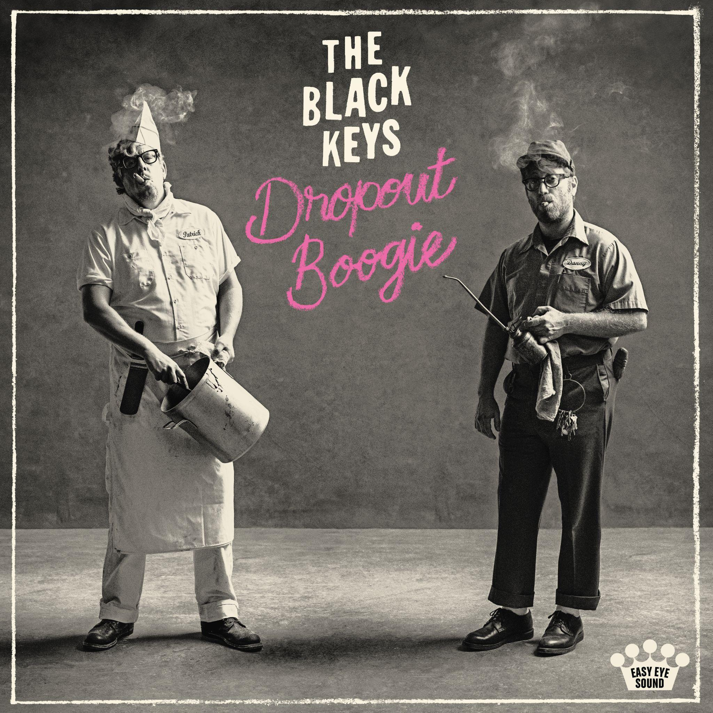

**Download high-res album art** [**here**](https://drive.google.com/file/d/1EDM5HhQcniUU2azMC-otLW1SooYW9l52/view?usp=sharing)

**March 10, 2022 -** After 10 albums, the last five of which have gone top 10 or better, six Grammy awards, and sold-out tours around the world, The Black Keys are back: The duo, called “America’s Most Trusted Band” by Stephen Colbert, and “one of the best rock’n’roll bands on the planet” by *Uncut*, releases its eleventh studio album, *Dropout Boogie*, on May 13 via Nonesuch Records. The first single, “Wild Child,” is out today along with a video directed by the band’s longtime collaborator Bryan Schlam. *Dropout Boogie* features collaborations with Billy F. Gibbons (ZZ Top), Greg Cartwright (Reigning Sound), and Angelo Petraglia (Kings of Leon).

[**Watch the Video Here**](https://theblackkeys.lnk.to/WildChildVideo)

*Dropout Boogie* will be released one day before the twentieth anniversary of The Black Keys’ first album, *The Big Come Up*. As they have done their entire career, the duo of Dan Auerbach and Patrick Carney wrote all of the material in the studio, and the new album captures a number of first takes that hark back to the stripped-down blues rock of their early days making music together in Akron, Ohio basements.

“That’s always been the beauty of the thing Pat and I do. It’s instant,” Auerbach says. “We’ve never really had to work at it. Whenever we’d get together, we’d just make music, you know? We didn’t know what we were going to do, but we’d just do it and it would sound cool. It’s the natural chemistry Pat and I have. Being in a band this long is a testament to that. It was a real gift that we were given. I mean, the odds of being plopped down a block-and-a-half from each other in Akron, Ohio–it just seems crazy.”

After hashing out initial ideas as a duo at Auerbach’s Nashville-based Easy Eye Sound studio, Auerbach and Carney welcomed new collaborators Billy F. Gibbons, Greg Cartwright, and Angelo Petraglia to the *Dropout Boogie* sessions. Although The Black Keys previously co-wrote songs with frequent producer/collaborator Danger Mouse, this is the first time they have invited multiple new contributors to work simultaneously on one of their own albums. Both Cartwright and Petraglia can be heard on the new album’s first single, “Wild Child.”

“Living in Nashville and making records here has opened both of our minds to that experience a little bit more,” said Auerbach. “I knew Pat would love working with both of these guys, so we decided we’d give it a shot. It was the first time we’d ever really done that. It was fun as hell. We just sat around a table with acoustic guitars and worked out a song ahead of time.” “The cool thing with Greg is that he wants to approach stuff with a story in mind — there’s a plot, almost,” added Carney.

The Black Keys had previously jammed with ZZ Top guitar legend Billy F. Gibbons more than a decade ago in Los Angeles, while ZZ Top was working on an album with producer Rick Rubin. “We never even really wrote one song–we just had some ideas we put down,” Carney said. “We really just wanted to hang out with him. We stayed in touch, and Dan invited him to the studio once we started working on this album.”

Between the duo’s albums, Auerbach, through his Easy Eye Sound studio and label, has produced and co-written with artists including Yola, Marcus King, Robert Finley, Ceramic Animal, and the Velveteers.

Carney has also been busy as a producer at his Nashville-by-way-of-Akron studio Audio Eagle, where he has worked with Michelle Branch, Tennis, Jessy Wilson, Calvin Johnson, and The Sheepdogs, among others.

The Black Keys will tour North America for the first time in three years starting in July. Band of Horses will support on all dates, while Ceramic Animal (July 9-30), Early James (Aug. 24-Sept. 9), and the Velveteers (Oct. 2-18) will open at select performances. A full list of dates and ticket information is below. International tour dates will be announced in the coming weeks.

The Black Keys *Dropout Boogie* album is now available for pre-order [here](http://theblackkeys.lnk.to/DropoutBoogie). The first single “Wild Child” is out now for streaming and download. A limited edition *Dropout Boogie* ‘Pink Panther’ vinyl is now available for pre-order exclusively in the band’s online store. Select indie retailers will also be receiving a limited quantity of *Dropout Boogie* ‘White’ vinyl available for pre-order.

**About The Black Keys**

Formed in Akron, Ohio in 2001, The Black Keys are singer/guitarist Dan Auerbach and drummer Patrick Carney. Last year, the duo received its fourteenth Grammy nomination, this time for Best Contemporary Blues Album for *Delta Kream*, which was released in May 2021 by Nonesuch. The project, which features eleven Mississippi hill country blues songs by artists such as R.L. Burnside and Junior Kimbrough, was the band’s fifth consecutive top 10 debut on The Billboard 200. Internationally, *Delta Kream* was the band’s fourth consecutive top 10 album in the U.K., where it debuted at No. 5. It reached the top 10 in Australia, Austria, Belgium, Finland, France, Germany, Netherlands, New Zealand, Portugal, Spain, Croatia, and Switzerland, among others, and scored career peaks in several countries.

Most recently, The Black Keys released the Super Deluxe 10th anniversary edition of their landmark seventh studio album, [*El Camino*](https://theblackkeys.lnk.to/DeltaKream) in late 2021. *El Camino* was produced by Danger Mouse and The Black Keys and was recorded in the band’s then-new hometown of Nashville during the spring of 2011. The Black Keys won three Grammy Awards for *El Camino*—Best Rock Performance, Best Rock Song, and Best Rock Album—among other worldwide accolades.

The Black Keys have been called “rock royalty” by the Associated Press. Cutting their teeth playing small clubs, the band has gone on to sell out arena tours and has released 10 previous studio albums: its debut *The Big Come Up* (2002), followed by *Thickfreakness* (2003) and *Rubber Factory* (2004), along with their releases on Nonesuch Records, *Magic Potion* (2006), *Attack & Release* (2008), *Brothers* (2010), *El Camino* (2011), *Turn Blue* (2014), “*Let’s Rock*” (2019) and *Delta Kream* (2021). The band has won six Grammy Awards and a BRIT and headlined festivals in North America, South America, Mexico, Australia, and Europe.

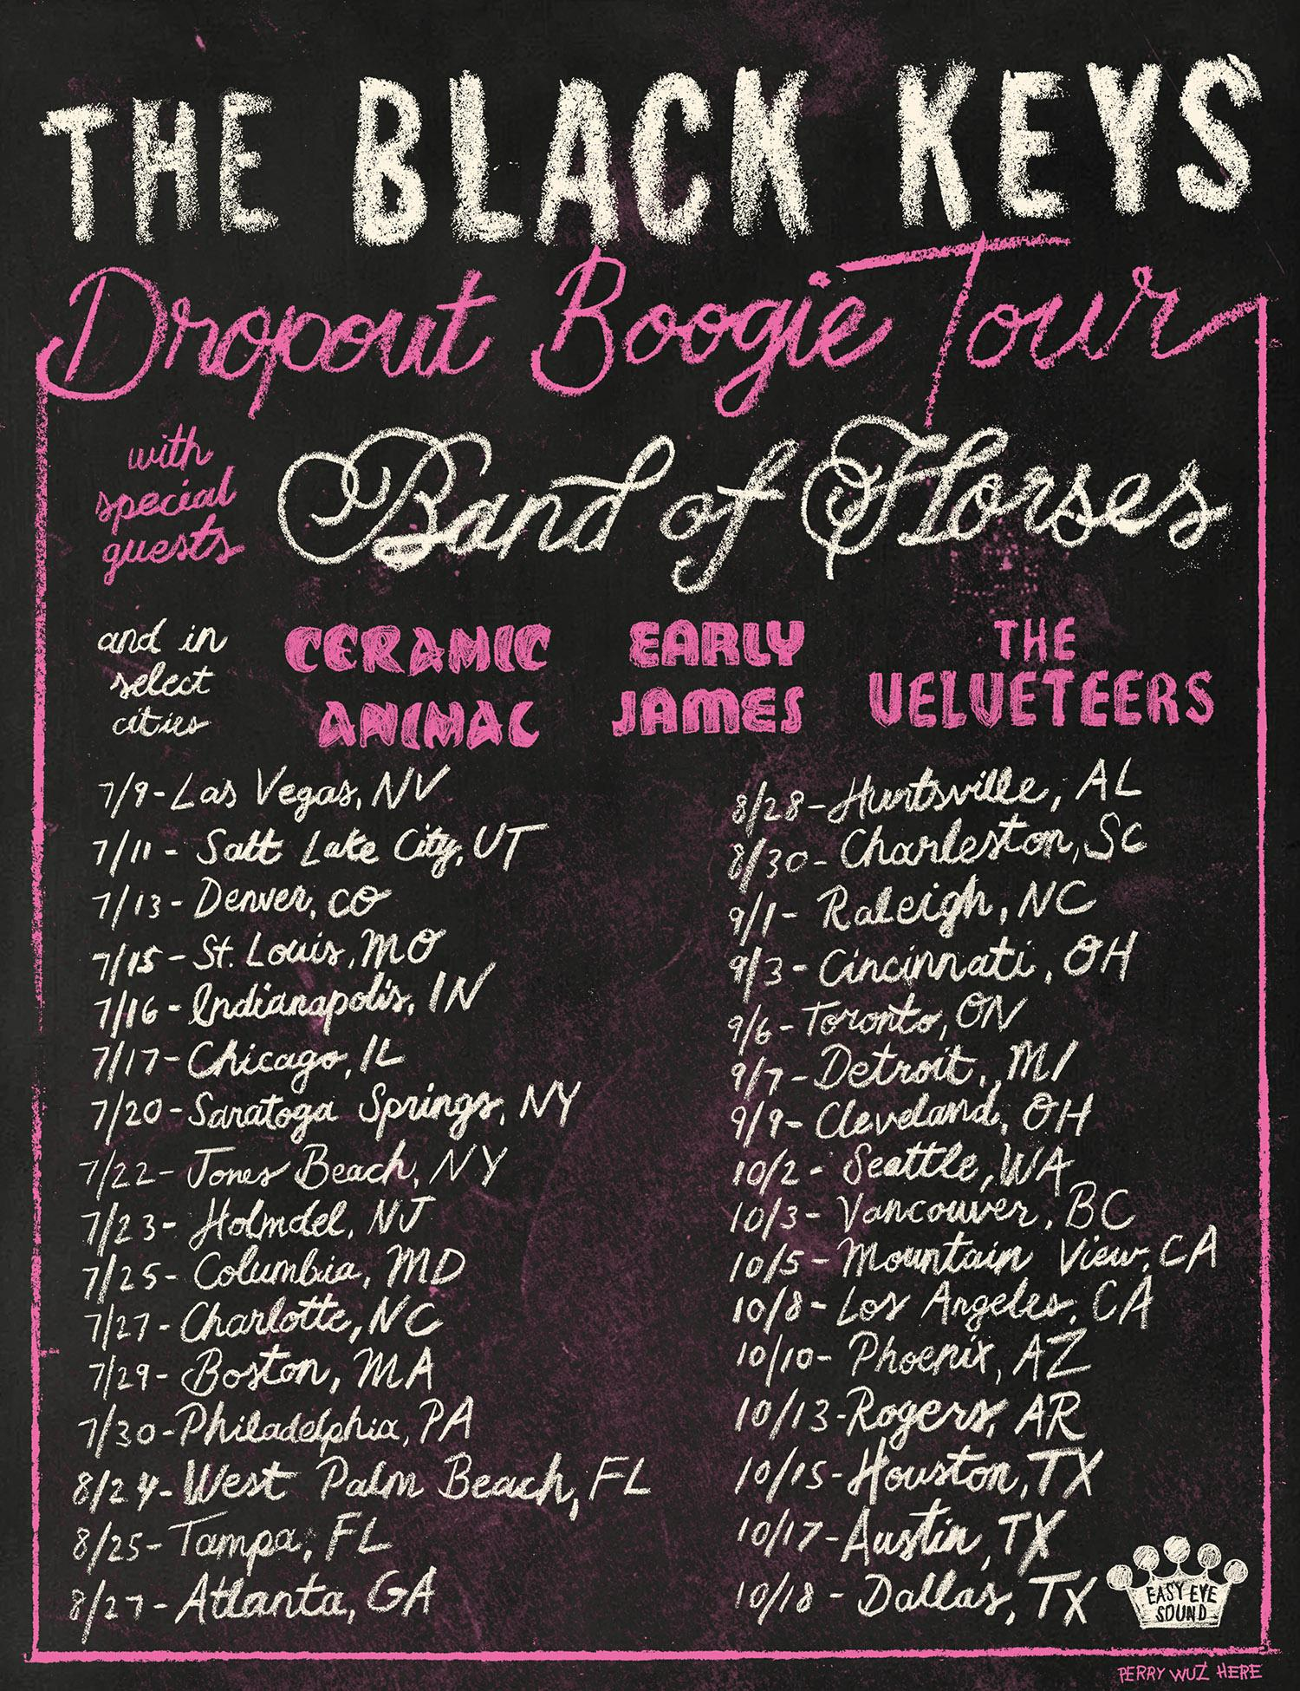

**The Black Keys’ *Dropout Boogie* tour dates and cities:**

July 9: Las Vegas, NV – MGM Grand Garden Arena

July 11: Salt Lake City, UT – USANA Amphitheatre

July 13: Denver, CO – Red Rocks Amphitheatre

July 15: St. Louis, MO – Hollywood Casino Amphitheatre St. Louis

July 16: Indianapolis, IN – Ruoff Music Center

July 17: Chicago, IL – Hollywood Casino Amphitheatre Tinley Park

July 20: Saratoga Springs, NY – Saratoga Performing Arts Center

July 22: Jones Beach, NY – Northwell Health at Jones Beach Theater

July 23: Holmdel, NJ – PNC Bank Arts Center

July 25: Columbia, MD – Merriweather Post Pavilion

July 27: Charlotte, NC – PNC Music Pavilion

July 29: Boston, MA – Xfinity Center

July 30: Philadelphia, PA – Waterfront Music Pavilion (formerly BB&T Pavilion)

Aug. 24: West Palm Beach, FL – iTHINK Financial Amphitheatre

Aug. 25: Tampa, FL – MIDFLORIDA Credit Union Amphitheatre

Aug. 27: Atlanta, GA – Ameris Bank Amphitheatre

Aug. 28: Huntsville, AL – Orion Amphitheatre

Aug. 30: Charleston, SC – Credit One Stadium

Sept. 1: Raleigh, NC – Coastal Credit Union Music Park at Walnut Creek

Sept. 3: Cincinnati, OH – Riverbend Music Center

Sept. 6: Toronto, ON – Budweiser Stage

Sept. 7: Detroit, MI – Pine Knob Music Theatre

Sept. 9: Cuyahoga Falls, OH – Blossom Music Center

Oct. 2: Seattle, WA – Climate Pledge Arena

Oct. 3: Vancouver, BC – Rogers Arena

Oct. 5: Mountain View, CA – Shoreline Amphitheatre

Oct. 8: Los Angeles, CA – The Forum

Oct. 10: Phoenix, AZ – Ak-Chin Pavilion

Oct. 13: Rogers, AR – Walmart AMP

Oct. 15: Houston, TX – Cynthia Woods Mitchell Pavilion

Oct. 17: Austin, TX – Moody Center ATX

Oct. 18: Dallas, TX – Dos Equis Pavilion

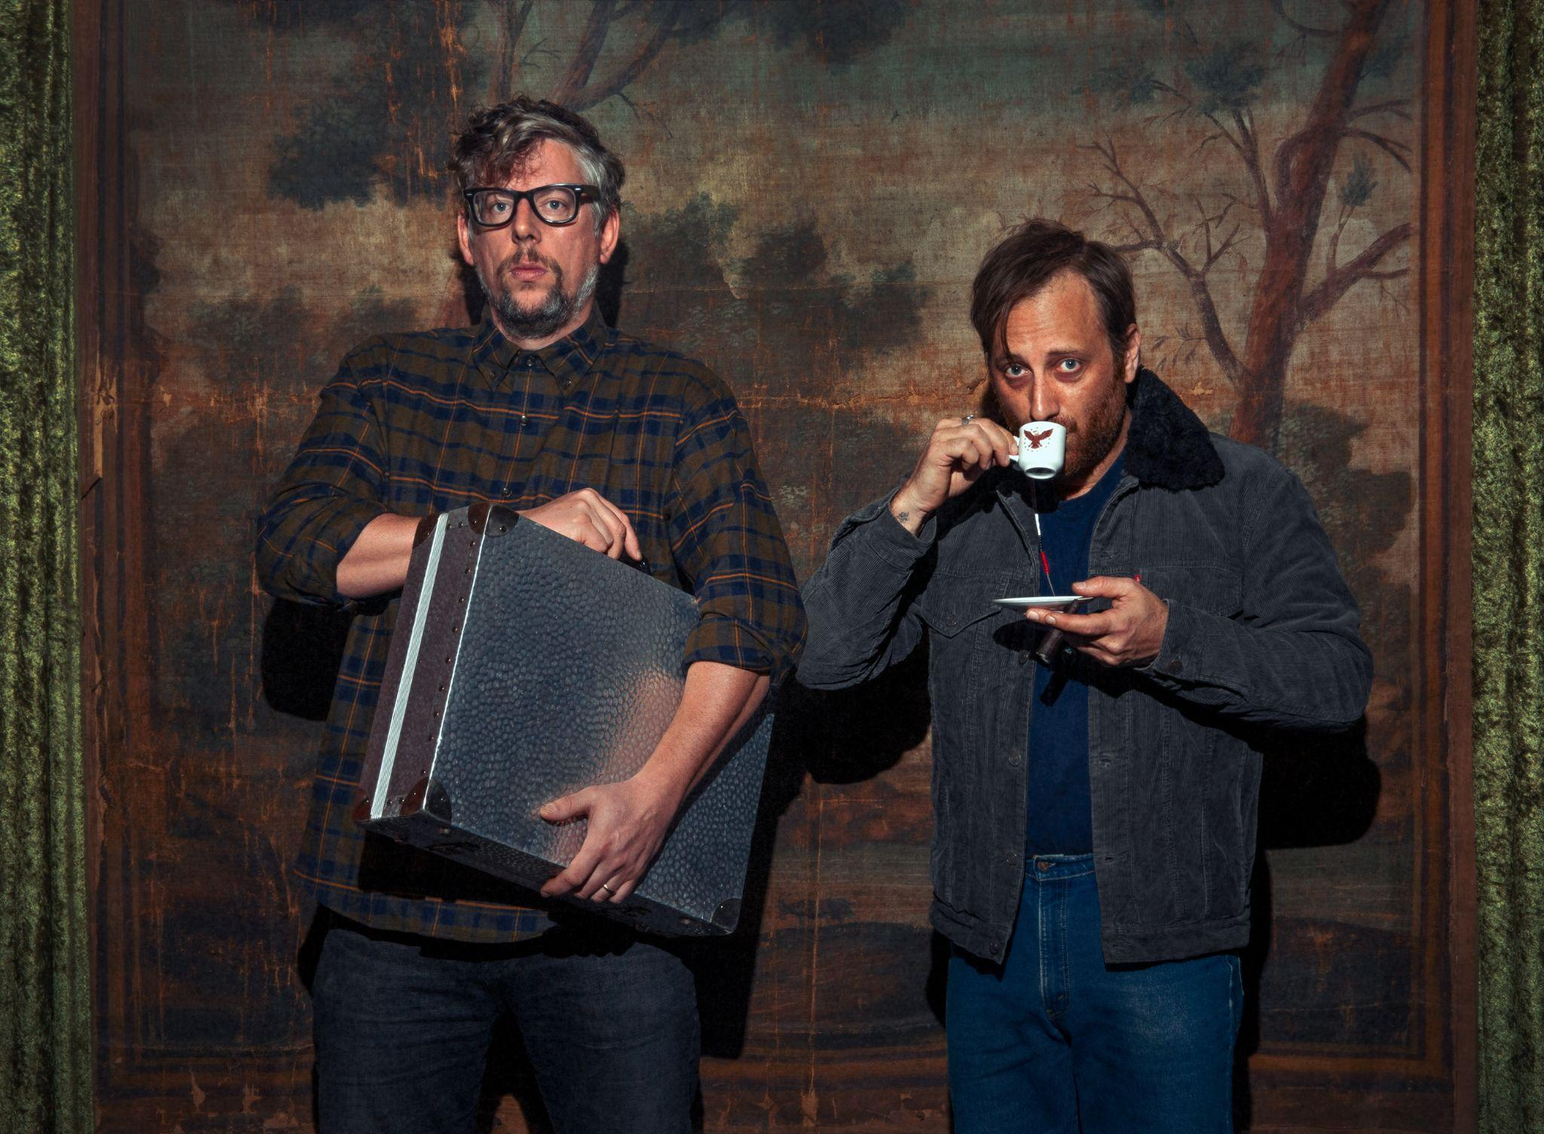

**Photo Credit: Jim Herrington | high-res** [**here**](https://drive.google.com/file/d/1EdgmLxztnOM8WLw4QZIEQKK59aex7IDT/view?usp=sharing)

**Follow The Black Keys here:**

[https://theblackkeys.com](https://theblackkeys.com/) **[Twitter](https://twitter.com/theblackkeys) **[Instagram](https://www.instagram.com/theblackkeys/?hl=en) **[Facebook](https://www.facebook.com/TheBlackKeys) **[Youtube](https://www.youtube.com/channel/UCJL3h2-wEOB6EigQOBZ3ryg)