**Bäckman ready for the STCC finale at Mantorp Park**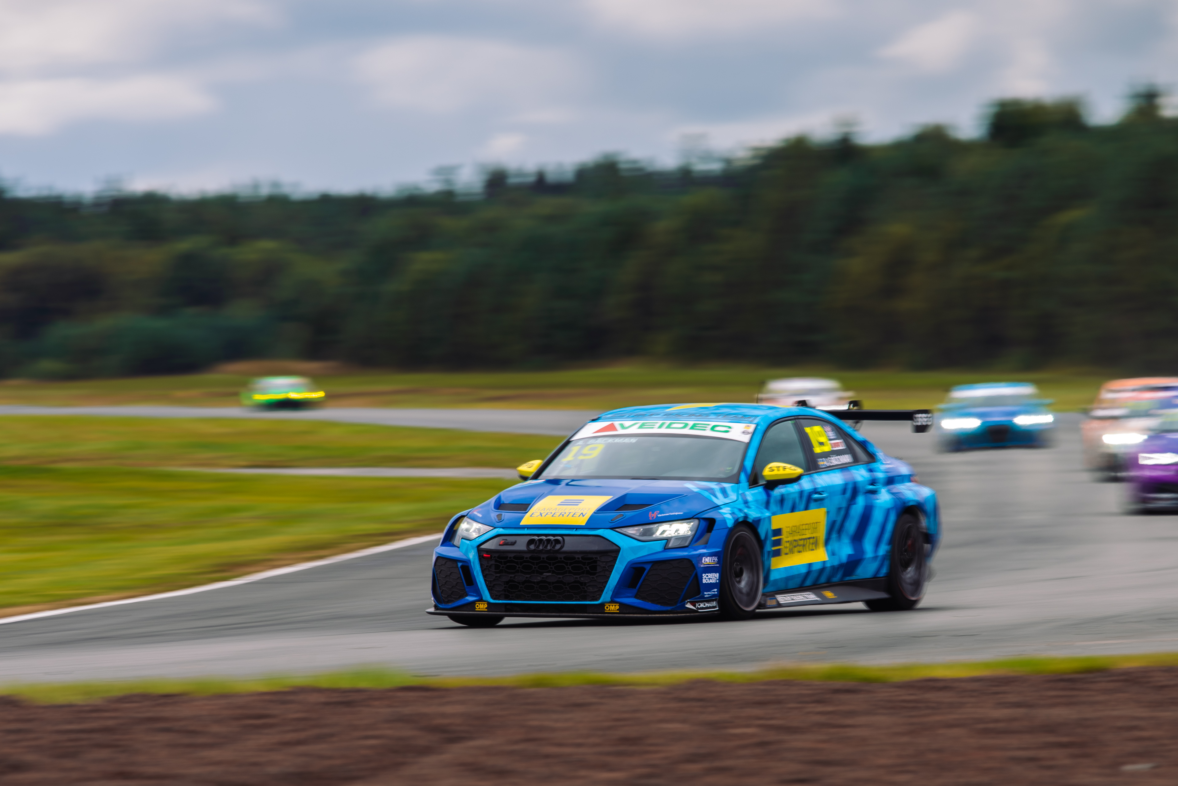Andreas Bäckman is competing this weekend with his Audi RS 3 LMS TCR car for Lestrup Racing Team in this year’s final STCC event at Mantorp Park in Sweden.  
Photo: Martin Öberg (Free rights to use the image)

**This weekend, September 30th-October 1st, the STCC finale are being held at Mantorp Park, Sweden. Andreas Bäckman are feeling ready and is second in the championship standings heading into the finale.  
– Mantorp is the track I have been looking forward to the most this year and I like the track, so I’m looking forward to finishing the season in the best possible way, Andreas Bäckman says.**

STCC (Scandinavian Touring Car Championship) is Sweden's most prestigious motorsport championship and is today the leading class for Touring Car Racing in Sweden. The cars are built according to the global TCR regulations, which means that the cars used in STCC are the same as those in the other TCR series around the world. The series consists of six races that are run on different Swedish tracks and this weekend, September 30th- October 1st, the sixth and final round of the championship are being held at Mantorp Park, which is located near Linköping, Sweden. Mantorp Park is one of Sweden's top motorsport facilities and a large number of motor events are arranged here every year, some of which are among the largest in Sweden and Europe.

Andreas competes together with Lestrup Racing Team in an Audi RS 3 LMS TCR car in this year's STCC season and is in second place in the driver's championship heading into the season finale, 24 points behind the championship leader Robert Dahlgren, with 65 points left to fight for in this year’s final STCC round.

- Mantorp is the track I have been looking forward to the most this year and I had good speed there last year in my one-off race where I got the lap record in the qualifying. The strategy heading into this weekend won’t change compared the previous events, even though it’s the final round. The aim is to score as many points as possible in both the qualifying and the races, and then we will see where that takes us. I will give my everything to finish the STCC-season in the best possible way, **Andreas Bäckman says**.

**The structure of the race weekend**  
 On Friday, the practice begins with one official test session, which are 30 minutes long. This are then followed by two more practice sessions, and on Friday afternoon it is time for the timed qualifying. The timed qualifying consists of two qualifying segments, Q1 (20 minutes) and Q2 (10 minutes), where it is important to drive as fast as possible and the lap times are counted. The eight fastest drivers in Q1 will continue to drive in Q2. The result from Q1 determines the starting position for Race 1 and the Q2 starting position for Race 2 for the top eight drivers.

Saturday is the race-day and consists of three races: Race 1, Race 2 and Race 3. The starting position for Race 3 is based on the result from Race 2 but with the reverse starting order for the eight top drivers from that race.

Points are awarded to the top five in the Qualifying and the top 15 in each race.

**The event are broadcasted LIVE at STCC+**The STCC weekend at Mantorp Park are broadcasted LIVE at: [plus.stcc.se](https://plus.stcc.se/)  
Live-timing:   
<raceresults.se>  
[livetiming.getraceresults.com](https://livetiming.getraceresults.com/stcc#screen-results)  
More information about STCC can be found here: [stcc.se](https://www.stcc.se/)  
Information about the event:  
[stcc.se/race/mantorp/](https://www.stcc.se/race/mantorp/)  
<https://www.stcc.se/2022/09/28/fem-forare-gor-upp-om-stcc-titeln-i-klassisk-finalrysare-pa-mantorp-park/>  
<https://www.stcc.se/2022/09/22/vilka-ar-utmanarna-om-stcc-titeln-2022/>

**Timetable for this weekend (STCC round 6 - Mantorp):**(all times are in CEST/Swedish time)

**Friday September 30th:**09:40 Official test  
11:55 Free Practice 1  
13:30 Free Practice 2  
16:15 Qualifying (Q1 and Q2)

**Saturday October 1st:**  
10:38 Race 1 (Broadcasted LIVE on [plus.stcc.se](https://plus.stcc.se/))  
13:10 Race 2 (Broadcasted LIVE on [plus.stcc.se](https://plus.stcc.se/))  
15:43 Race 3 (Broadcasted LIVE on [plus.stcc.se](https://plus.stcc.se/))

**About the track (Mantorp Park):**

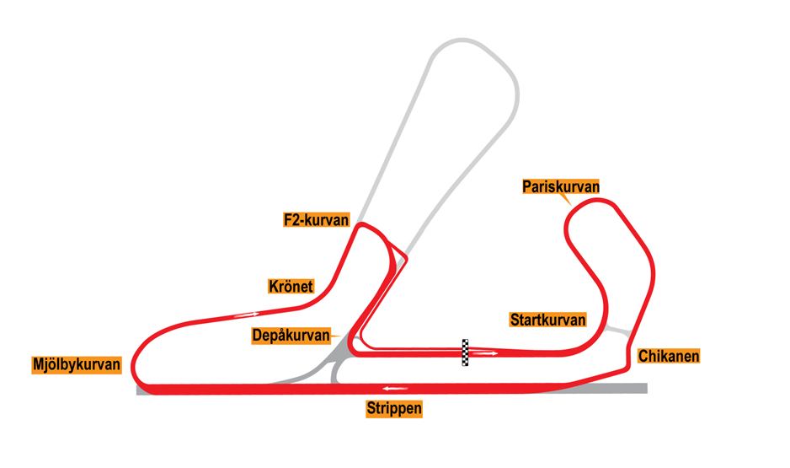

**Located in:** Mantorp, Sweden  
**Length:** 3,106 km  
**Corners:** 8  
**Race duration:** 10 laps (18 minutes + 1 lap)  
**Lap record (TCR):** 1:19.039 / average speed 141.47 kph, Andreas Bäckman (Audi RS3 LMS TCR) 2021

**STCC Championship Standings before round 6 of 6:**

**STCC – TCR Scandinavia – Drivers’ Championship Standings – Overall (Top 3)**STCC 2022 (After 5 of 6 race weekends)

1: Robert Dahlgren (SWE), 219 p.

**2: Andreas Bäckman (SWE), 195 p.**

3: Mattias Andersson (SWE), 182 p.

[See the full standings here](https://www.stcc.se/poang/stcc-2022/)

**STCC – TCR Scandinavia – Teams’ Championship Standings – Overall (Top 3)**STCC 2022 (After 5 of 6 race weekends)

1: CUPRA Dealer Team - PWR Racing, 371 p.

**2: Lestrup Racing Team, 359 p.**3: Brink Motorsport, 326 p.

[See the full standings here](https://www.stcc.se/poang/stcc-make-2022/)

**Did you miss the previous STCC race at Scandinavian Raceway in Anderstorp?**

[Click here](https://plus.stcc.se/video/s-stcc-scandinavian-raceway-anderstorp-5pmyq) to see the replay at STCC+

**Follow the STCC season:**Live-stream: [plus.stcc.se](https://plus.stcc.se/)   
Other information: [stcc.se](https://www.stcc.se/)Facebook: [facebook.com/STCCOfficial/](https://www.facebook.com/STCCOfficial/)  
Twitter: [twitter.com/stcc_official](https://twitter.com/stcc_official)Instagram: [instagram.com/stcc_official/](https://www.instagram.com/stcc_official/)YouTube: [youtube.com/c/STCCTV](https://www.youtube.com/c/STCCTV)

***Free rights to use the images.***

***Download press-photos here:***[***http://bit.ly/jabaeckman-photos***](http://bit.ly/jabaeckman-photos)[***https://www.mynewsdesk.com/se/ja-backman/images***](https://www.mynewsdesk.com/se/ja-backman/images)

