a-JAYS Four iPhone joins Apple in white
The Swedish earphone manufacturer Jays AB (publ) has achieved great international success with its a-JAYS Four iPhone. Jays is now launching it also in white, just in time for today's long-awaited launch of Apple's white iPhone 4.
White is apparently the color this spring. With a history of major product successes, review victories and awards, the Swedish earphone manufacturer Jays reached the international audience with a-JAYS Four iPhone, launched at the beginning of 2011. The model has quickly become a favorite among users of the Apple iPhone, iPad and iPod and the full-Compatibility headset in an attractive Scandinavian design also offers sound quality that is musically far ahead of many comparable alternatives. Jays have carefully awaited launch of the new white iPhone 4 and now it's finally time to join them with a matching white a-JAYS Four iPhone. It is expected to be in stores by the end of the second quarter of 2011.
“We are a company which sets the highest priority to quality and user's musical experience. We have, therefore, a carefully planned product range, focusing on strengthening the musical essence and usability of our products" says Rune Torbjörnsen, CEO at Jays AB (publ). “We already cover all the segments with high quality products in black, but now want to provide a stylistically perfect alternative to satisfy the musical experience, the introduction of a white iPhone compatible product meets this goal perfectly. We know that it is expected of us to meet up with our friends and users' needs and it would be wrong for us to call ourselves passionate and innovative if we did not do this.”

For more information, please contact:
Rune Torbjörnsen, CEO Jays AB (publ)
Cell: +46 (0)733-730 770

E-mail: rune.torbjornsen@jays.se

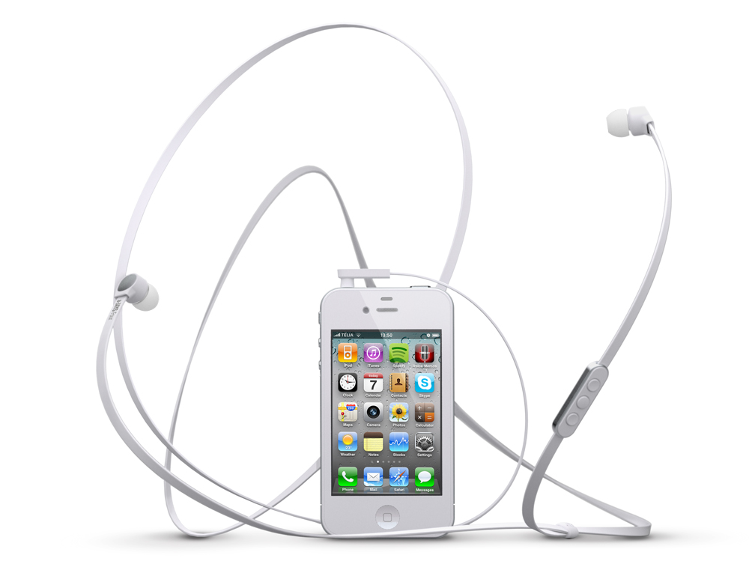

Jays AB (publ) develops, designs and produces earphones and equipment for portable media players. Jays supplies high quality products, aimed to provide the user with maximum sound experience. Jays passion is the quest for the perfect sound – the sound that affects and inspires user’s body and soul.The company is expanding rapidly and its products are being sold in more than 20 countries worldwide.

