Kongsberg Maritime consolidates construction and shipping partnerships with third wellboat contract win
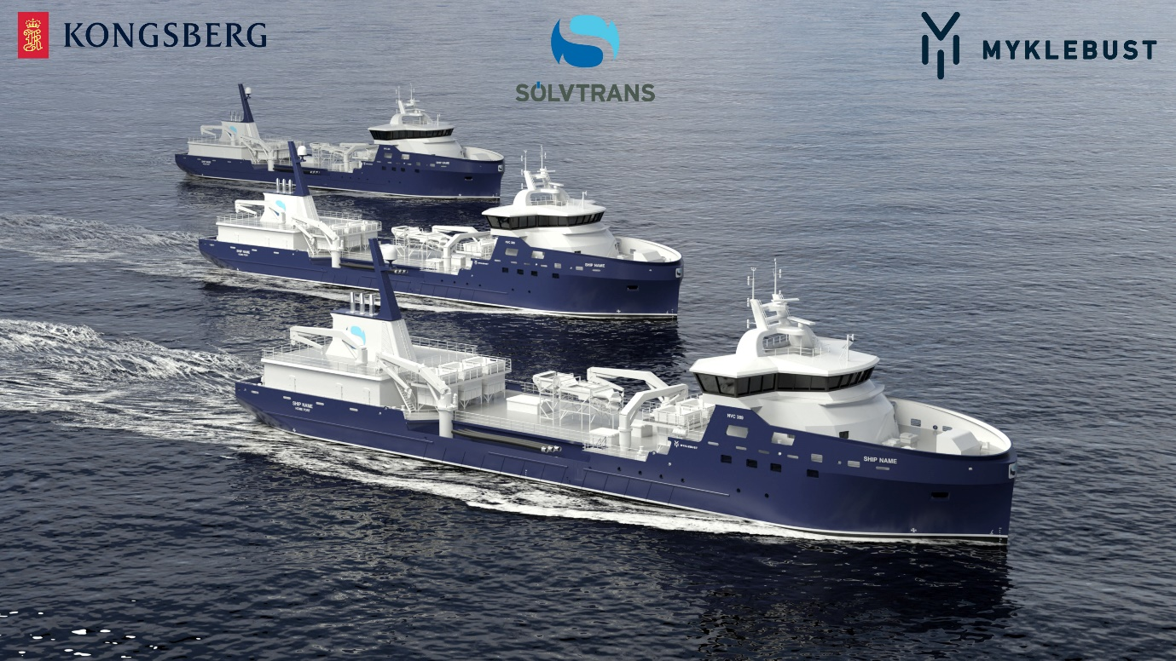
Kongsberg Maritime will design and equip the third Sølvtrans wellboat in a series to be built by Myklebust Verft
Kongsberg, Norway, 23rd September 2020 – Kongsberg Maritime (KM) has reinforced two long-standing business relationships with the news that it is to design and equip the third wellboat in a series to be built for Sølvtrans Rederi by the Myklebust Verft yard in Gursken, Norway. KM estimates the value of this contract to be approximately NOK 45 million.
Based in Ålesund, Sølvtrans is one of the world’s largest wellboat shipping companies for the transportation and processing of live salmon. There are 19 wellboats in its fleet, seven of which have been designed by KM. Of these, three are now under construction by Myklebust Verft, with its 135-strong permanent workforce.
The new wellboat, with a loading capacity of 4,000m³, is a KONGSBERG NVC 389 live fish carrier vessel design. It will sport a host of onboard features designed to ensure the safe, gentle, humane and cost-effective handling of fish stocks: freshwater production and treatment systems, movable bulkheads, vacuum and under-pressure loading, over-pressure unloading, and a generous hold capacity.
In addition to assuming responsibility for the wellboat’s design, KONGSBERG will also deliver a comprehensive equipment package. Designed to greatly reduce environmental impact with its efficient diesel-electric propulsion system, the vessel will also benefit from the presence of a PROMAS solution, in which the rudder and propeller are integrated into a single system for enhanced hydrodynamic performance. KONGSBERG thrusters will provide the side force required to optimise manoeuvring capabilities, and the vessel will be fitted out with an array of KONGSBERG electrical and automation systems as well as vital deck machinery such as winches.
“The collaborative partnership we have developed over time with Sølvtrans and Myklebust Verft is deeply appreciated and of considerable value to us,” says Monrad Hide, Sales Director in Ship Design, Kongsberg Maritime. “All three companies are leaders in our respective fields, and what we’ve seen is that the strong synergy of our skills and specialisms has had an overwhelmingly positive ripple effect on sales and supplier infrastructures in the local region and well beyond.”
“The building and commissioning of the new wellboat is destined to be another high-profile project which will bolster our collective reputation and generate business across a number of sectors,” adds Roger Halsebakk, CEO, Sølvtrans. “We know that we can rely on KONGSBERG’s well-established expertise in vessel design and maritime technology, just like we can count on Myklebust Verft to carry out an impeccable construction job.”
Ends

For further information, please contact:
Gunvor Hatling Midtbø, VP Communication
Kongsberg Maritime
Tel: +47 9921 4209
gunvor.hatling.midtbo@km.kongsberg.com
David Pugh
Saltwater Stone
Tel: +44 (0)1202 669244
d.pugh@saltwater-stone.com

About Kongsberg Maritime
Kongsberg Maritime is a global marine technology company providing innovative and reliable ‘Full Picture’ technology solutions for all marine industry sectors including merchant, offshore, cruise, subsea and naval. Headquartered in Kongsberg, Norway, Kongsberg Maritime has manufacturing, sales and service facilities in 34 countries.
Kongsberg Maritime solutions cover all aspects of marine automation, safety, manoeuvring, navigation, and dynamic positioning as well as energy management, deck handling and propulsion systems, and ship design services. Subsea solutions include single and multibeam echo sounders, sonars, AUV and USV, underwater navigation and communication systems.
Training courses at locations globally, LNG solutions, information management, position reference systems and technology for seismic and drilling operations are also part of the company’s diverse technology portfolio. Additionally, Kongsberg Maritime provides services within EIT (Electro, Instrument & Telecom) engineering and system integration, on an EPC (Engineering, Procurement & Construction) basis.
Kongsberg Maritime is part of Kongsberg Gruppen (KONGSBERG), an international, knowledge-based group that celebrated 200 years in business during 2014. KONGSBERG supplies high-technology systems and solutions to customers in the oil and gas industry, the merchant marine, and the defence and aerospace industries.
Web: Kongsberg Gruppen | Kongsberg Maritime
Social media: LinkedIn | Twitter | Facebook

