And the award goes to – ADAPT Parasol!
Swegon’s PARASOL comfort module family for ventilation with waterborne cooling and heating, continues its global success story. Already in 2007 the newly launched PARASOL won the Great Indoor Climate Prize, and the following year it was recognized at the GAIA Awards in Dubai.
The PARASOL has developed continuously and in 2014 the intelligent family member ADAPT Parasol stole the limelight when being one of the finalists for the British award “Air Movement Product of the Year”. ADAPT Parasol’s unique combination of comfort module and independent integrated controls for demand controlled ventilation, has continued to raise attention. The latest addition to the award collection was won in April 2015, this time on Canada’s largest exhibition for the mechanical and electrical industries, MCEE in Montreal. ADAPT Parasol was announced winner in the category “Heating and/or cooling hydronic appliances” in the New Product Competition.
“The MCEE-award is naturally an important verification that our efforts to develop the indoor climate business is well received by the market” says Jonas Åkesson, Product and Market Manager at Swegon. He continues “More and more professionals discover how ADAPT Parasol creates an energy efficient and comfortable indoor climate. When adding the other parts of Swegon’s product range, unbeatable combinations are created which facilitates the whole building process”.
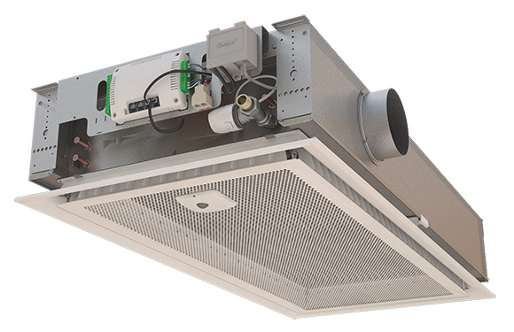

Swegon is part of the Latour group, listed on the Swedish stock market and is the market leader within energy efficient ventilation and indoor climate systems. Through the Swegon Group sales subsidiaries and partners Swegon supplies components and systems that create good indoor climate and highly contributes to saving energy.
Swegon has 11 production plants in Sweden, Finland, Italy, India, North America and Belgium. The company employs 1 800 staff and the turnover is approximately MEUR 360.

