**Jessica Bäckman won her first international race at the TCR Germany premiere**

**This weekend, Jessica Bäckman took her first international race win at the ADAC TCR Germany premiere at the Oschersleben track in Germany. Jessica qualified as 2nd on Saturday and then got a great start and took the lead at the start which she then kept all the way to the finish. This win was her first individual ever in a racing car, something that has been a big goal for her to achieve.   
- Very special feeling to finally take this long-awaited victory, and it also feels extra special to win at the premiere race in TCR Germany, Jessica Bäckman says.**

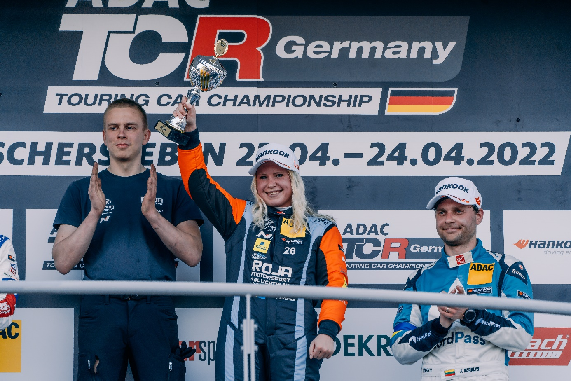

TCR Germany is one of the toughest TCR series in the world and has a high status of drivers coming from several different countries around Europe. Each round is built on two free practice sessions on Friday, one time qualifying on Saturday which determines the starting position in Race 1 on Saturday, and one time qualifying on Sunday which determines the starting position in Race 2 on Sunday. Points are awarded to the top 8 in the time qualifying’s and the top 15 in each race. The driver with the most points after the last race at the Hockenheimring at the end of October will take home the driver title "ADAC TCR Germany Drivers Title" in the ADAC TCR Germany series. Last weekend, April 22-24th, the first race was held at the Oschersleben track in Germany, where Jessica competed for a new team ROJA Motorsport and a new car model Hyundai Veloster N TCR car, which resulted in Jessica’s first international race win in her career in the premiere race.

**First win for Jessica Bäckman**Jessica started the weekend strong and was second fastest in the first and second practice sessions, despite the short time she has had in the new Hyundai Veloster N TCR car. In the first qualifying on Saturday, she had some bad luck, on her the last push lap she had the fastest first sector of all the drivers but then suffered with technical problems as the car slowed down in sector 2, which meant that she had to settle for a second place also in the first qualifying. Jessica started Race 1 on Saturday from the second starting position, from there she got a good start and took the lead right from the start which she then held all the way to the finish. With this said, Jessica took her first international race win ever in her career, something she has had as a big goal to achieve.

-Feels amazing to finally take my long-awaited race win, I have won a lot in karting both nationally and internationally but never in a racing car. That it also happened in an international race when I first hear the Swedish national anthem on the podium feels extra special as it has been another goal I have wanted to achieve, **Jessica Bäckman says.﻿**

﻿

**Technical problems on Sunday**During qualifying two on Sunday, Jessica was charged to try to take first place in the qualifying but instead suffered of technical problems with the fuel pump and did not any lap. This meant that she instead had to start Race 2 on Sunday at the back of the field. From there, Jessica quickly advanced up to a 5th place with some good overtakes and had a chance at better placements with good speed in the car. With just over 15 minutes left of the race, the safety car came out on the track and then Jessica had a chance to advance even more when the field shrank. Unfortunately, the safety car was going all the way to the finish so Jessica could not advance any more placements. Despite the difficult Sunday, Jessica is still 3rd in the championship table with 21 points up to first place**.**

- Not the best start on Sunday with the technical problems in the qualifying, otherwise I felt strong and had a good chance of another top place. I still feel satisfied with race 2 on Sunday, I did what I could from my starting position, so from here I look forward to the next race at Red Bull Ring in just over a month, big thanks to my team ROJA Motorsport, **Jessica Bäckman says.**

**Jessicas results:**Free Practice 1: 2nd place  
Free Practice 2: 2nd place   
Qualifying 1: 2nd place  
Race 1: 1st place  
Qualifying 2: DNS. Due to technical problems.   
Race 2: 5th place  
  
  
**Championship standings:**

**ADAC TCR Germany – Total (Top three)**  
ADAC TCR Germany 2022 (after 1 of 7 rounds)

1: Martin Andersen (DKK), 65 p.  
2: Jonas Karklys (LIT), 55 p.  
**3: Jessica Bäckman (SWE), 44 p.**

[Se hela mästerskapsställningen](https://www.adac-motorsport.de/adac-tcr-germany/rankings/2022)

***Free rights to use images.***