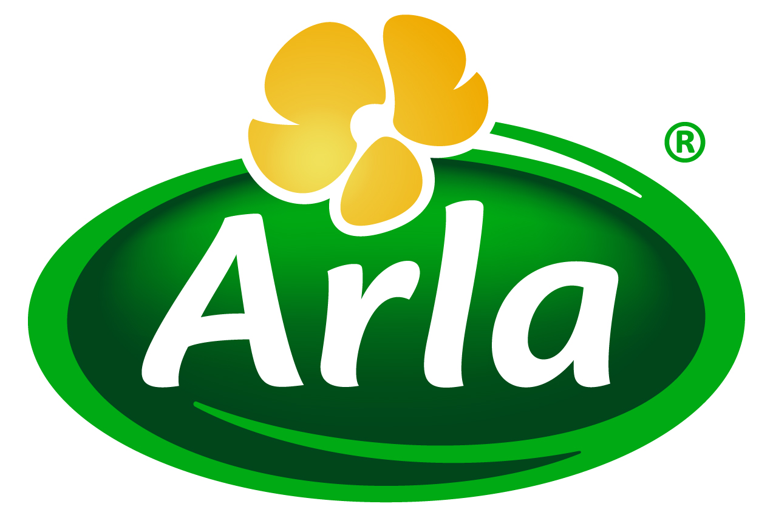

October 2016
PRESS RELEASE – HIE 2016 PREVIEW
‘Whey Better Proteins’ take centre stage
for Arla Foods Ingredients

In the spotlight for Arla Foods Ingredients at HI Europe 2016 will be a range of innovative application solutions under the theme of ‘Whey Better Proteins’.

Exhibiting on Stand G2, Arla Foods Ingredients will showcase WheyHi, a new RTD beverage ingredient solution developed to make it easy for companies to create nutritious long shelf life drinks targeting the mainstream sport and breakfast categories. WheyHi is suited to UHT applications using both direct and indirect heating, with no fouling of the protein. It is ideal for formulating in both water and dairy-based drinks, and delivers up to 40% protein in applications such as coffee, tea, fruit smoothies and chocolate beverages.

Arla Foods Ingredients will also introduce a delicious and refreshing iced coffee concept made with Lacprodan® DI-7017 whey protein. A high source of protein (>20%), it is a healthy beverage that will benefit not just the muscles but also the brain thanks to its natural caffeine content. Low in sugar and lactose, the iced coffee also contains Capolac® minerals from milk and is a source of calcium (>60mg/100ml).

In addition, Arla Foods Ingredients will highlight its dairy ingredient solutions for the toddler nutrition category. Rich in high quality proteins and minerals from milk, these will enable manufacturers to create delicious and nutritious products that parents will want to buy and toddlers will want to eat. They are perfect for snack bars, squeezable pouches, yoghurts, fruit drinks, milky drinks and toddler formulas.

HIE takes place in Frankfurt from 29 November to 1 December 2016. Visit Stand G2 to find out more about Whey Better Proteins from Arla Foods Ingredients.

ENDS

For more information, please contact:
Richard Clarke, Ingredient Communications
Tel: +44 7766 256176
Email: richard@ingredientcommunications.com
Twitter: @ingredientcomms

About Arla Foods Ingredients
Arla Foods Ingredients is a global leader in natural whey ingredients for products in a range of categories – from sports, clinical and infant nutrition to beverages, bakery, dairy and ice cream.
The cornerstones of our business are innovative ingredients, world-class facilities and a staff of dedicated experts. Drawing on our portfolio of functional and nutritional whey proteins, milk minerals, lactose and permeate, our expert team delivers solutions that bring new food products quickly and efficiently to market. Our application centres run hundreds of customer product trials every week. All ingredients are produced using state-of-the-art processing technology at our plant in Denmark, or by one of our joint ventures in Argentina, Germany and the UK.
Arla Foods Ingredients Group P/S is a 100% owned subsidiary of Arla Foods, a global dairy company and cooperative owned by dairy farmers in Denmark, Sweden, the UK, Germany, the Netherlands, Belgium and Luxemburg.

RSS Feed
Visit our website at http://www.mynewsdesk.com/arla-foods-ingredients and sign up to our News RSS feed for all the latest developments – updated regularly.

Twitter
Follow us on twitter for all the latest updates @ArlaIngredients

LinkedIn
http://www.linkedin.com/company/arla-foods-ingredients

Facebook
https://www.facebook.com/arlaingredients

