**Big crash ended the weekend for the Bäckman siblings in Germany**

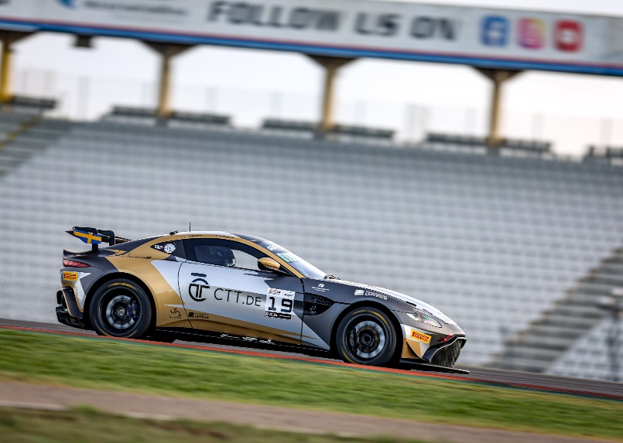Andreas and Jessica Bäckman competed last weekend at the classic Formula 1 track Hockenheimring in Germany at the fifth round of the GT4 European Series.  
Photo: GT4 European Series (Free rights to use the image)

**Last weekend, September 1st-3rd, Andreas and Jessica Bäckman competed at the German Hockenheimring circuit at the fifth round of the GT4 European Series in an Aston Martin Vantage GT4 car. However, the siblings' weekend was cut shorter than planned when Jessica was involved in a big crash at the end of Race 1 where she was hit and went airborne.**

**- Several people crashed around me and there was nothing I could have done to avoid the crash. It was very a big crash, says Jessica Bäckman.**

The previous weekend, September 1-3, the Bäckman siblings competed in the GT4 European Series at the Formula 1 track Hockenheimring, located approximately 8 kilometers from the city of Frankfurt in Germany. On the starting line, Bäckman faced 47 of the best GT4 drivers/cars in the world. It was another tough weekend for the siblings, with the race weekend ending a day early due to a crash at the end of the first race for Jessica. It was at the end of the hour long race with about five minutes left in the race that there was a big crash with several cars involved, where Jessica was unfortunately involved. She was hit by several cars and the car flew into the air with extensive car damage.

**Small steps forward in the Qualifying**  
The competition weekend started with the test/practice sessions on Thursday and Friday. The siblings worked with the team to get the car up to speed better than the previous races, and small progress was made, although still far from where they want to be. They qualified in 14th and 17th place respectively in the Silver class in the Qualifying sessions.

In the first race, Andreas started the race. The first laps were very eventful and intense. Unfortunately, he lost a few places after some collisions in the side and from behind. It also caused them to start getting some warning messages in the car as a consequence of this during the rest of the race. Even some radio problems were close to causing it when it was time for the pit stop and the mandatory driver change. But despite this, the pit stop went almost perfectly, and Jessica gained a position out of the pits and continued the second half of the race. However, with about five minutes left in the race right after the last safety car restart, she became involved in the aforementioned crash. The extensive damage to the car unfortunately meant that they could not start the next day for the second race.

- The race was challenging and many things happened during the race. The collisions during the first lap affected the car more than we first thought and then we had to deal with these problems for the rest of the race. It was a sad end to this weekend as Jessica would be involved in the crash. There was nothing she could have done differently, so it was very unfortunate that she was in the wrong place at the wrong time. It was nice to hear she was okay, as it was a big crash. It shows how safe the cars are, **Andreas Bäckman** says.

- It wasn't the end to the weekend we had hoped for, unfortunately, but now we can only look forward. The next race is the final race in Barcelona in Spain, it's a track that we both have good memories from before. We aim to finish the season strong there, **Jessica Bäckman** says.

**Andreas and Jessica’s results (Silver class):**Free practice 1: 21st place  
Free practice 2: 16th place  
Qualifying 1 (Q1): 14th place  
Qualifying 2 (Q2): 17th place  
Race 1: DNF (Retired)  
Race 2: DNS (Did not start due to the damage after the crash in Race 1)

**TV links in case you missed last weekend’s qualifying and races:**

[Click to watch Qualifying 1 & 2](https://www.youtube.com/live/LGqOPKoY07I?si=7xr_8-vuvzh1lTsW)[Click to watch Race 1](https://www.youtube.com/live/JjkTXlv3mh4?si=NIHBfhbfptZJyrgn)

*Next up for the siblings is the sixth and final round of the GT4 European Series in four weeks, September 29th – October 1st, at the Circuit de Barcelona-Catalunya, located near Barcelona, Spain.*

**GT4 Europe Calendar 2023:**April21st-23rd - Monza, Italy  
June 2nd-4th - Paul Ricard, France  
June 29th - July 2nd - Spa-Francorchamps, Belgium  
July 14th-16th - Misano, Italy  
September 1st-3rd - Hockenheim, Germany  
September 29th - October 1st - Barcelona, Spain

***Free rights to use images.***

**Download press pictures here:**[http://bit.ly/jabaeckman-photos](http://postman.mynewsdesk.com/ls/click?upn=4mSYdFH0I-2BnSctn7rnXbif8-2FRfm6fHVIS6FXq16TURLmrFdqRw6dteDZaOJjr-2FMyMv-C_ZtyLTlYa78bQffWNrIlGC89uBpjFc4wPoL31whaXJXqA-2BRsUrcXzNWFVj0soHGyX26TNNKzSJG8P29CGUwlZk8wMQScmiadZYmHpC5iaM8tEj74cd2-2Bshm3O-2FicQq1rN-2B0J0spS3qWh-2BTd-2BFOtBEGa0hOPevvcT2ZyNuHn4H24lKD8TOMITvV1ITcL4U3LzSFx4eOoVK5r4xBL0-2BnU3AkA5GnTB1N-2FfgzX5T-2FCyjfX8QYE-2B1bRomuvp1CRJ9jo6VHV7zdrYo8QRpmhYze5b1YEUC-2FpQPaNS-2BzMu0kM7NT7Yj7NRMRxsnQvHEYLLpOvzAprZR9xDIqp0dZewR1BOC3zAHf53kx-2FmuoA3Hk-2BNR0k1GbIbiJM8AVhlcZn785MT2KNYO7jZK3B-2Btt9-2B05D3EU9yXtL1yaNt074kK1qPv7UA-3D)[https://www.mynewsdesk.com/se/ja-backman/images](http://postman.mynewsdesk.com/ls/click?upn=WoIcRi1A806qLxoNW47-2ByDMK-2FB9-2BYkCh6O459BWDJ545aOroHSZTzKtBcMykYW8eQ6ERGgPGp-2FcoK9cMyYIVnA-3D-3D9B3L_ZtyLTlYa78bQffWNrIlGC89uBpjFc4wPoL31whaXJXqA-2BRsUrcXzNWFVj0soHGyX26TNNKzSJG8P29CGUwlZk8wMQScmiadZYmHpC5iaM8tEj74cd2-2Bshm3O-2FicQq1rN-2B0J0spS3qWh-2BTd-2BFOtBEGa0hOPevvcT2ZyNuHn4H24lKD8TOMITvV1ITcL4U3LzSFx4eOoVK5r4xBL0-2BnU3AkH-2FkBB-2Fy-2BZ-2FJS-2Bo4uhkD6tP2ZO42tgESlOtnQ-2FJzqTvHzSuvUBXoWvWlpWT3ykHsq37UjtrEBmbC4dNCOeD0zEK7OxzrMO3WGfBVeo2bEXTCg7wK3CBUoYPKnYb-2FitNVPaMjt-2BjF-2BhA5xQzTnF-2BLcTU3m0CGdhkEXaQWnN8EoYJIsF-2FE9yWeYWT1x8pPJqLs1djRjvnKGJE249ArqbthAmg-3D)

