Kongsberg Maritime to design and equip an
innovative new krill vessel for Rimfrost
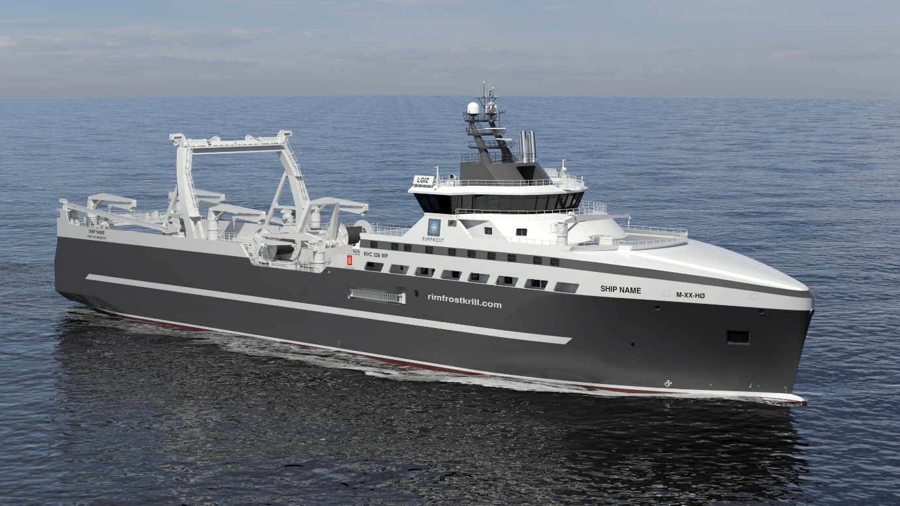
Rimfrost’s innovative new Kongsberg Maritime-designed krill fishing vessel
Kongsberg, Norway, 10th September 2020 – Kongsberg Maritime is delighted to announce that it has been contracted to design and equip a highly innovative vessel for the Norwegian krill processing firm Rimfrost. The ship is to be built by Westcon, who will complete the vessel at their facility in Norway after initial construction at the Tersan Shipyard in Turkey. It is expected that the 120m ship will be ready to begin operations in 2022.
The contract has been awarded in several stages during 2020, with the final stage signed in September 2020. The total value of the contract exceeds 200 MNOK.
Kongsberg Maritime’s design incorporates technology which is destined to set a completely new standard for krill fishing in Antarctica in terms of climate-friendliness, sustainability and optimal resource use, satisfying both DNV GL Clean Design class notation and the IMO’s Polar Code. Extensive use of heat recovery from exhaust gases, coolant water and factory processes will ensure the best possible energy utilisation, while the large-scale application of electric components will limit the danger of pollution from hydraulic systems.
Much of this innovative technology is sourced from KONGSBERG’s comprehensive product portfolio, including propulsion, steering and deck machinery, power, automation and telecoms. A Fishmaster integrated bridge solution comprising navigation, fish finding, catch monitoring and communications systems will also be supplied by KONGSBERG, in addition to remote support.
The ship’s pioneering design is firmly focused on sustainable operation in one of our planet’s most fragile ecosystems. With this in mind, the vessel will be able to carry out much of the product processing on board, making more efficient use of the krill caught and thereby reducing the quantity required. Rimfrost CEO Stig Remøy explains: “This will be the only vessel in the world where health food and food supplements are actually produced at sea immediately after catching. Short and careful processing will have a positive effect upon product quality. This will allow us to develop a number of new products as food additives for humans, animals and farmed fish as well as for pharmaceutical use. We believe this vessel will revolutionise krill fishing in Antarctica.”
Rimfrost gained its krill licence from the Norwegian Directorate of Fisheries based on the environmental and innovative aspects of the application, in addition to the vessel’s planned use as a research platform. There is also an option to construct a further vessel.
“It’s inspiring to partner Rimfrost in such an innovative project,” said Egil Haugsdal, President, Kongsberg Maritime. “Here at Kongsberg Maritime we are strongly focused on a sustainable maritime future, and Rimfrost’s vision pairs perfectly with our own. Our deep involvement with this project, both in its design and in its equipment specification, has allowed us to plan a vessel which we believe is a real game-changer. By minimising emissions and maximising the efficient use of energy, we can make our industry smarter, safer and more sustainable.”
Ends

For further information, please contact:

Gunvor Hatling Midtbø, VP Communication
Kongsberg Maritime
Tel: +47 9921 4209
gunvor.hatling.midtbo@km.kongsberg.com

David Pugh
Saltwater Stone
Tel: +44 (0)1202 669244
d.pugh@saltwater-stone.com

About Kongsberg Maritime
Kongsberg Maritime is a global marine technology company providing innovative and reliable ‘Full Picture’ technology solutions for all marine industry sectors including merchant, offshore, cruise, subsea and naval. Headquartered in Kongsberg, Norway, Kongsberg Maritime has manufacturing, sales and service facilities in 34 countries.
Kongsberg Maritime solutions cover all aspects of marine automation, safety, manoeuvring, navigation, and dynamic positioning as well as energy management, deck handling and propulsion systems, and ship design services. Subsea solutions include single and multibeam echo sounders, sonars, AUV and USV, underwater navigation and communication systems.
Training courses at locations globally, LNG solutions, information management, position reference systems and technology for seismic and drilling operations are also part of the company’s diverse technology portfolio. Additionally, Kongsberg Maritime provides services within EIT (Electro, Instrument & Telecom) engineering and system integration, on an EPC (Engineering, Procurement & Construction) basis.
Kongsberg Maritime is part of Kongsberg Gruppen (KONGSBERG), an international, knowledge-based group that celebrated 200 years in business during 2014. KONGSBERG supplies high-technology systems and solutions to customers in the oil and gas industry, the merchant marine, and the defence and aerospace industries.
Web: Kongsberg Gruppen | Kongsberg Maritime
Social media: LinkedIn | Twitter | Facebook

