Bäckman ready for GT4 European Series at Misano
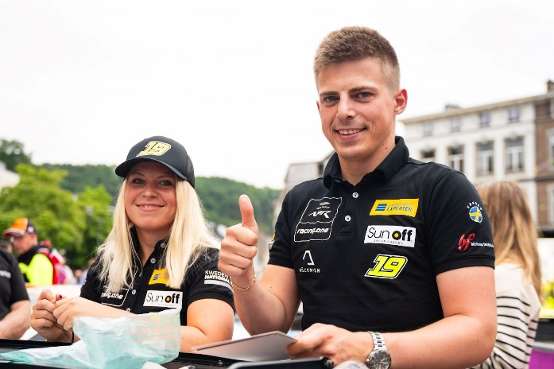
Andreas and Jessica Bäckman are ready for the fourth round of the GT4 European Series in Misano, Italy in their Aston Martin AMR Vantage GT4.
Photo: GTPhotography (Free rights to use the image)
Next weekend, July 14-16th, it's time for Andreas and Jessica Bäckman to take on the Misano World Circuit track in Italy. It's the fourth race of the GT4 European Series where the siblings are hungry for revenge after the previous messy races.
- Misano is a new track for us and seems to be technically difficult, which is something me and Andreas normally like. It will also be very hot this weekend so it will be a challenge, Jessica Bäckman says.
This weekend, July 14-16th, it's time for the fourth round of the GT4 European Series at the Misano World Circuit in Italy, which will be the siblings' fifth race together in GT4.
- We've had a rough start to the season, we don't really have the speed in race conditions yet, which is something we'll focus extra on for the weekend, we're hungry for revenge and it'll be fun to see what the Misano track has to offer, Andreas Bäckman says.
The structure of the GT4 European Series
The GT4 European Series consists of six races around Europe. The series is considered one of the toughest GT4 series in the world and has a high status among the drivers who come from several different countries around Europe. The start of the season went on the well-known Monza circuit in Italy, which is also called "The Temple of Speed" and will end on the well-known Formula 1 circuit Barcelona in Spain. In addition to Barcelona and Monza, the world-famous Formula 1 tracks Spa, Hockenheim, Paul Ricard and Misano where Bäckman will drive this weekend will also be on the 2023 calendar.
Each competition consists of two free practice sessions, two time qualifying’s and two races of 60 minutes each where drivers are changed halfway through the race. Points are awarded to the fastest cars in the time qualifying’s and the top 10 in each race. The drivers in the car with the most points after the final race at Barcelona will take home the driver's title together "GT4 European Series Drivers Title" in the GT4 European Series.
- It will be fun and exciting to take on the Misano World Circuit this weekend. We are hungry for revenge and will give everything we have against this weekend's 48-cars strong grid, Jessica Bäckman says.
Time schedule for this weekend’s races (GT4 European Series Round 4):
(all times in CEST)
Friday July 14th:
11:10 Free Practice 1 (60 min) – LIVETIMING
17:30 Free Practice 2 (60 min) – LIVETIMING
Saturday July 15th:
10:00 Q1/Q2 – Qualifying 1 & 2 (2 x 20 min) - LIVE TV QUALIFYING
17:30 Race 1 (61 min) – driver change in the middle of the race - LIVE TV RACE 1
Sunday July 16th
10:25 Race 2 (61 min) – driver change in the middle of the race - LIVE TV RACE 2

About the track (Misano World Circuit):
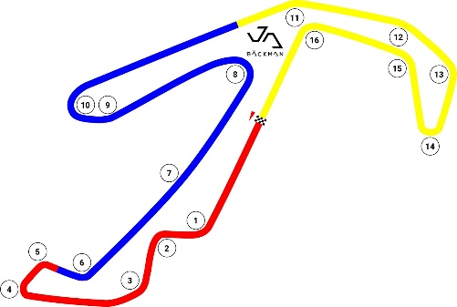
Location: Misano, Italy
Length: 4,064 km
Corners: 16

GT4 Europe Calendar 2023:
April 22nd-23rd - Monza, Italy
June 2nd-4th - Paul Ricard, France
June 29th-July 2nd - Spa, Belgium
July 14th-16th - Misano, Italy
September 1st-3rd - Hockenheim, Germany
September 29th-October 1st - Barcelona, Spain

Free rights to use the images.
Download press-photos here:
http://bit.ly/jabaeckman-photos
https://www.mynewsdesk.com/se/ja-backman/images

