Andreas Bäckman receives elite sports scholarship
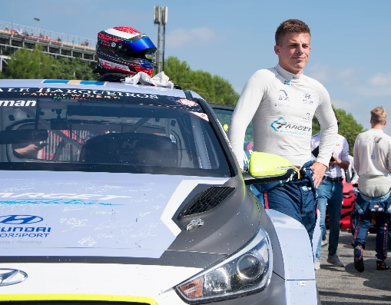
Andreas Bäckman has been awarded the Swedish Sports Confederation's and Svenska Spel's elite sports scholarship.
Photo: Sergi Campdelacreu Mogas (Free rights to use the image)
Racing driver Andreas Bäckman, who competes in TCR Europe on a daily basis, has been awarded the Swedish Sports Confederation's and Svenska Spel's elite sports scholarship as one of 60 athletes.
- Really fun. It was really not something I expected, says Andreas Bäckman.
Today, when the list was released for this year's scholarship holders by the Swedish Sports Confederation (Riksidrottsförbundet) and Svenska Spel's elite sports scholarship, Sweden National Team driver Andreas Bäckman was included as one of the 60 names.
- Really fun. It was really not something I expected, says Andreas Bäckman, who this weekend will compete in the fourth round of TCR Europe in Barcelona, Spain.
Almost 400 applications from 50 different special sports federations were sent this year to the Swedish Sports Confederation's department for elite sports support. The list of the 60 scholarship recipients includes biathlete Mona Brorsson, who has Olympic medals. Also Karolin Ohlsson who has World Cup gold in orienteering. From motorsport Andreas Bäckman managed to get on the list. Something that the Sweden National Team captain Pier Steffansson sees as very positive.
- Fun for Andreas and really fun that we in motorsport with him are among the sixty scholarship recipients who receive the Swedish Sports Confederation's and Svenska Spel's elite sports scholarship in the form of money and development support. This shows that Andreas' work in TCR Europe has yielded results. There are many successful names on the list, so it is truly an achievement to be included as one of the scholarship recipients, says Pier Steffansson, Sweden National Team captain.
The challenges for many athletes are greater than ever, just as for associations and federations. In addition to the financial difficulties caused by the corona pandemic, the active also wrestle with issues concerning cancelled and moved competitions and camps, uncertainty about qualifiers and rankings, concerns about sponsors and other income and other things that are limited by current restrictions.
- Our hope is that the elite sports scholarship will support the active, so that they have the strength to develop into the hopefully brighter future. The careers for both studies and sports are longer now than before. Something that is positive, as many of the best invest and perform at the top for many years, says Liselotte Ohlson, head of the department for elite sports support, Riksidrottsförbundet (The Swedish Sports Confederation).
In addition to the financial support of SEK 50,000 each that the scholarship entails, the active support from the Elite Sports Support department at the Swedish Sports Confederation is also offered in areas such as sports psychology and sports medicine. Both the financial and the operational support are often crucial for the elite athlete's development and performance.
Money and support that will come in handy for the student Andreas Bäckman, who is now completing his fifth year at Luleå University of Technology, where he is studying for a Master of Science in Industrial Design Engineering.
- If you look at motorsport and the costs of driving, the sum may not look so great, but for me personally as a student and who has no other job, it will be a good addition and also includes some other parts of the scholarship that I think I will benefit from later. It feels really fun to be one of the 60 who receive this scholarship, Andreas Bäckman concludes.
Here is the list of all the scholarship holders
More information here: https://www.rf.se/Nyheter/Allanyheter/elitidrottsstipendiumtill60idrottarefran35idrotter
Free rights to use the images.

